Summer Course on Scientific Computing


Introduction to Boundary Integral Method
and Artificial Boundary Method

活動時間： 2013-07-26 (10:00) ~ 2013-08-20 (16:00)
活動地點：R631(7/26) & Lecture Room A (8/2, 8/9, 8/13, 8/19, 8/20) National Center for Theoretical Sciences, NTHU

主講者： | 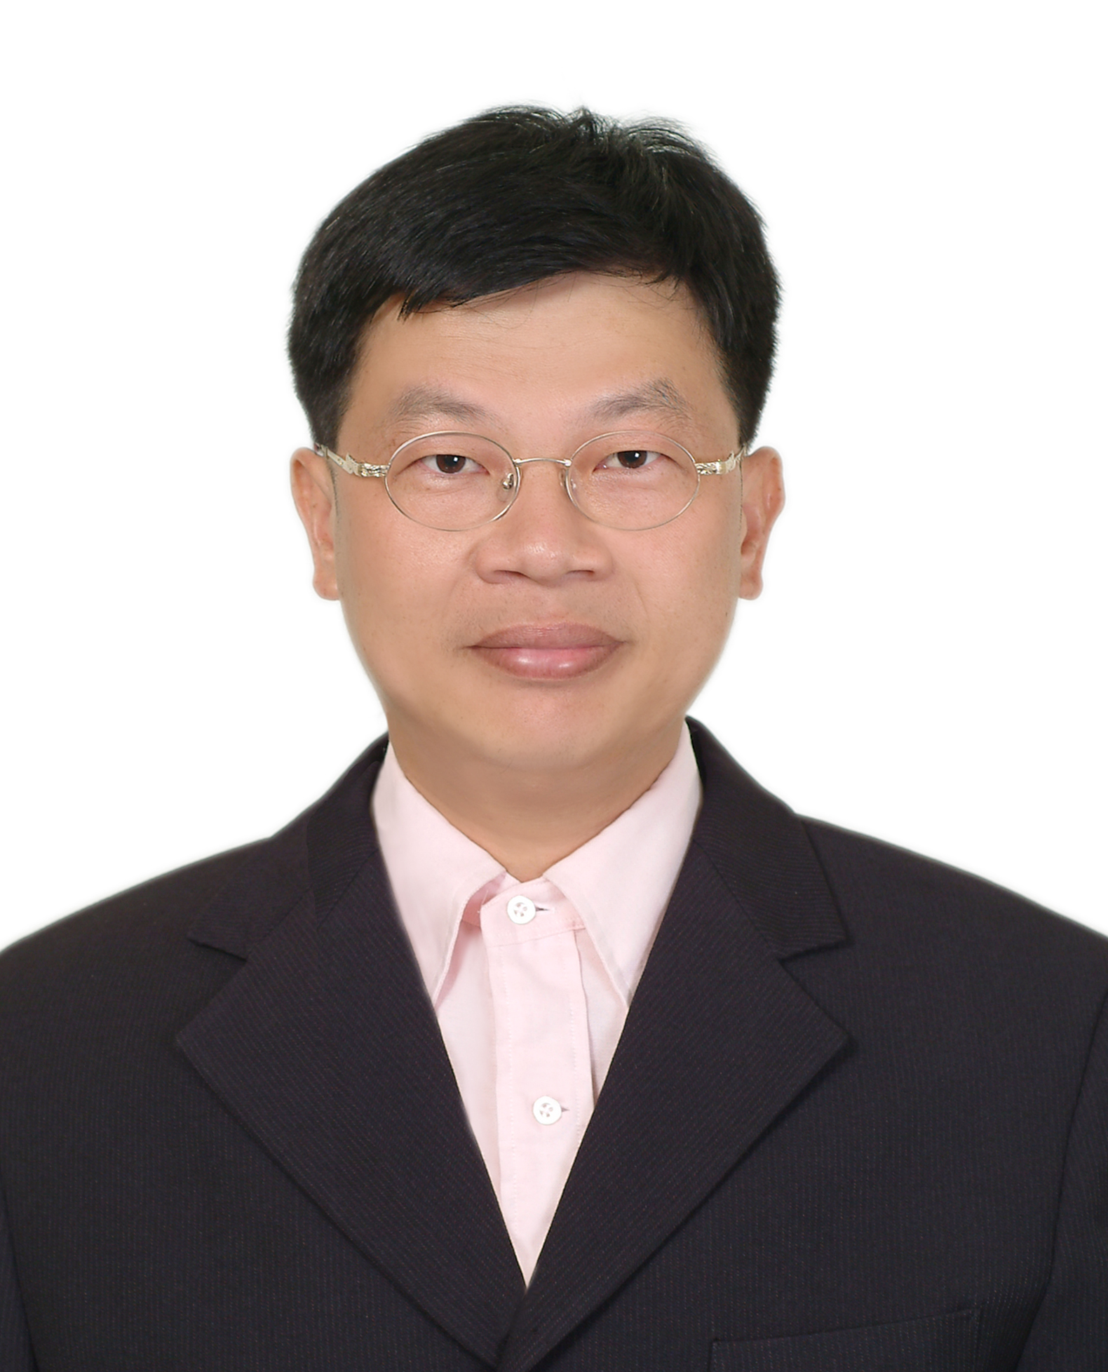  Jeng-Tzong Chen  (NTOU) |   Zhongyi Huang  (Beijing Tsinghua) | 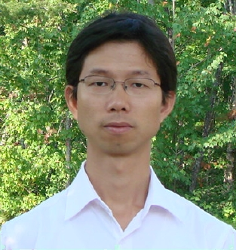  Wenjun Ying  (SJTU) |   Der-Liang Young  (NTU)

講題內容： | (1) Introduction to BIM.  (2) ABM for elliptic equations.  (3) ABM for heat equations.  (4) ABM for Schrodinger equations.  (5) Implicit ABM using BIM.  (6) High order discretization of BIM on 2D surfaces  and some related topics.
參考文獻：
(1) Houde Han and Xiaonan Wu, Artificial boundary method, Springer: Beijing, 2003.
(2) 韓厚德、巫孝南，人工邊界方法，清華大學出版社，北京，2009。
(3) 陳正宗、洪宏基，邊界元素法，新世界出版社，台北，1992。
(4) Web of NTOU/MSV: http://ind.ntou.edu.tw/~msvlab/



