Beprog 135 近乎奇異—分離核
(有分內外的好處)

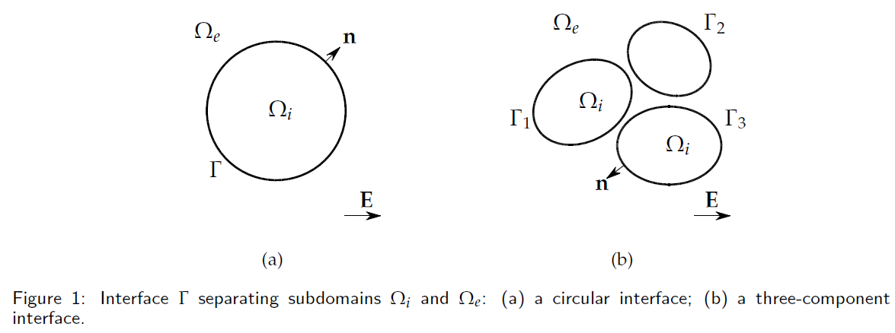

1顆 3顆 20顆
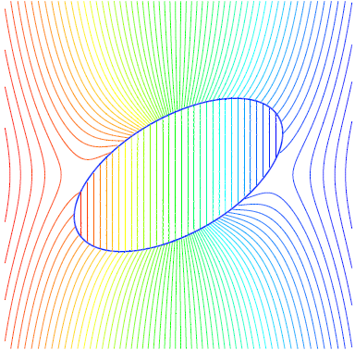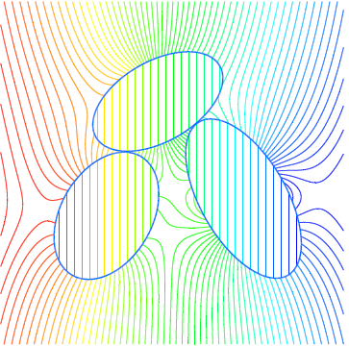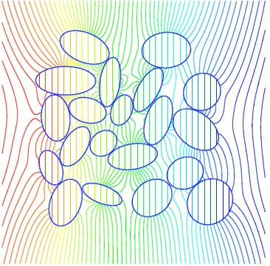

References
1、Wenjun Ying, J.Thomas Beale. A fast accurate boundary integral method for potentials on closely packed cells. Communications in Computational Physics 2013;14:1073-1093
2、Jeng-Tzong Chen, An-Chien Wu. Null-field approach for piezoelectricity problems with arbitrary circular inclusions. Engineering Analysis with Boundary Elements 2006;30:971–993.
3、Jeng-Tzong Chen, Wen-Cheng Shen, An-Chien Wu. Null-field integral equations for stress field around circular holes under antiplane shear. Engineering Analysis with Boundary Elements 2006;30:205–217.
4、Jeng-Tzong Chen, An-Chien Wu. Null-field approach for the multi-inclusion problem under antiplane shears. ASME Applied
Mechanics 2007;74:469.
5、Ying-Te Lee, Jeng-Tzong Chen. Null-field approach for the antiplane problem with elliptical holes and/or inclusions. Composites:
Part B 2013;44:283–294.
6、程式 (李應德教授提供)

