About the author: Prof. J T Chen

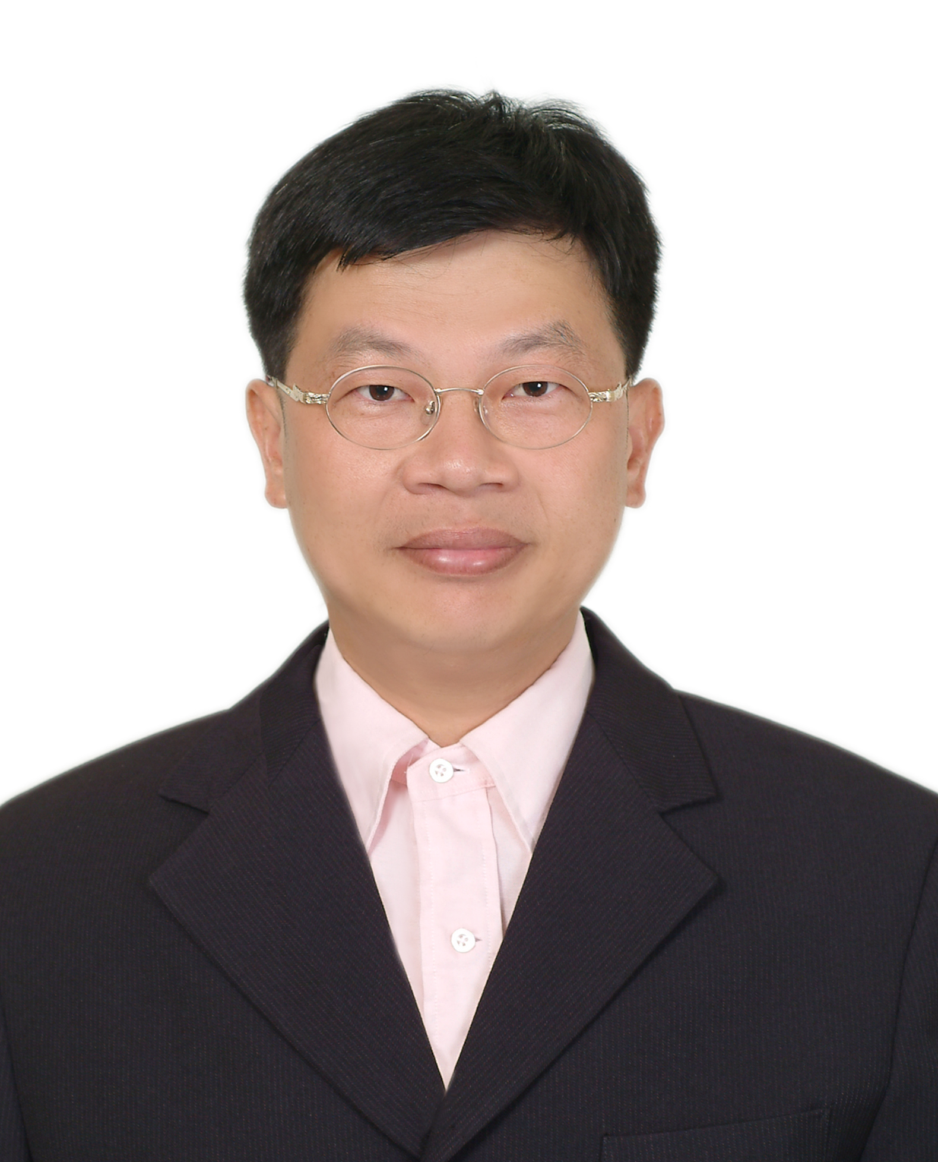
Jeng-Tzong Chen, born in 1962, received a BS degree in Civil Engineering, an M.S. in Applied Mechanics, and a Ph.D. in Civil Engineering, respectively, in 1984, 1986 and 1994, from National Taiwan University, Taipei, Taiwan, R.O.C. He had worked as a research assistant in the Structural Division of the Department of Rocket and Missile System, Chung Shan Institute of Science and Technology, from 1986 to 1990. In 1994, he was invited to be an Associate Professor in the Department of Harbor and River Engineering, National Taiwan Ocean University, Keelung, Taiwan, R.O.C. He was promoted to a full professor in 1998. Later in 2004, he was selected to be the Distinguished Professor. In 2007, he was selected as the Life-time Distinguished Professor. He is also the Professor of Department of Mechanical and Mechatronic Engineering of Taiwan Ocean University. In 2011, he won the MOE academic award and the ICACM Fellow Award. His major interest is computational mechanics. He had derived the theory of dual integral equations for boundary value problems with degenerate boundary. Prof. Chen also developed four dual BEM programs for the BVPs of Laplace equation, Helmholtz equation, bi-Helmholtz and modified Helmhotlz equation and Navier equation. Recently, he also employed the null field integral equations to solve BVPs with circular and/or elliptical boundaries including holes and inclusions. He wrote two books in Chinese on dual BEM and FEM using MSC/NASTRAN, respectively. He was ever invited to give plenary and keynote lectures, e.g., twice in World Congress on Computational Mechanics (WCCM4 (1998) in Buenos Aries and WCCM5 (2002) in Vienna), twice in ICOME 2006 and 2009, FEM/BEM 2003 in St. Petersburg, Russia and ICIP 2010 in Hong Kong. Also, he is now the editor of Engineering Analysis with Boundary Elements and the associate editor of Journal of Mechanics. He has been the editor of Journal of Marine Science and Technology and the guest editor of J. Chinese Institute of Engineers. He won three times of Outstanding Research Awards from National Science Council, Taiwan. He also won the first Wu, Ta-You Memorial Award in 2002. In 2011, he also won the HiWin Award. He is currently the member of editorial board of six international SCI journals. Until now, he has published more than 172 SCI papers on BEM and FEM in technical Journals. More than 1458 citings from 911 papers are found to cite Chen’s work.. Two papers (ASCE and ASME) were both cited more than 100 times form SCOPUS and WOS systems. Boundary element method is one focus of Professor Chen's research interests. Others may be categorized into two areas. One is vibration and acoustics, and the other is computational mechanics.

E-mail: jtchen@mail.ntou.edu.tw
URL: http://ind.ntou.edu.tw/~msvlab
Autobiography2012-Feb.doc

