Bispherical coordinates
3-D Bipolar coordinates
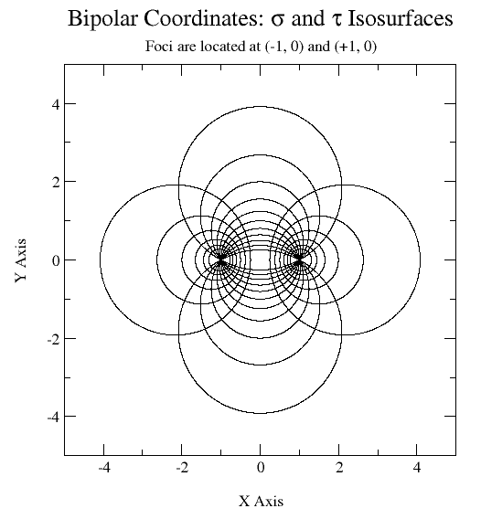

Laplace equation

Separate variables

Problem statement
h
h
O
a
a
z
x
y

Because of and are constant

Match boundary conditions

!!!!!!!!!!!!!!!!!!!!!!!!!!!!!!!!!!!!!!!!!!!!!!!!!!!!!!!!!!!!!!!!!!!!!!!!!!!!!!!!!!!!!!!!!!!!!!!!!!!!!!!!!!!!!!!!!!!!!!!!!!!!!!!!!!!!!!!!!!!!!!!!!!!!!
Series expansion

!!!!!!!!!!!!!!!!!!!!!!!!!!!!!!!!!!!!!!!!!!!!!!!!!!!!!!!!!!!!!!!!!!!!!!!!!!!!!!!!!!!!!!!!!!!!!!!!!!!!!!!!!!!!!!!!!!!!!!!!!!!!!!!!!!!!!!!!!!!!!!!!!!!!!

!!!!!!!!!!!!!!!!!!!!!!!!!!!!!!!!!!!!!!!!!!!!!!!!!!!!!!!!!!!!!!!!!!!!!!!!!!!!!!!!!!!!!!!!!!!!!!!!!!!!!!!!!!!!!!!!!!!!!!!!!!!!!!!!!!!!!!!!!!!!!!!!!!!!!!!!!!!!!

!!!!!!!!!!!!!!!!!!!!!!!!!!!!!!!!!!!!!!!!!!!!!!!!!!!!!!!!!!!!!!!!!!!!!!!!!!!!!!!!!!!!!!!!!!!!!!!!!!!!!!!!!!!!!!!!!!!!!!!!!!!!!!!!!!!!!!!!!!!!!!!!!!!!!!!!!!!!!

!

!!!!!!!!!!!!!!!!!!!!!!!!!!!!!!!!!!!!!!!!!!!!!!!!!!!!!!!!!!!!!!!!!!!!!!!!!!!!!!!!!!!!!!!!!!!!!!!!!!!!!!!!!!!!!!!!!!!!!!!!!!!!!!!!!!!!!!!!!!!!!!!!!!!!!
x
y
z
Degenerate kernel in bispherical coordinates??

in spherical coordinates

in bispherical coordinates

!!!!!!!!!!!!!!!!!!!!!!!!!!!!!!!!!!!!!!!!!!!!!!!!!!!!!!!!!!!!!!!!!!!!!!!!!!!!!!!!!!!!!!!!!!!!!!!!!!!!!!!!!!!!!!!!!!!!!!!!!!!!!!!!!!!!!!!!!!!!!!!!!!!!!

