Bispherical coordinates
3-D Bipolar coordinates
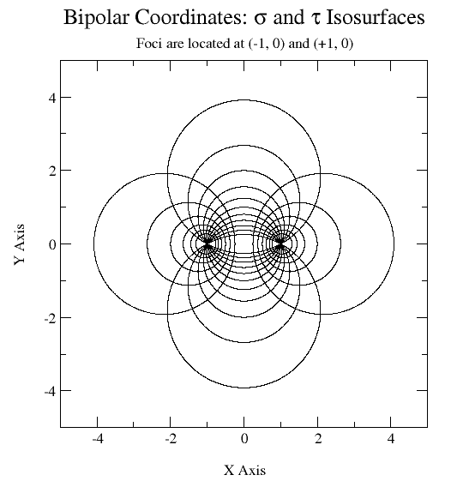

Problem statement
O
z
x
y

!!!!!!!!!!!!!!!!!!!!!!!!!!!!!!!!!!!!!!!!!!!!!!!!!!!!!!!!!!!!!!!!!!!!!!!!!!!!!!!!!!!!!!!!!!!!!!!!!!!!!!!!!!!!!!!!!!!!!!!!!!!!!!!!!!!!!!!!!!!!!!!!!!!!!!!!!!!!!

!!!!!!!!!!!!!!!!!!!!!!!!!!!!!!!!!!!!!!!!!!!!!!!!!!!!!!!!!!!!!!!!!!!!!!!!!!!!!!!!!!!!!!!!!!!!!!!!!!!!!!!!!!!!!!!!!!!!!!!!!!!!!!!!!!!!!!!!!!!!!!!!!!!!!!!!!!!!!

!!!!!!!!!!!!!!!!!!!!!!!!!!!!!!!!!!!!!!!!!!!!!!!!!!!!!!!!!!!!!!!!!!!!!!!!!!!!!!!!!!!!!!!!!!!!!!!!!!!!!!!!!!!!!!!!!!!!!!!!!!!!!!!!!!!!!!!!!!!!!!!!!!!!!!!!!!!!!

!!!!!!!!!!!!!!!!!!!!!!!!!!!!!!!!!!!!!!!!!!!!!!!!!!!!!!!!!!!!!!!!!!!!!!!!!!!!!!!!!!!!!!!!!!!!!!!!!!!!!!!!!!!!!!!!!!!!!!!!!!!!!!!!!!!!!!!!!!!!!!!!!!!!!!!!!!!!!
Image method (yz-plane) | Bispherical coordinates (yz-plane)
Image method | Bispherical coordinates
Image method | Bispherical coordinates
Image method | Bispherical coordinates

h
h
O
z
x
y
Bispherical coordinates | Cartesian coordinates

Bispherical coordinates | Cartesian coordinates

