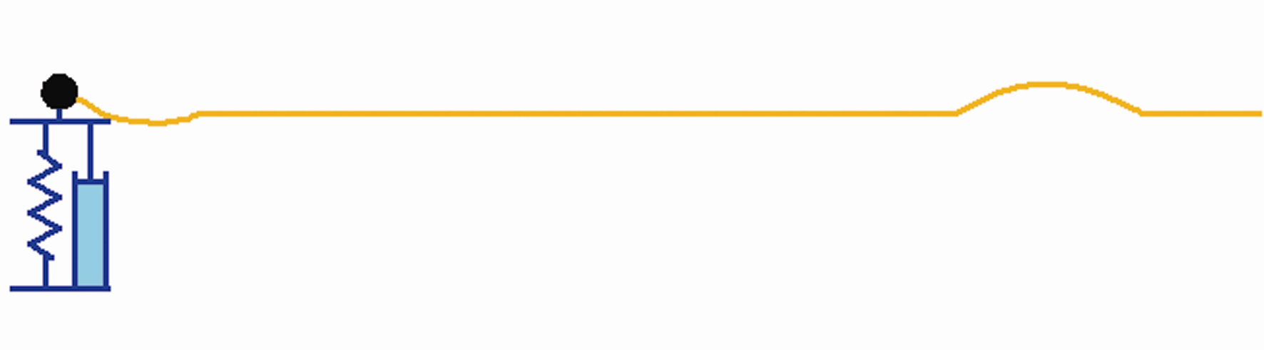

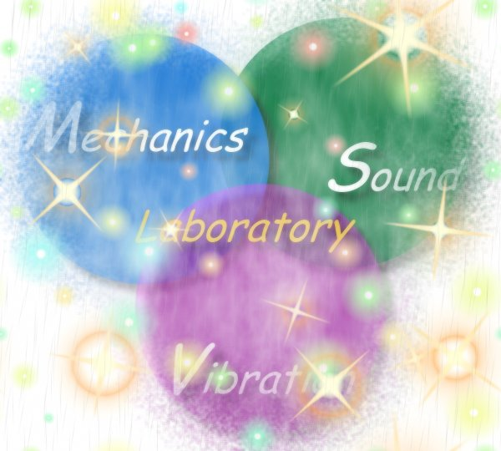
Wave animation by using Mathematica
( Accepted by Computer Applications in Engineering Education, 2007)
One-dimensional wave animation using Mathematica
Abstract
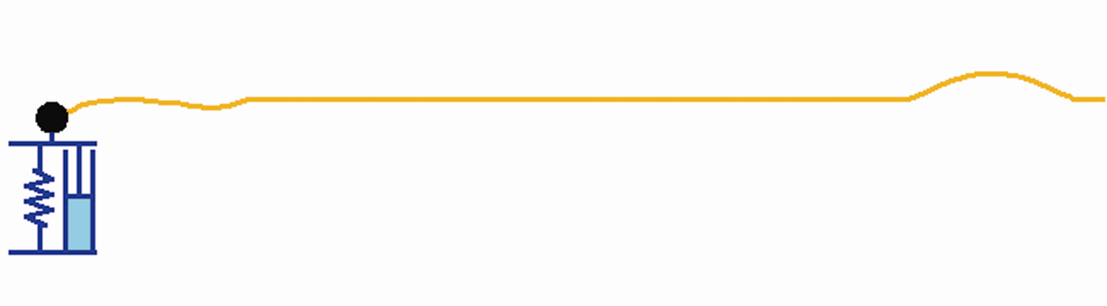
This paper presents how one-dimensional wave phenomenon is animated. Several methods including the D’Alembert solution, the diamond rule, the Laplace transform and the convolution integral, are employed in the Mathematica animation. All the analytical derivations were carried out by using the symbolic software. Several examples, including an infinite string with spring, mass and damper as well as a semi-infinite string, two-media string, string and beam subject to support motions, were demonstrated to show the validity of the present formulation. Parameter study of impedance ratio and mass, spring and dashpot was also examined to see the transmission and reflection coefficient.

Autobiography of authors
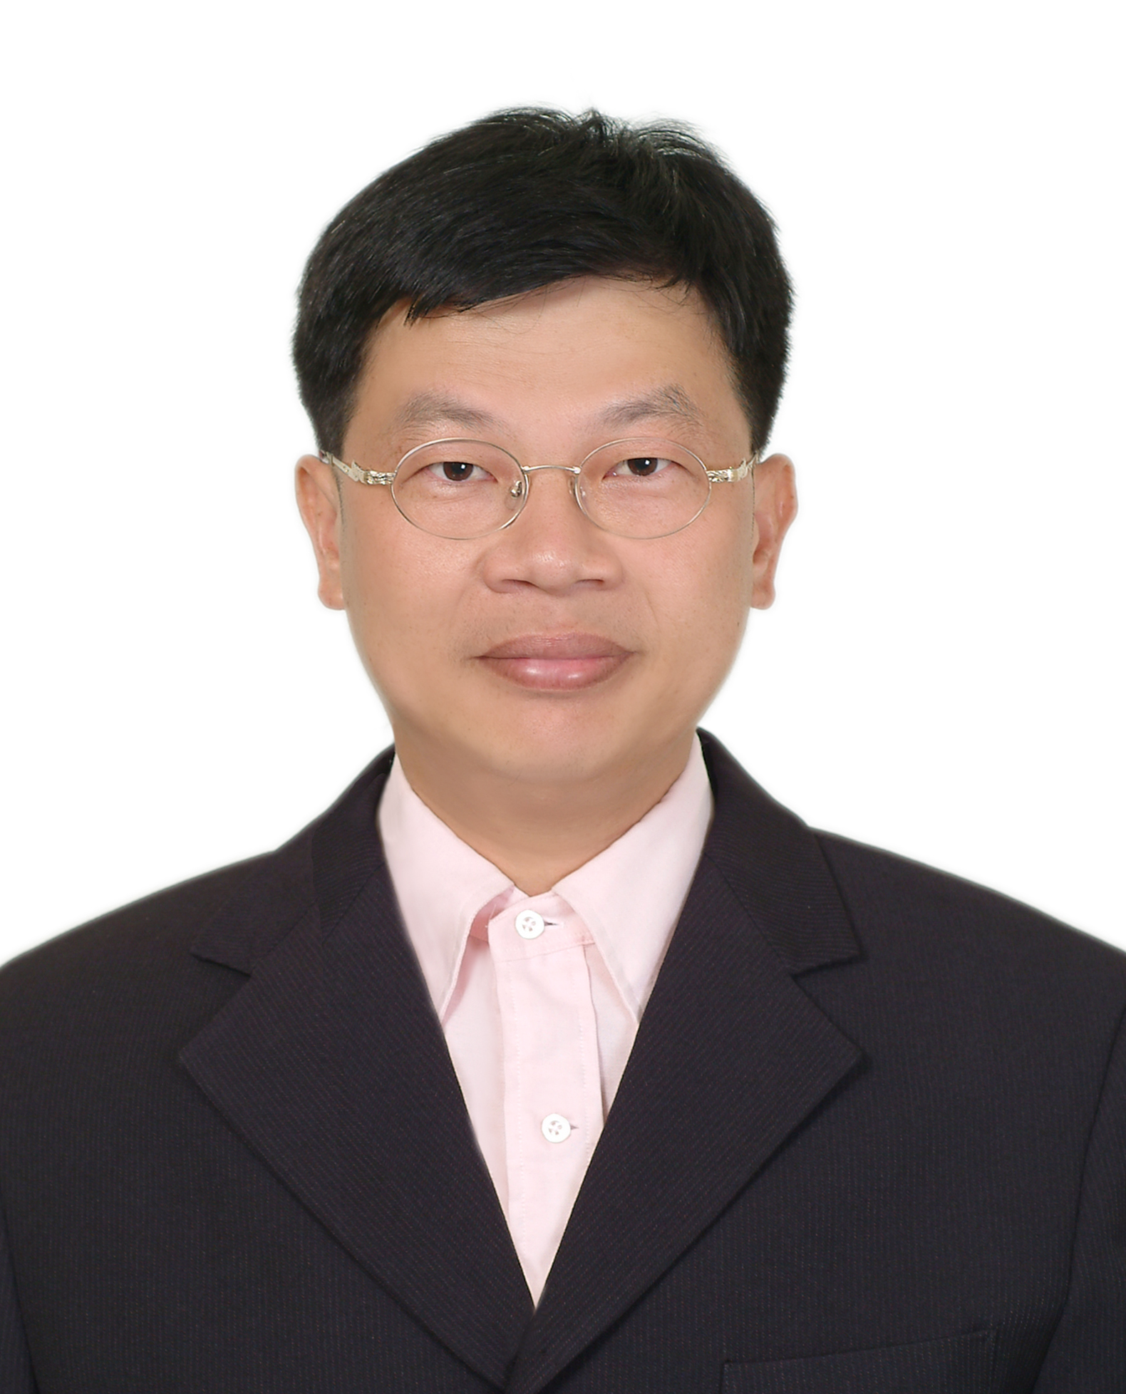
Jeng-Tzong Chen, born in 1962, received a BS degree in Civil Engineering, an M.S. in Applied Mechanics, and a Ph.D. in Civil Engineering, respectively, in 1984, 1986 and 1994, from National Taiwan University, Taipei, Taiwan, R.O.C. He had worked as a research assistant in the Structural Division of the Department of Rocket and Missile System, Chung Shan Institute of Science and Technology, from 1986 to 1990. In 1994, he was invited to be an Associate Professor in the Department of Harbor and River Engineering, National Taiwan Ocean University, Keelung, Taiwan, R.O.C. He was promoted to full professor in 1998. Later in 2004, he was selected to be the Distinguished Professor. Furthermore, he was selected as the Life-time Distinguished Professor in 2007. His major interest is computational mechanics. He had derived the theory of dual integral equations for boundary value problems with degenerate boundary. Prof. Chen also developed four dual BEM programs for the BVPs of Laplace equation, Helmholtz equation, bi-Helmholtz and modified Helmhotlz equation and Navier equation. Recently, he also employed the null field integral equations to solve BVPs with circular boundaries. He wrote two books in Chinese on dual BEM and FEM using MSC/NASTRAN, respectively. He was ever invited to give plenaray and keynote lectures, e.g., twice in World Congress on Computational Mechanics (WCCM4 in Buenos Aries and WCCM5 in Vienna) and FEM/BEM 2003 in St. Petersburg, Russia. Also, he is the editor of Journal of the Chinese Institute of Civil and Hydraulic Engineering. He has been the Editor of Journal of Marine Science and Technology and the guest editor of J. Chinese Institute of Engineers. He won several times of Outstanding Research Awards from National Science Council, Taiwan. He also won the Wu, Ta-You Memorial Award in 2002. He is currently the member of editorial board of five international journals. Until now, he has published more than 112 SCI papers on BEM and FEM in technical Journals. Near 477 citings can be found. Boundary element method is one focus of Professor Chen's research interests. Others may be categorized into three areas. One is vibration and acoustics, another is computational mechanics and the other is engineering and mathematical education.
E-mail: jtchen@mail.ntou.edu.tw , URL: http://ind.ntou.edu.tw/~msvlab


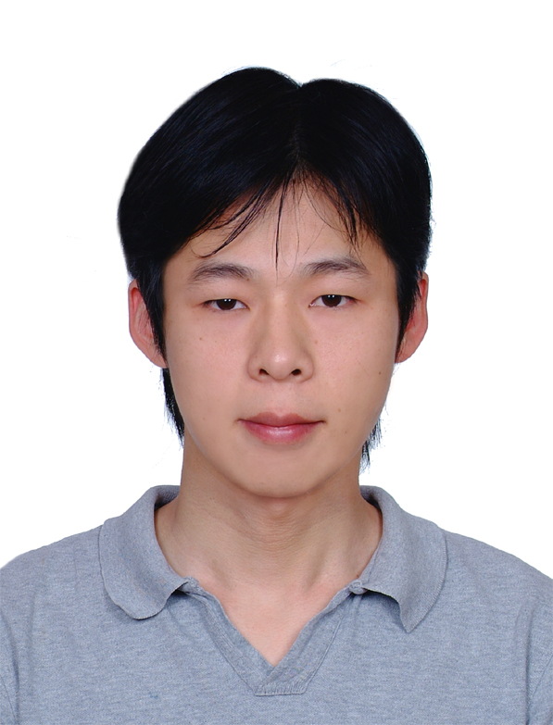
Ke-Shun Chou was born in Taiwan on Jan. 12, 1983. He is currently a master student and a member of the Mechanics, Sound and Vibration Laboratory at the Department of Harbor and River Engineering at National Taiwan Ocean University. His research focuses on the application of the null-field BIEM.
E-mail: m95520083@mail.ntou.edu.tw

Shing-Kai Kao, born in 1978, is currently a master student and a member of the Mechanics, Sound and Vibration Laboratory at the Department of Harbor and River Engineering at National Taiwan Ocean University. His interest is on the applications of Hilbert transform and K-K transform to engineering problems.
E-mail: m96520009@mail.ntou.edu.tw


http://ind.ntou.edu.tw/~msvlab
Welcome to visit our web site.

SFI-2007.doc/S.K. Kao edited/Nov. 26,2007

