Beprog 136 含板樁異向滲流對偶邊界元研究

等向 異向

等向 異向
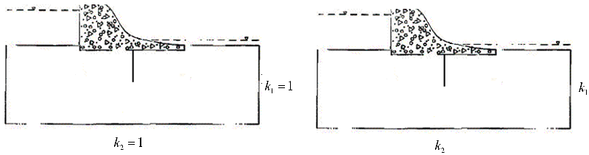
() ()

Reference
J.-T. Chen, H.-K. Hong and S.-W. Chyuan. Boundary element analysis and design in seepage problems using dual integral formulation. Finite Elements in Analysis and Design 1994;17:1-20.
J.-T. Chen, C.-C. Hsiao, Y.-P. Chiu and Y.-T. Lee. Study of free-surface seepage problems using
hypersingular equations. Commun. Numer. Meth. Engng. 2007;23:755–769

Beprog 136.doc 20130827 嘉焜製表

