Beprog 138 間接法 CHIEF版
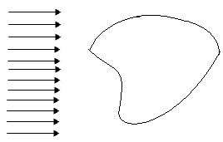
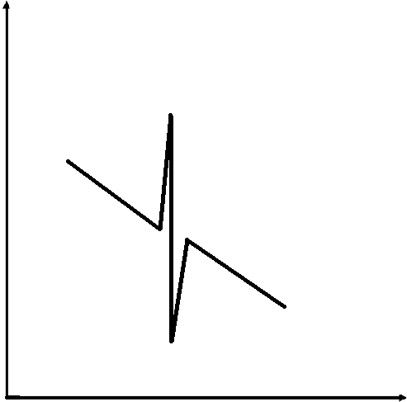
u

k_{f} k
Direct method + null–field BIE => CHIEF
Indirect method + ? => ?
Motivated by Fichera's approach

(X)
Nonuniqueness，degenerate scale
(○)
subject to
Laplace Helmholtz
(degenerate scale) (fictitious frequency)
γ => ?
=> ?
20131003 Beprog 138 嘉焜製表

