Beprog 124 任意圓弧形凸起地形中隧洞對入射平面SH波的影響
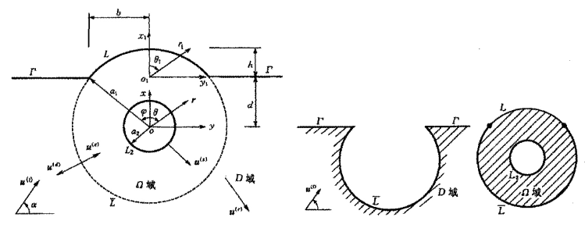

G. E.
B. C.
References:
- 袁曉銘, 廖振鵬, 1996, 任意圓弧形凸起地形中隧洞對入射平面SH波的影響, 地震工程與工程振動, 16(2), pp. 1~13.
- Abramowitz M., Stegun I. A., 1972, Handbook of Mathematical Functions, with Formulas, Graphs, and Mathematical Tables. New York, Dover Publication, pp. 355~389.
- Lee V. W., Trifuanc M. D. 1979, Response of tunnels to incident SH-wave, Jour. Engin. Mech., ASCE, 105(4), pp. 643~659.
- Pao Y. H., Mow C. C., 1973, Diffraction of Elastic Waves and Dynamics Stress Concentrations, New York, Crane, Russak & Company Inc., pp. 131~140.

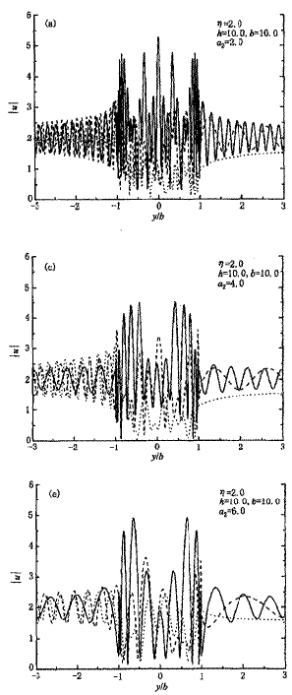 | 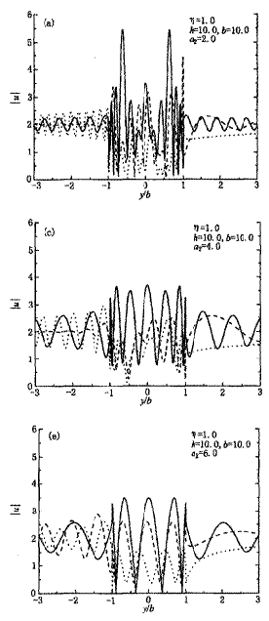 | 