Beprog 128 我們可以聽出鼓的形狀嗎?

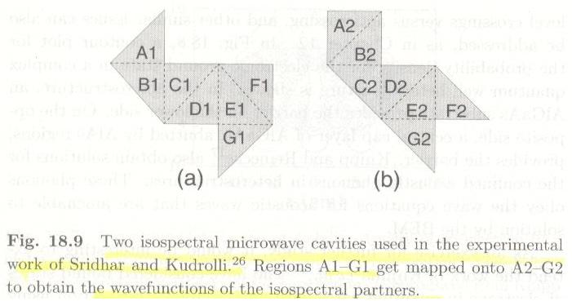

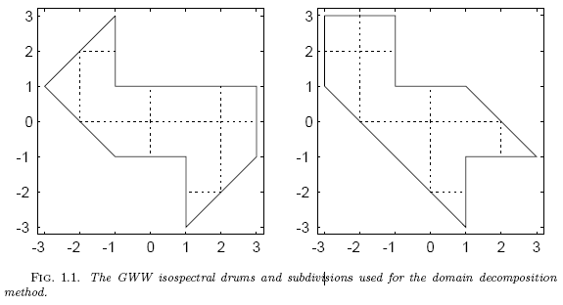

Governing equation:
Boundary condition:

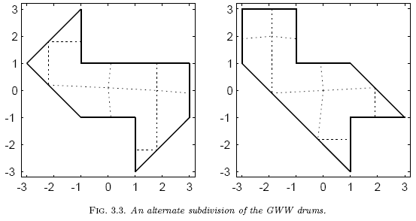

References:
- L. Ramdas Ram-Mohan, Finite Element and Boundary Element Applications in Quantum Mechanics, Oxford, 2002.
- S. Sridhar and A. Kudrolli, Experiments on Not“Hearing the Shape”of Drums, 1994, Phys. Rev. Lett. 72, 2175.
- T. A. Driscoll, “Eigenmodes of isospectral drums,”1997, SIAM Rev. 39, pp.1-17.
- The author wishes to thank Professor P. Knipp for generously providing him with Fig. 18.10, which is a beautiful illustration of the remarkable power of the BEM.
- G. Chen, J. Zhou, Boundary Element Methods, Academic Press, 1992.
- G. Chen and J. Zhou, Vibration and Damping in Distributed Systems Volume II: WKB and Wave Methods, Visualization and Experimentation, CRC, 1993.
- P. Greiner，我們可以聽出鼓的形狀嗎? 數學傳播民國95年 ，30卷4期，pp.34-47。

