Beprog 143 An infinite domain with two circular holes (同焦，偏心)
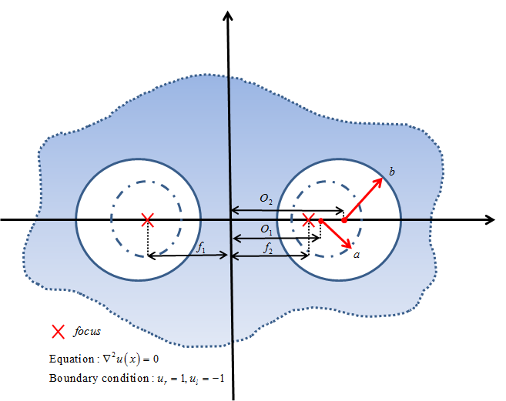
無限域挖兩個洞的外域問題，其中，，，，，，，幾何對稱。
使用基本解法求之。將源點布置於偏心小圓上，並分別考量三種情況的場解(正解)表示式如
(1)對稱：
(2)反對稱： B.C
(3)反對稱+常數場： B.C
算出源點強度後再算出，數值結果以等高線圖呈現。
References
1. Jeng-Tzong Chen, Hung-Chih Shieh, Jhen-Jyun Tsai, Jia-Wei Lee, A study on the method of fundamental solutions using an image concept, Applied Mathematical Modelling, 2010, 34, 4253–4266.
2. Jeng-TzongChen, Jheng-LinYang, Ying-TeLee, Yu-LungChang, Formulation of the MFS for the two-dimensional Laplace equation with an added constant and constraint, Engineering Analysis with Boundary Elements, 2014, 46, 96-107.
3. Jeng-Tzong Chen, Shing-Kai Kao and Jia-Wei Lee, Analytical derivation and numerical experiment of degenerate scale by using the degenerate kernel of the bipolar coordinates.

