1. Extend the point source to screw dislocation using degenerate kernel. (大學部)

u=0
$$(ρ,0)$$
$$(\frac{a^{2}}{ρ},0)$$
a

$$\frac{a^{2}}{ρ}$$

Degenerate kernel:
$$U(s,x)=\left\{\begin{matrix}U^{I}(R,θ;ρ,φ)=θ+π+\sum_{m=1}^{∞}{\frac{1}{m}(\frac{ρ}{R})^{m}\text{sin}m(θ−φ), R≥ρ,} \\ U^{E}(R,θ;ρ,φ)=φ−\sum_{m=1}^{∞}{\frac{1}{m}(\frac{R}{ρ})^{m}\text{sin}m(θ−φ), R<ρ,}\end{matrix}\right.$$

2. Extend the point source to screw dislocation using degenerate kernel. (研究所)
u=0
a
u=0
⊙
b

Degenerate kernel:
$$U(s,x)=\left\{\begin{matrix}U^{I}(R,θ;ρ,φ)=\text{ln}R−\sum_{m=1}^{∞}{\frac{1}{m}(\frac{ρ}{R})^{m}\text{cos}m(θ−φ), R≥ρ,} \\ U^{E}(R,θ;ρ,φ)=\text{ln}ρ−\sum_{m=1}^{∞}{\frac{1}{m}(\frac{R}{ρ})^{m}\text{cos}m(θ−φ), R<ρ,}\end{matrix}\right.$$

1. Extend the point source to screw dislocation using degenerate kernel. (

已知，代入邊界條件
消掉級數項可得
為了符合，可得：

IMPLICIT NONE
INTEGER M,I
PARAMETER (M=50)
REAL*8 R,RHO,SUM,PI,PHI,THETA,a
101 FORMAT (100F16.8)
OPEN(15,FILE='OUT.TXT')
OPEN(16,FILE='IN.TXT')
OPEN(17,FILE='ALL.TXT')
PI=Atan(1.0)*4.0
R=2
THETA=Atan(0.0/1.0)
a=1
DO PHI=0.,2*PI,0.01
DO RHO=1,10,0.1
IF (R.LT.RHO) THEN
SUM=PHI-PI
DO I=1,M
SUM=SUM-1./I*((R/RHO)**I+((a**2)/(RHO*R))**I)*SIN(I*(THETA
&-PHI))
ENDDO
WRITE(15,101) RHO*COS(PHI),RHO*SIN(PHI),SUM/(2*PI)
ELSE
SUM=THETA
DO I=1,M
SUM=SUM+1./I*((RHO/R)**I-((a**2)/(RHO*R))**I)*SIN(I*(THETA
&-PHI))
ENDDO
WRITE(16,101) RHO*COS(PHI),RHO*SIN(PHI),SUM/(2*PI)
ENDIF
WRITE(17,101) RHO*COS(PHI),RHO*SIN(PHI),SUM/(2*PI)
ENDDO
ENDDO
STOP
END

2. Extend the point source to screw dislocation using degenerate kernel.

外域
內域

可推導出
，
為了讓其位移為0,可知其項為常數與的線性組合有關，故可令補解為
將其解做級數展開並代入邊界條件
當最後為時
當最後為時

將學長的解拿出來比較(假設)
，
先比較級數解
學長的級數解，利用mathematica展開如下

比較常數項
學長的解
最後為
最後為
兩者相同!!

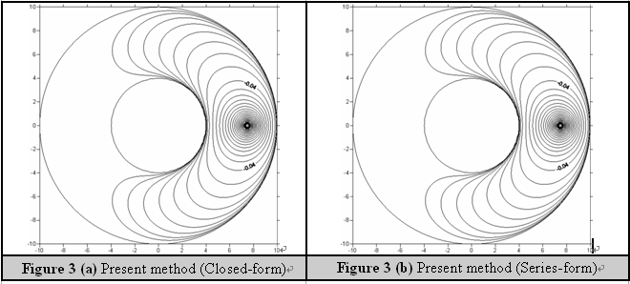

IMPLICIT NONE
INTEGER M,I
PARAMETER (M=50)
REAL*8 R,RHO,SUM,PI,PHI,a,b,D1,D2,D3,D4
REAL*8 R1,R2,R3,R4,C1,C2,X,Y,U,XX
101 FORMAT (100F16.8)
OPEN(17,FILE='ALL.TXT')
PI=Atan(1.0)*4.0
R=7.5
a=4.
b=10.
XX=2*M*LOG(R/a)
C1=-LOG(b)*(LOG(R)-LOG(a))/(LOG(b)-LOG(a))-XX
C2=(LOG(R)-LOG(b))/(LOG(b)-LOG(a))
DO RHO=4.,12.,0.03
DO PHI=0.,2*PI,0.01
SUM=LOG(SQRT((RHO**2)+(R**2)-2*RHO*R*Cos(PHI)))+C1+C2*LOG(RHO)
DO I=1,M
R1=(b**2/R*((b/a)**(2*(I-1))))
R2=(a**2/R*((a/b)**(2*(I-1))))
R3=(b**2*R/a**2*((b/a)**(2*(I-1))))
R4=(a**2*R/b**2*((a/b)**(2*(I-1))))
D1=(RHO**2)+(R1**2)-2*RHO*R1*Cos(PHI)
D2=(RHO**2)+(R2**2)-2*RHO*R2*Cos(PHI)
D3=(RHO**2)+(R3**2)-2*RHO*R3*Cos(PHI)
D4=(RHO**2)+(R4**2)-2*RHO*R4*Cos(PHI)
SUM=SUM-(LOG(SQRT(D1))+LOG(SQRT(D2))-LOG(SQRT(D3))-
& LOG(SQRT(D4)))
ENDDO
U=SUM/(2*PI)
X=RHO*DCOS(PHI)
Y=RHO*DSIN(PHI)
WRITE(17,*) X,Y,U
ENDDO
ENDDO
STOP
END

