班級：_____________學號：______________姓名：______________
國立台灣海洋大學河海工程研究所BEM第3次作業(2008)/NTOU-MSV
Lame’s solution:
ODE:
$\frac{d^{2}u(r)}{{\text{dr}}^{2}}+\frac{1}{r}\frac{\text{du}(r)}{\text{dr}}−\frac{1}{r^{2}}u(r)=0 , a<r<b$
(1) IVP(大學部)初值問題
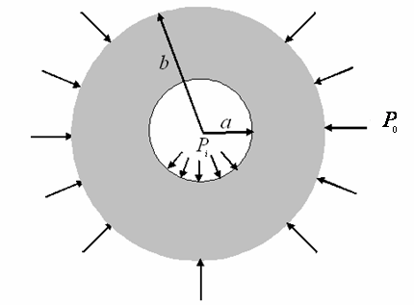
$\begin{aligned}u(a)=u_{0} \\ \overset{˙}{u}(a)=θ_{0}\end{aligned}$
(2) BVP(研究所)邊值問題
$\begin{aligned}u^{'}(a)+ν\frac{u(a)}{a}=\frac{−(1−ν^{2})}{E}p_{i} \\ u^{'}(b)+ν\frac{u(b)}{a}=\frac{−(1−ν^{2})}{E}p_{0}\end{aligned}$

Transform ODE to IE
- Voltera 2nd kind IE(大學部)
$$u(x)=\int{K_{v}(x,ξ)}u(ξ)dξ+F(x)$$
- Fredholm 2nd kind IE(研究所)
$$u(x)+\int{K_{F}(x,ξ)}u(ξ)dξ=f(x)$$

References:
- 陳正宗與洪宏基合著, 邊界元素法, 第二版, 新世界, 台北, 1992.
- Francis B. Hildebrand, Methods of applied mathematics, Dover, New York, 1992.
- Autar Kaw and Son Ho, On Introducing Approximate Solution Methods in Theory of Elasticity, Computer Applications in Engineering Education, Vol.14, No.2, pp.120-134, 2006.
【 BEM第3次作業，日期：Feb.22, 2008 bem03-2008.doc 】陳正宗終身特聘教授 羿州 製

