班級： 河海工程系 學號： M97520023 姓名： 吳建鋒
國立台灣海洋大學河海工程研究所BEM 2009 第4次作業

大學部:
- Please derive the Green’s function,
subject to U(0,s)=0, Ux(1,s)=0 .

(1). Is U(x,s) singular when x=s ?
(2). Is U(x,s) symmetric ?
(3). Is U(x,s) degenerate form ?
(4). 3D Plot U(x,s) and contour plot.

研究所:
- In the course, we have derived the fundamental solution of
by using Fourier transform, inverse Fourier transform and residue theorem.
Please extend the second order ODE to fourth order ODE.

(1). Is U(x,s) singular when x=s ?
(2). Is U(x,s) symmetric ?
(3). Is U(x,s) degenerate form ?
(4). 3D Plot U(x,s) and contour plot.

Ref:
- 鍾壽國, 推廣的留數定理及其應用, 武漢大學出版社, 武漢, 1993.(路見可審校)
2. 陳鈺文, 複變數對偶邊界元素法研究, 海大河工所碩士論文, 1988.
【 BEM第4次作業，日期：2009/10/15，bem04-2009_CFWu.doc 】
Sol：
Satisfied two boundary conditions （1）U(0,s)=0, （2）Ux(1,s)=0
s⁻ s⁺
a+bx
c+dx
Satisfied two conditions

- U(x, s) is regular
- U(x, s) is symmetric
- U(x, s) is degenerate form
Fortran | Mathematica
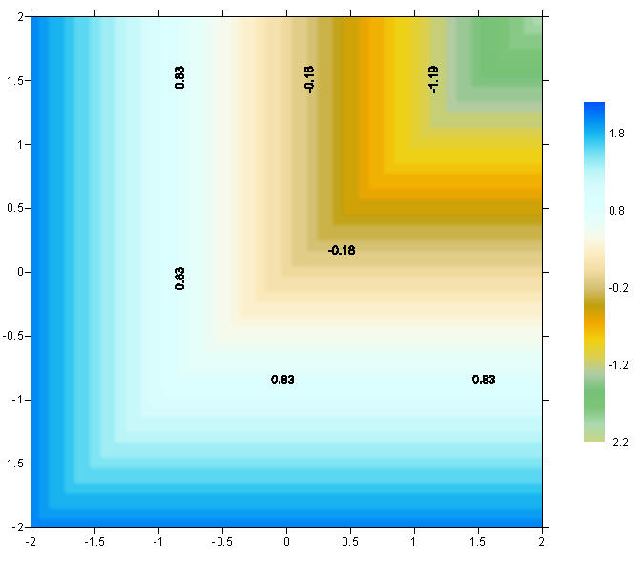 | 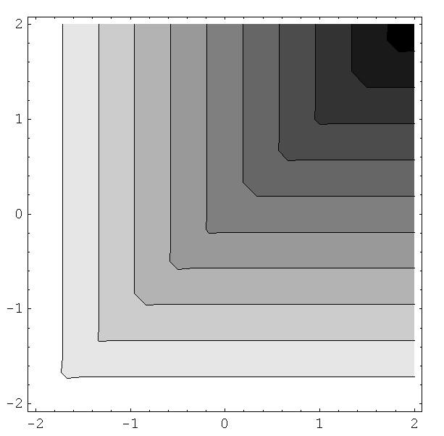
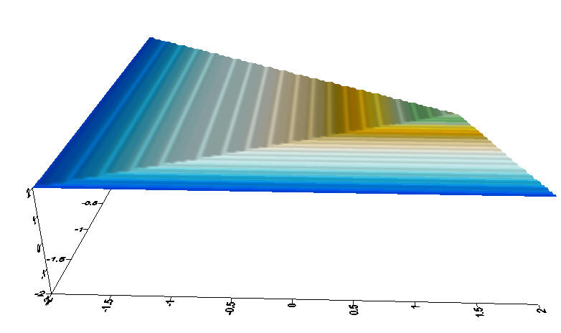 | 