班級：_____________學號：______________姓名：______________
國立海洋大學河海工程研究所BEM第4次作業 (2011)/NTOU-MSV

- Direct BEM

In the course, we have derived the constraint among u(0), u(1), t(0) and t(1) by using the integral equation for the domain point approaching boundary ($s=0^{+}$ and $1^{−}$) for UT and LM formulations.
Dirichelet BC in the course u(0)=0, u(1)=1

Please solve BVP of mixed BC in this homework of u(0)=0, t(1)=1.

- Method of fundamental solutions (MFS)

請利用 MFS法 (研究生取左邊兩點計算，大學部取右邊兩點計算。)
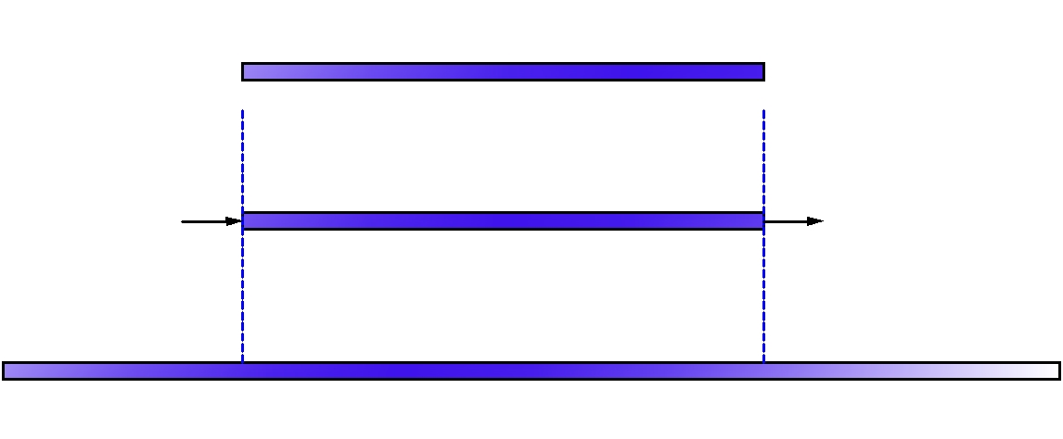
碩士生
大學部

唯有努力補破網 方能釣大小魚 您說是嗎 ?
【 BEM第3次作業，日期：Mar. 09, 2011，檔名bem04-2011.doc 】陳正宗終身特聘教授

