班級：_____________學號：______________姓名：______________
國立台灣海洋大學河海工程研究所BEM第4.5次作業(2008)/NTOU-MSV

In the course, we separated the closed-form fundamental solution into separable form for the fundamental solution of Laplace problem as shown below:

Closed-form:
Degenerate form (separable form):
where $x=(ρ,φ)$ and $s=(R,θ)$.
Based on the degenerate kernel, please plot the boundary densities of and along the circular boundary.
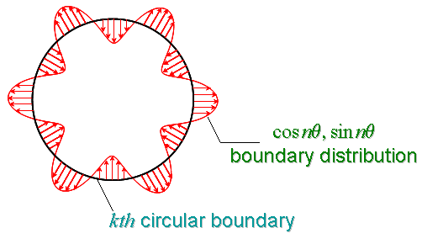

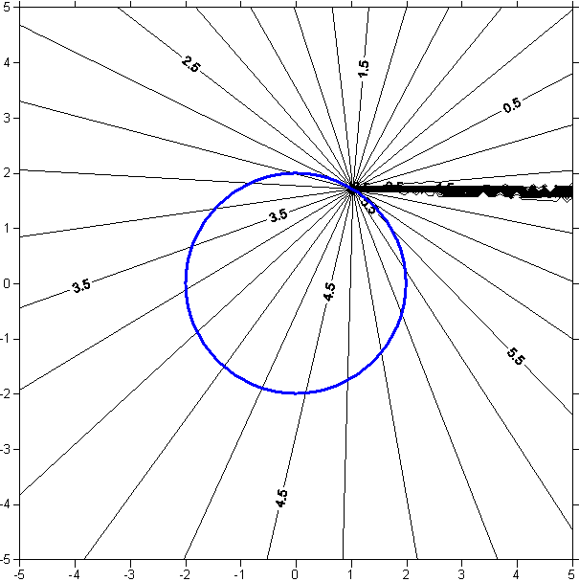

大學部
- Using the degenerate kernel of to plot the boundary densities and along the circular boundary .
研究所
- Using the degenerate kernel of to plot the boundary densities and along the circular boundary .

【 BEM第4.5次作業，日期：April.21, 2008，檔名bem04.5-2008.doc 】陳正宗終身特聘教授
~ K. H. Chou 製表

