班級：_____________學號：______________姓名：______________
國立台灣海洋大學河海工程研究所BEM第四.七次作業(2008)
Given an annular region subject to a concentrated source as shown in Fig. 1, the radii of inner and outer boundaries are a and b. ($a=4$, $b=\text{10}$, $R=7\text{.}5$)
⊕
a
b
(R,0)
$$u=0$$
$$u=0$$

Fig. 1 Sketch of the problem

1. There is a concentrated source in an infinite plane as shown below:
⊕

Fig. 2 Sketch of an infinite plane with a concentrated source
Please plot the potential distribution (u^{s}) on the radii a and b versus θ using addition theorem or close-form (lnr) as shown in Fig. 3.
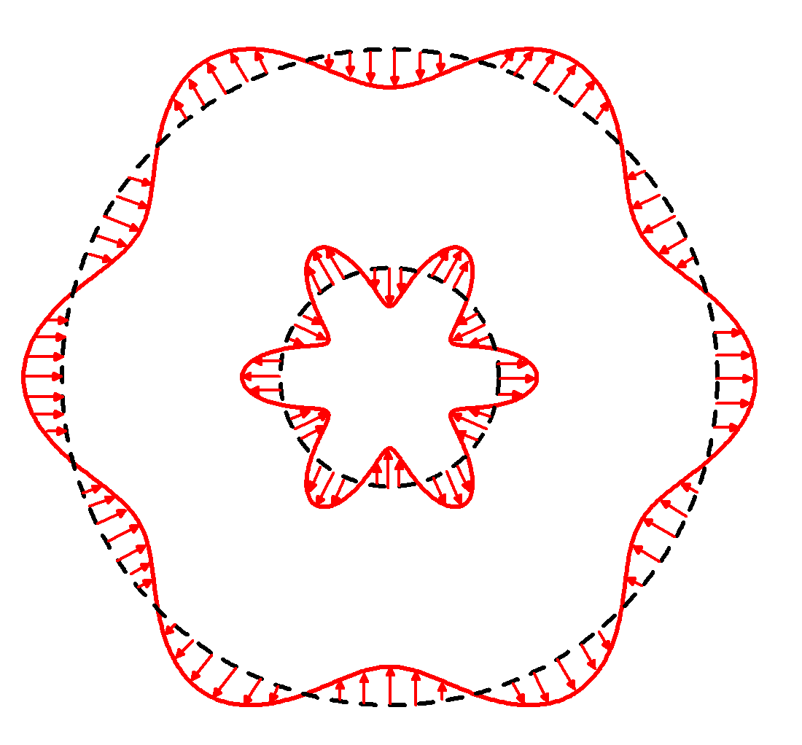
Fig 3. Boundary distribution of $u(θ)$
2. Plot the potential distribution (u^{h}=-u^{s}) on the radii a and b versus θ.

3. MFS-1
Please use the method of fundamental solutions to solve Prob. 2.
$$u(x)=\sum_{j=1}^{N}{c_{j}U(s,x)}$$
where N is number of the source points for inner and outer fictitious boundaries, respectively. (Given N=2M+1, M is an arbitrary number decided by yourself)

(a) Please plot the potential at $(6,π/3)$ versus the number of M. ($a^{'}=0\text{.}8a$, $b^{'}=1\text{.}2b$)
(b) Please plot the potential at $(6,π/3)$ versus $a^{'}$ and $b^{'}$, respectively.
(M is decided by forward exercise)

4. MFS-2
The image points are given
$ζ_{1}=\frac{b^{2}}{R}$, $ζ_{2}=\frac{a^{2}}{b^{2}}R$, …, $ζ_{2n−1}=(\frac{b^{2}}{a^{2}})^{n−1}\frac{b^{2}}{R}$, $ζ_{2n}=(\frac{a^{2}}{b^{2}})^{n}R$
$ζ_{1}^{'}=\frac{a^{2}}{R}$, $ζ_{2}^{'}=\frac{b^{2}}{a^{2}}R$, …, $ζ_{2n−1}^{'}=(\frac{a^{2}}{b^{2}})^{n−1}\frac{a^{2}}{R}$, $ζ_{2n}^{'}=(\frac{b^{2}}{a^{2}})^{n}R$

$$ζ_{2n−1}$$
$$ζ_{2n}$$
$$ζ_{2n−1}^{'}$$
$$ζ_{2n}^{'}$$

$$u(x)=c_{1}+c_{2}\text{ln}ρ+\sum_{n=1}^{M}{p_{n}\text{ln}\left|x−ζ_{2n−1}\right|+q_{n}\text{ln}\left|x−ζ_{2n}\right|+p_{n}^{'}\text{ln}\left|x−ζ_{2n−1}^{'}\right|+q_{n}^{'}\text{ln}\left|x−ζ_{2n}^{'}\right|}$$
Please determine the coefficients, $c_{1}$, $c_{2}$, $p_{n}$, $q_{n}$, $p_{n}^{'}$, $q_{n}^{'}$ by matching boundary conditions (Given in Prob. 2). Then, plot the potential at $(6,π/3)$ versus the number of M.

5. Trefftz method (numerical solution)
The Trefftz method represents the solution as
$$u(x)=\sum_{j=1}^{N_{T}}{c_{j}φ_{j}}$$
where $φ_{j}$ is the T-complete function and N_{T} is the number of T-complete function. Here the T-complete functions are given as 1, $ρ^{m}\text{cos}mφ$, $ρ^{m}\text{sin}mφ$ for interior case and are given as $\text{ln}ρ$, $ρ^{−m}\text{cos}mφ$, $ρ^{−m}\text{sin}mφ$ for exterior case. Please determine the coefficients, $c_{j}$, by matching boundary conditions (Given in . Prob. 2 and $m=M$). Plot the potential at $(6,π/3)$ versus the number of M.

6. Trefftz solution (analytical solution)
$$\begin{aligned}G(x,ζ)=−(b\text{ln}{\text{bp}}_{0}+a\text{ln}ρ {\bar{p}}_{0}) \\ +\sum_{m=1}^{∞}{\frac{1}{2m}\left[\left(b{\left(\frac{ρ}{b}\right)}^{m}p_{m}+a{\left(\frac{a}{ρ}\right)}^{m}{\bar{p}}_{m}\right)\right]\text{cos}mφ}+\left[\left(b{\left(\frac{ρ}{b}\right)}^{m}q_{m}+a{\left(\frac{a}{ρ}\right)}^{m}{\bar{q}}_{m}\right)\right]\text{sin}mφ\end{aligned}$$
where
$\left\{\begin{matrix}p_{0} \\ {\bar{p}}_{0}\end{matrix}\right\}=\left\{\begin{matrix}\frac{\text{ln}a−\text{ln}R}{2πb(\text{ln}a−\text{ln}b)} \\ \frac{\text{ln}b−\text{ln}R}{2πa(\text{ln}b−\text{ln}a)}\end{matrix}\right\}$,
$\left\{\begin{matrix}p_{m} \\ {\bar{p}}_{m}\end{matrix}\right\}=\left\{\begin{matrix}\frac{b^{m−1}\text{cos}mθ\left[b^{m}{\left(\frac{R}{b}\right)}^{m}−a^{m}{\left(\frac{a}{R}\right)}^{m}\right]}{(b^{2m}−a^{2m})π} \\ \frac{b^{m}\text{cos}mθ\left[b^{m}{\left(\frac{a}{R}\right)}^{m}−a^{m}{\left(\frac{R}{b}\right)}^{m}\right]}{a(b^{2m}−a^{2m})π}\end{matrix}\right\}$$\left\{\begin{matrix}q_{m} \\ {\bar{q}}_{m}\end{matrix}\right\}=\left\{\begin{matrix}\frac{b^{m−1}\text{sin}mθ\left[b^{m}{\left(\frac{R}{b}\right)}^{m}−a^{m}{\left(\frac{a}{R}\right)}^{m}\right]}{(b^{2m}−a^{2m})π} \\ \frac{b^{m}\text{sin}mθ\left[b^{m}{\left(\frac{a}{R}\right)}^{m}−a^{m}{\left(\frac{R}{b}\right)}^{m}\right]}{a(b^{2m}−a^{2m})π}\end{matrix}\right\}$
Note: $(R,θ)$ is the position of source point.

7. Image solution (analytical solution)
(a)
$$\begin{aligned}G(x,ζ)=\text{ln}\left|x−ζ\right|−\sum_{i=1}^{n}{\left(\text{ln}\left|x−ζ_{2i−1}\right|+\text{ln}\left|x−ζ_{2i−1}^{'}\right|−\text{ln}\left|x−ζ_{2i}\right|−\text{ln}\left|x−ζ_{2i}^{'}\right|\right)} \\ −\left(\frac{\text{ln}ρ−\text{ln}a}{\text{ln}b−\text{ln}a}\right)\left(\text{ln}b{\left(\frac{R^{2}}{a^{2}}\right)}^{n}−\sum_{m=1}^{∞}{\frac{1}{m}{\left[{\left(\frac{a^{2}}{b^{2}}\right)}^{n}\frac{R}{b}\right]}^{m}}\text{cos}m(θ−φ)\right) \\ −\left(\frac{\text{ln}b−\text{ln}ρ}{\text{ln}b−\text{ln}a}\right)\left(\text{ln}R{\left(\frac{R^{2}}{a^{2}}\right)}^{n}−\sum_{m=1}^{∞}{\frac{1}{m}{\left[{\left(\frac{a^{2}}{b^{2}}\right)}^{n}\frac{a}{R}\right]}^{m}}\text{cos}m(θ−φ)\right), a<ρ<b\text{.}\end{aligned}$$
(b)
$$\begin{aligned}G(x,ζ)=\text{ln}\left|x−ζ\right|−\sum_{i=1}^{n}{\left(\text{ln}\left|x−ζ_{2i−1}\right|+\text{ln}\left|x−ζ_{2i−1}^{'}\right|−\text{ln}\left|x−ζ_{2i}\right|−\text{ln}\left|x−ζ_{2i}^{'}\right|\right)} \\ −\underset{n→∞}{\text{lim}}n\text{ln}\frac{R^{2}}{a^{2}}−\text{ln}b\left(\frac{\text{ln}ρ−\text{ln}a}{\text{ln}b−\text{ln}a}\right)−\text{ln}R\left(\frac{\text{ln}b−\text{ln}ρ}{\text{ln}b−\text{ln}a}\right), a<ρ<b\text{.}\end{aligned}$$

8. Show the plots of the five methods (3,4,5,6 and 7) in one figure and compare their convergence rate.

M

9. Plot the coefficients diagram of MFS-1 and MFS-2.

MFS-2
7 (b)

$$c_{1}$$
$$c_{2}$$
$$p_{1}$$
$$p_{n}$$
$$q_{n}$$
……
$$c_{1}$$
$$c_{2}$$
$$p_{1}$$
$$p_{n}$$
$$q_{n}$$
……

10. Plot the coefficients diagram of analytical solution and numerical solution of Trefftz.

……
Treffte method (numerical)
……
Treffte method (analytical)

