班級：_____________學號：______________姓名：______________
國立台灣海洋大學河海工程研究所BEM第7次作業(2008)/NTOU-MSV

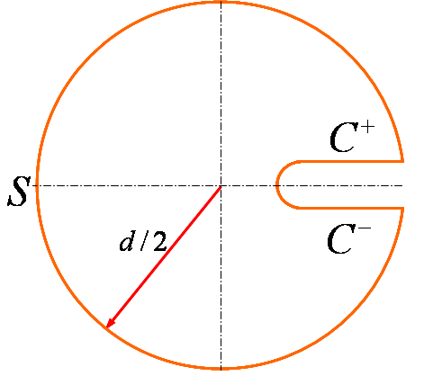
1

2

4

3

$$ε=0$$
cracked bar cutoff wall
(大學部) (研究所)
$\begin{aligned}U \\ T \\ L \\ M\end{aligned}$ $⇒ {\text{ΦΣΨ}}^{T}$
$$⇓$$
SVD分解
due to degenerate boundary

due to rigid body

References:
- J. T. Chen, S. R. Lin, K. H. Chen, I. L. Chen and S. W. Chyuan, 2003, Eigenanalysis for membranes with stringers using conventional BEM in conjunction with SVD technique, Computer Methods in Applied Mechanics and Engineering, Vol.192, No.11-12, pp.1299-1322(SCI and EI)(也可以看林書睿碩士論文)
【 BEM第7次作業，Feb.23, 2008, bem07-2008.doc 】陳正宗終身特聘教授 羿州 製

