BEM 2013 第八次作業 May 16, 2013
河工3A黃郁凱
(0,0)
1
2
3
4
5
6
7
8
(1,0.5)
(-1,0.5)
(-1,-0.5)
(1,-0.5)
在作業四中，我們以BEPO2D去求解2D問題，並在作業五與六去作驗證。本次作業將探討板樁滲流問題，將問題分成8個元素(如上圖)，其邊界條件分別是：
與
也就是上下不透水，左右兩端水頭分別為-1與1(由右向左流)。
試解下列問題：
- Run BEPO2D並輸出4個矩陣。
- 上述4個矩陣之秩各是多少？是否有秩降的現象？其原因為何？
- 所謂奇異值分解(SVD)，是將矩陣分解成：
,
試對做奇異值分解，並針對其最小奇異值所對應之左酉向量與右酉向量做柱狀圖(bar charts)。
- 從SVD結構中，觀察中最小奇異值所對應的左酉向量與右酉向量，彼此間有何關係？
- 試對合併矩陣，補充行(updating documents)與補充列((updating terms))做SVD，並針對其最小奇異值所對應之左酉向量與右酉向量做柱狀圖(bar charts)。
- 將3與5之結果做比對，試說明其之間的關係。
References
- J. T. Chen and H.-K. Hong, 1988, Applications of Integral Equations with Superstrong Singularity to Steady State Heat Conduction. Thermochimica Acta, 135:133-138.
- H.-K. Hong, J. T. Chen, 1988, Derivations of integral equations of elasticity. Journal of Engineering Mechanics; 114(6):1028–1044.
- J. T. Chen, H.-K. Hong and S. W. Chyuan, 1994, Boundary Element Analysis and Design in Seepage Problems Using Dual Integral Formulations, Finite Elements in Analysis and Design, 17(1):1-20.
- J. T. Chen and Y. W. Chen, 2000, Dual Boundary Element Analysis Using Complex Variables for Potential Problems with or without a Degenerate Boundary, Engineering Analysis with Boundary Elements, 24(9):671-684.
- Y. Fan, Y. T. Lee, J. W. Lee and J. T. Chen, DBEM analysis for an elliptic torsion bar with a double-edge crack. The 35th National Conference on Theoretical and Applied Mechanics, 2011.
S為左酉、V為Sigma、 D為右酉
U的SVD
S =

-0.3194 -0.0651 0.6309 -0.5000 0.1506 -0.3847 -0.2739 0.0000
0.3194 -0.0651 0.6309 0.5000 0.1506 0.3847 -0.2739 0.0000
0.5441 -0.0374 -0.0692 0.0000 -0.5413 -0.4516 -0.4481 0.0000
0.3194 0.3659 -0.2335 -0.5000 0.3586 0.3847 -0.4277 0.0000
0.0000 0.6004 0.2064 0.0000 -0.2360 0.0000 0.2031 -0.7071
0.0000 0.6004 0.2064 0.0000 -0.2360 0.0000 0.2031 0.7071
-0.3194 0.3659 -0.2335 0.5000 0.3586 -0.3847 -0.4277 0.0000
-0.5441 -0.0374 -0.0692 -0.0000 -0.5413 0.4516 -0.4481 0.0000

V =

3.3192 0 0 0 0 0 0 0
0 3.0860 0 0 0 0 0 0
0 0 1.9293 0 0 0 0 0
0 0 0 1.3394 0 0 0 0
0 0 0 0 1.0600 0 0 0
0 0 0 0 0 1.0339 0 0
0 0 0 0 0 0 0.8417 0
0 0 0 0 0 0 0 0.0000

D =

0.3160 0.0495 -0.6366 0.5000 -0.1361 0.3875 0.2716 -0.0000
-0.3160 0.0495 -0.6366 -0.5000 -0.1361 -0.3875 0.2716 -0.0000
-0.5480 0.0500 0.0772 -0.0000 0.5428 0.4469 0.4438 -0.0000
-0.3160 -0.4639 0.1962 0.5000 -0.3051 -0.3875 0.3914 0.0000
-0.0000 -0.5290 -0.2243 -0.0000 0.3062 -0.0000 -0.2759 0.7071
-0.0000 -0.5290 -0.2243 0.0000 0.3062 -0.0000 -0.2759 -0.7071
0.3160 -0.4639 0.1962 -0.5000 -0.3051 0.3875 0.3914 -0.0000
0.5480 0.0500 0.0772 0.0000 0.5428 -0.4469 0.4438 0.0000
T的SVD
S =

0.0232 0.5227 0.2978 -0.2539 -0.3983 -0.5262 -0.3709 0.0000
0.0232 0.5227 0.2978 0.2539 0.3983 0.5262 -0.3709 0.0000
0.0260 -0.0401 -0.5223 -0.6094 -0.0749 0.3507 -0.4742 0.0000
-0.0564 -0.4715 0.3701 0.2532 -0.5795 0.3164 -0.3709 0.0000
0.7040 -0.0535 0.0391 0.0000 -0.0000 0.0000 0.0000 -0.7071
0.7040 -0.0535 0.0391 -0.0000 0.0000 0.0000 0.0000 0.7071
-0.0564 -0.4715 0.3701 -0.2532 0.5795 -0.3164 -0.3709 0.0000
0.0260 -0.0401 -0.5223 0.6094 0.0749 -0.3507 -0.4742 0.0000

V =

7.3074 0 0 0 0 0 0 0
0 4.5665 0 0 0 0 0 0
0 0 4.3672 0 0 0 0 0
0 0 0 4.2851 0 0 0 0
0 0 0 0 3.6451 0 0 0
0 0 0 0 0 2.7332 0 0
0 0 0 0 0 0 0.0000 0
0 0 0 0 0 0 0 0.0000

D =

0.1623 -0.5423 -0.2336 0.2884 0.4264 0.4436 -0.3536 0.1955
0.1623 -0.5423 -0.2336 -0.2884 -0.4264 -0.4436 -0.3536 -0.1955
0.1541 0.0215 0.5923 0.5779 0.0488 -0.3059 -0.3536 -0.2647
0.2890 0.4472 -0.3024 -0.2878 0.5258 -0.1711 -0.3536 -0.3338
-0.6053 0.0736 -0.0563 -0.0009 -0.1984 0.4247 -0.3536 -0.5294
-0.6053 0.0736 -0.0563 0.0009 0.1984 -0.4247 -0.3536 0.5294
0.2890 0.4472 -0.3024 0.2878 -0.5258 0.1711 -0.3536 0.3338
0.1541 0.0215 0.5923 -0.5779 -0.0488 0.3059 -0.3536 0.2647
L的SVD
S =

-0.0967 0.3906 0.5571 -0.3714 -0.2058 -0.3164 0.4973 0.0000
0.0967 0.3906 -0.5571 0.3714 0.2058 -0.3164 0.4973 0.0000
0.0882 0.4474 -0.2417 -0.0207 -0.6583 0.5476 -0.0030 0.0000
0.1659 0.3838 -0.3099 -0.5937 0.1546 -0.3163 -0.5027 -0.0000
0.6748 0.0000 0.1876 0.0954 0.0186 -0.0000 0.0000 -0.7071
-0.6748 -0.0000 -0.1876 -0.0954 -0.0186 0.0000 0.0000 -0.7071
-0.1659 0.3838 0.3099 0.5937 -0.1546 -0.3163 -0.5027 -0.0000
-0.0882 0.4474 0.2417 0.0207 0.6583 0.5476 -0.0030 -0.0000

V =

7.4677 0 0 0 0 0 0 0
0 6.0680 0 0 0 0 0 0
0 0 3.3514 0 0 0 0 0
0 0 0 2.6424 0 0 0 0
0 0 0 0 2.3824 0 0 0
0 0 0 0 0 2.3542 0 0
0 0 0 0 0 0 1.7020 0
0 0 0 0 0 0 0 0.0000

D =

-0.1444 0.3982 0.5166 -0.3853 -0.2526 -0.2870 0.4883 0.1439
0.1444 0.3982 -0.5166 0.3853 0.2526 -0.2870 0.4883 0.1439
0.2137 0.3939 -0.2523 -0.0088 -0.6250 0.5790 -0.0095 0.0973
0.3334 0.3962 -0.2137 -0.5477 0.2080 -0.2869 -0.5077 0.0539
0.5678 0.1712 0.3518 0.2269 0.0489 -0.0006 0.0614 -0.6833
-0.5678 0.1712 -0.3518 -0.2269 -0.0489 -0.0006 0.0614 -0.6833
-0.3334 0.3962 0.2137 0.5477 -0.2080 -0.2869 -0.5077 0.0539
-0.2137 0.3939 0.2523 0.0088 0.6250 0.5790 -0.0095 0.0973
M的SVD
S =
-0.0451 -0.5900 0.2416 -0.2806 0.5000 -0.3025 -0.4138 -0.0000
0.0451 0.5900 -0.2416 -0.2806 0.5000 0.3025 -0.4138 -0.0000
0.0079 -0.3881 -0.3889 0.5852 0.0000 0.4451 -0.3969 -0.0000
0.1572 -0.0214 0.5294 -0.2806 -0.5000 0.4411 -0.4138 -0.0000
-0.6879 0.0293 0.1007 0.0000 -0.0000 0.1258 0.0000 -0.7071
0.6879 -0.0293 -0.1007 -0.0000 0.0000 -0.1258 0.0000 -0.7071
-0.1572 0.0214 -0.5294 -0.2806 -0.5000 -0.4411 -0.4138 -0.0000
-0.0079 0.3881 0.3889 0.5852 0.0000 -0.4451 -0.3969 -0.0000
V =

18.2985 0 0 0 0 0 0 0
0 6.2218 0 0 0 0 0 0
0 0 5.5725 0 0 0 0 0
0 0 0 5.5709 0 0 0 0
0 0 0 0 3.5282 0 0 0
0 0 0 0 0 1.5535 0 0
0 0 0 0 0 0 0.0000 0
0 0 0 0 0 0 0 0.0000
D =
-0.0704 -0.5824 0.2403 -0.2887 0.5000 -0.3132 -0.4082 -0.0000
0.0704 0.5824 -0.2403 -0.2887 0.5000 0.3132 -0.4082 -0.0000
0.0402 -0.3984 -0.3934 0.5774 0.0000 0.4300 -0.4082 -0.0000
0.3265 -0.0416 0.4946 -0.2887 -0.5000 0.3835 -0.4082 -0.0000
-0.6220 0.0183 0.2070 0.0000 -0.0000 0.2645 -0.0000 0.7071
0.6220 -0.0183 -0.2070 -0.0000 0.0000 -0.2645 -0.0000 0.7071
-0.3265 0.0416 -0.4946 -0.2887 -0.5000 -0.3835 -0.4082 -0.0000
-0.0402 0.3984 0.3934 0.5774 -0.0000 -0.4300 -0.4082 -0.0000
U(S第8行左，Ｄ第８行右)
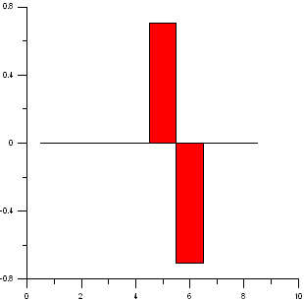

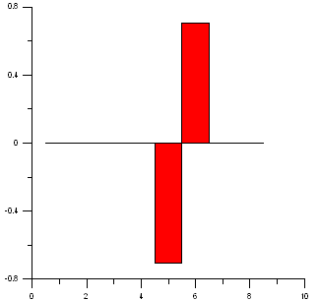

T(S第7行左上，第8行右上。D第7行左下，第8行右下。)
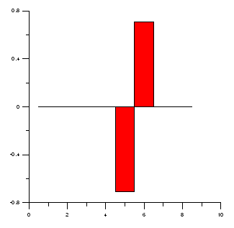
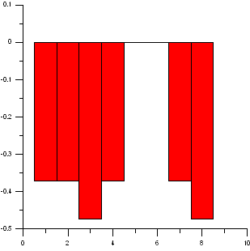

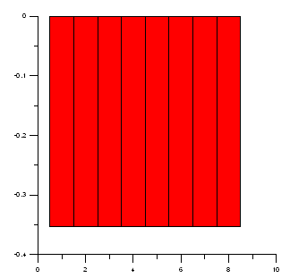
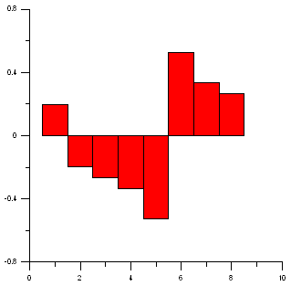

L(S第8行左，Ｄ第８行右)
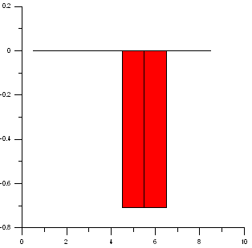
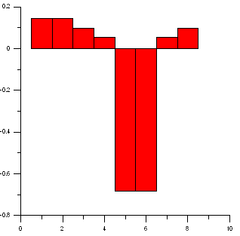

M(S第7行左上，第8行右上。D第7行左下，第8行右下。)
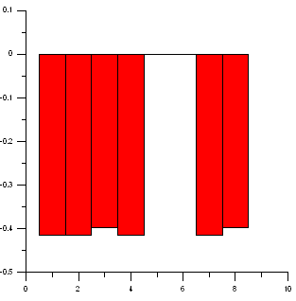
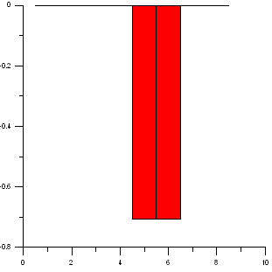

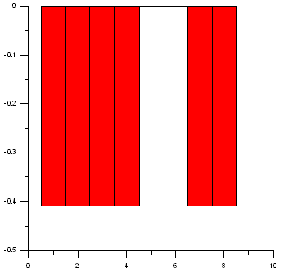
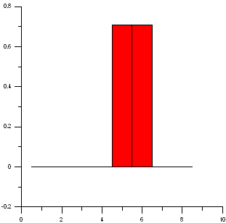

[U T]矩陣的奇異值
7.7795
5.0665
4.7589
4.5923
4.0319
3.7544
1.0598
0.0000
[L M]矩陣的奇異值
19.5001
6.8219
6.3257
6.2829
5.8244
4.4567
3.9172
0.0000
[T；M]矩陣的奇異值
18.5269
7.4506
7.4254
6.9794
6.5857
5.7409
2.0012
0.0000
流線圖(八個元素,七個節點)

