班級：___河工碩一___學號：__M96520027__姓名：____謝祥志___
國立台灣海洋大學河海工程研究所BEM第4.5次作業(2008)/NTOU-MSV

In the course, we separated the closed-form fundamental solution into separable form for the fundamental solution of Laplace problem as shown below:

Closed-form:
Degenerate form (separable form):
where $x=(ρ,φ)$ and $s=(R,θ)$.
Based on the degenerate kernel, please plot the boundary densities of and along the circular boundary.
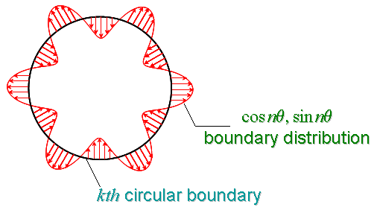

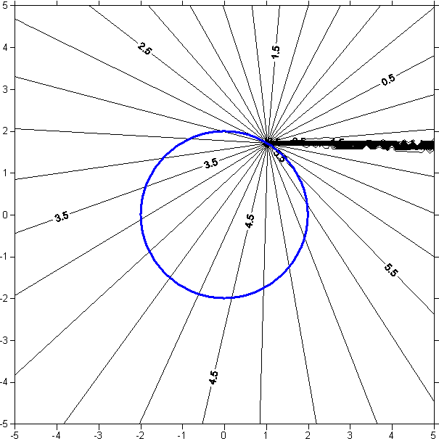

研究所
- Using the degenerate kernel of to plot the boundary densities and along the circular boundary .
【 BEM第4.5次作業，日期：April.21, 2008，檔名bem04.5-2008.doc 】陳正宗終身特聘教授
~ K. H. Chou 製表
Sol:
目的:
在距離screw dislocation右上方半徑為一的小圓上產生的位移，同時也可以了解”加法定理”的應用，並且做出closed-form與級數解的比較來討論初期函數的收斂性。

數據方法及圖表:
- 先利用公式得到screw dislocation圖(圖一)，其中的紅色小圓即是半徑為一的圓。
φ
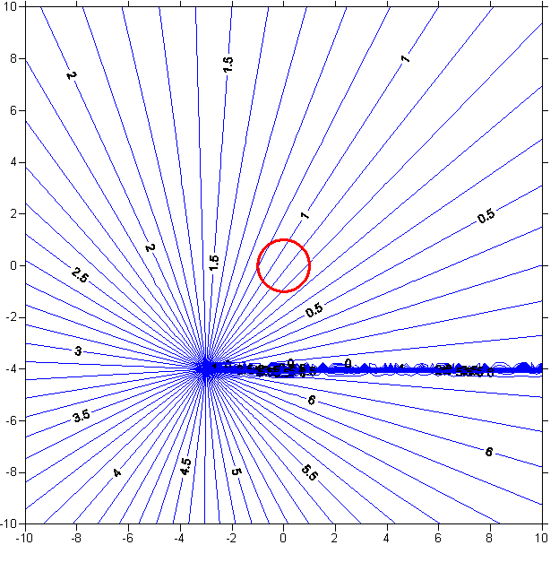
圗一 screw dislocation
θ

- 畫出小U的圗並與closed-form畫出的小U做比較，最後在畫出小圓上的位移圖;同理畫小T圖的時候也是一樣
closed-form:
separable-form:

y
u(θ)
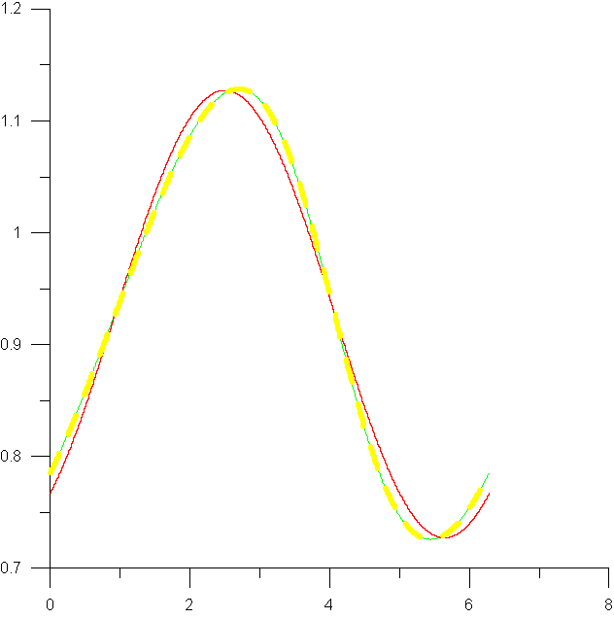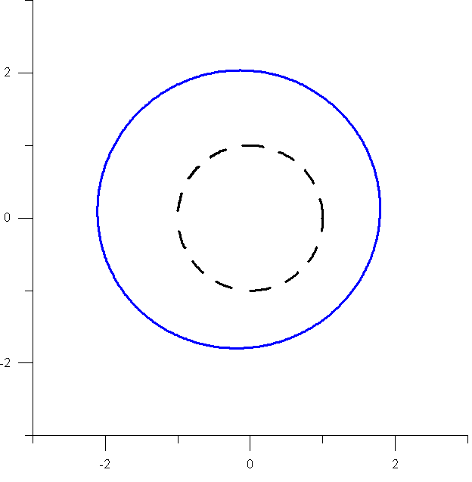
θ
x
圗二 u(θ)-θ
圗三 小U位移圖
N=1
N=5
Closed-form
t(θ)

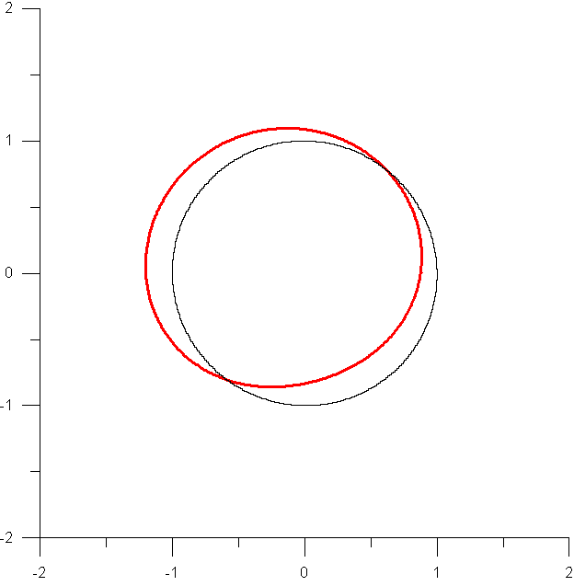
θ
小T

附錄:(程式碼)
- screw dislocation:
!************練習畫出差排***********
PROGRAM TEXT
IMPLICIT NONE

INTEGER M,N

REAL*8 X,Y,PI,THO,SD
REAL*8 U,R,THETA,PHI

OPEN (11,FILE='TEST.TXT')
OPEN (13,FILE='INSIDE.TXT')
OPEN (14,FILE='OUTSIDE.TXT')

PI=ATAN(1.0)*4
THETA=PI+ATAN(4./3.)
R=5
N=100

DO THO=0,20.,0.1
DO PHI=0,2*PI,0.01
X=THO*COS(PHI)
Y=THO*SIN(PHI)

IF (R.GE.THO) THEN
U=THETA+PI
DO M=1,N
U=U+1./M*(THO/R)**M*SIN(M*(THETA-PHI))
ENDDO
WRITE(13,*) X,Y,U
ELSE
U=PHI
DO M=1,N
U=U-1./M*(R/THO)**M*SIN(M*(THETA-PHI))
ENDDO
WRITE(14,*) X,Y,U
END IF
IF (U.GE.2*PI) THEN
SD=U-2*PI
ELSEIF (U.LT.0) THEN
SD=U+2*PI
ELSE
SD=U
ENDIF
WRITE(11,*) X,Y,SD
ENDDO
ENDDO
STOP
END
- 小U(級數型):
!*********小U*******
PROGRAM smallU
IMPLICIT NONE

INTEGER M,N

REAL*8 X,Y,PI,THO,SD
REAL*8 U,R,THETA,PHI

OPEN (11,FILE='UU.TXT')

PI=ATAN(1.0)*4
THETA=PI+ATAN(4./3.)
R=5
N=30
THO=1

DO PHI=0,2*PI,0.01
X=THO*COS(PHI)
Y=THO*SIN(PHI)

IF (R.GE.THO) THEN
U=THETA+PI
DO M=1,N
U=U+1./M*(THO/R)**M*SIN(M*(THETA-PHI))
ENDDO
ELSE
U=PHI
DO M=1,N
U=U-1./M*(R/THO)**M*SIN(M*(THETA-PHI))
ENDDO
END IF
IF (U.GE.2*PI) THEN
SD=U-2*PI
ELSEIF (U.LT.0) THEN
SD=U+2*PI
ELSE
SD=U
ENDIF
WRITE(11,*) (SD+1)*COS(PHI),(SD+1)*SIN(PHI)
ENDDO
STOP
END
- 小U(close-form)
!************CLOSED-FORM***********
PROGRAM CLOSED
IMPLICIT NONE

INTEGER M,N

REAL*8 X,Y,PI,THO,SD,QQ,PP
REAL*8 U,R,THETA,PHI,SUM

OPEN (11,FILE='CLOSED.TXT')

PI=ATAN(1.0)*4.
THETA=PI+ATAN(4./3.)
R=5
N=10
THO=1

DO PHI=0,2*PI,0.01
SUM=0.0
QQ=THO*COS(PHI)-R*COS(THETA)
PP=SQRT(THO**2+R**2-2*R*THO*COS(PHI-THETA))
SUM=SUM+ACOS(QQ/PP)
WRITE(11,*) PHI,SUM
ENDDO
STOP
END

4. 小T
!*******小T的程式*******
PROGRAM smallT
IMPLICIT NONE

INTEGER M,N

REAL*8 X,Y,PI,THO,SD
REAL*8 U,R,THETA,PHI

OPEN (11,FILE='TT.TXT')

PI=ATAN(1.0)*4
THETA=PI+ATAN(4./3.)
R=5.
N=30
THO=1.

DO PHI=0,2*PI,0.01
U=0.0
DO M=1,N
U=U+((THO**(M-1))/(R**M))*SIN(M*(THETA-PHI))
ENDDO
WRITE(11,*) (U+1)*DCOS(PHI),(U+1)*DSIN(PHI)
ENDDO
STOP
END

