Point source of two cylinders
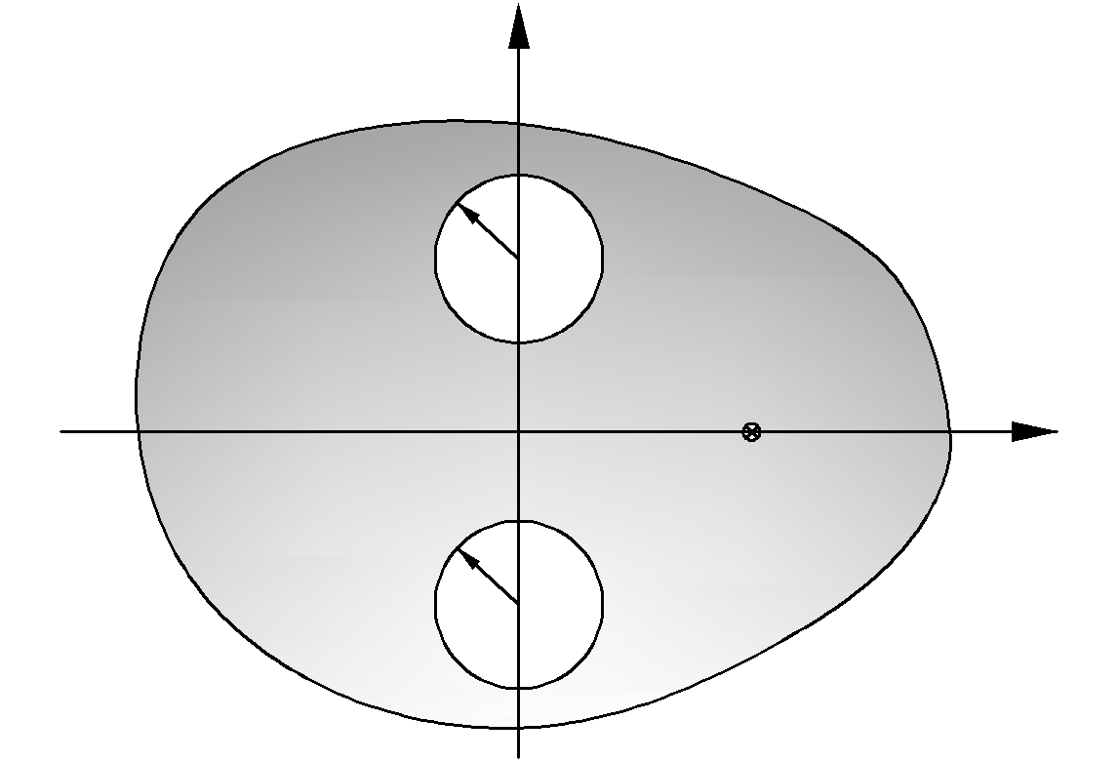
a
a
a
a
=
=
Herd cylinder
Soft cylinder

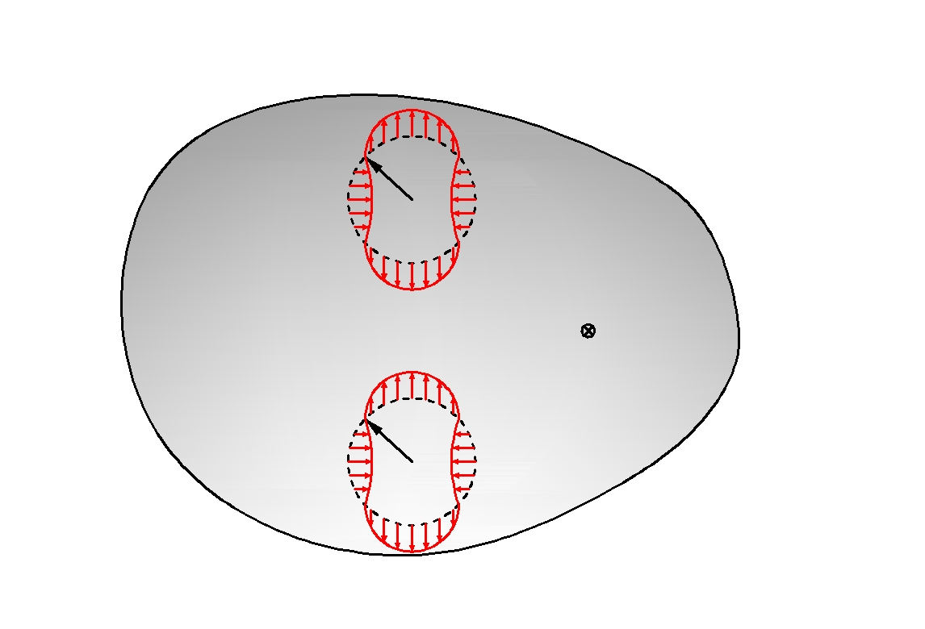
+
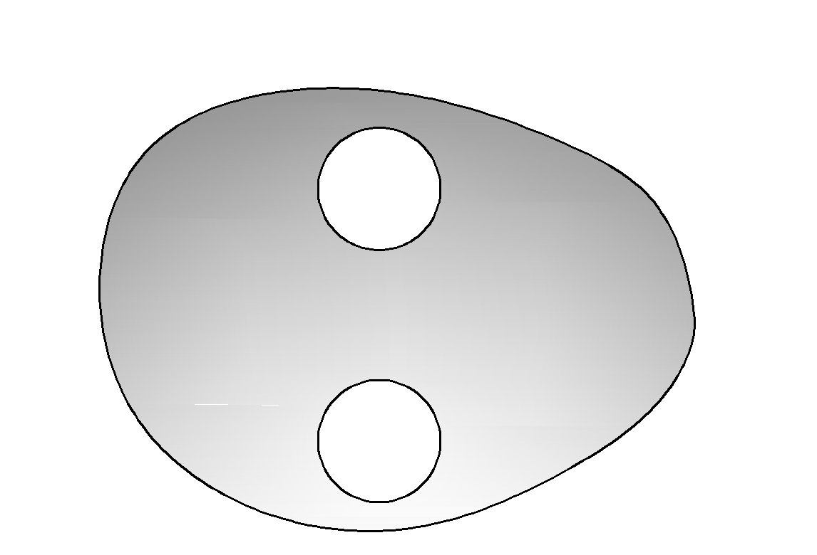
+

+

- method 1：BEM(陳義麟或陳桂鴻博士指導)
- method 2：null-field (using Green’s third identity)-查陳柏源學長論文
- method 3：addition theorem and superposition technique(周克勳學長碩士論文)
References:
R.V. Row, Theoretical and experimental study of electromagnetic scattering by two identical conducting cylinders. Journal of Applied physics 26 (1955) 666-675. C:pp.129, 177, 206 4.5.3(P.131)
Scott E. Sherer, Scattering of sound for axisymetric sources by multiple circular cylinders. J. Acoust. Soc. Am. 115(2) (2004) 488-496.

