Point source of two cylinders
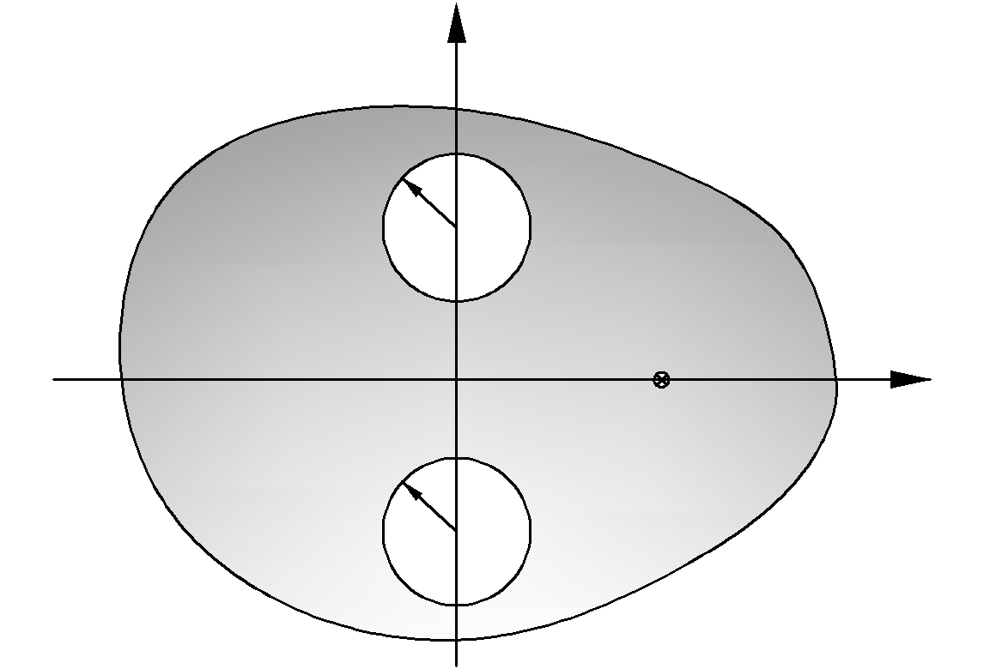
a
a
a
a
=
=
Herd cylinder
Soft cylinder

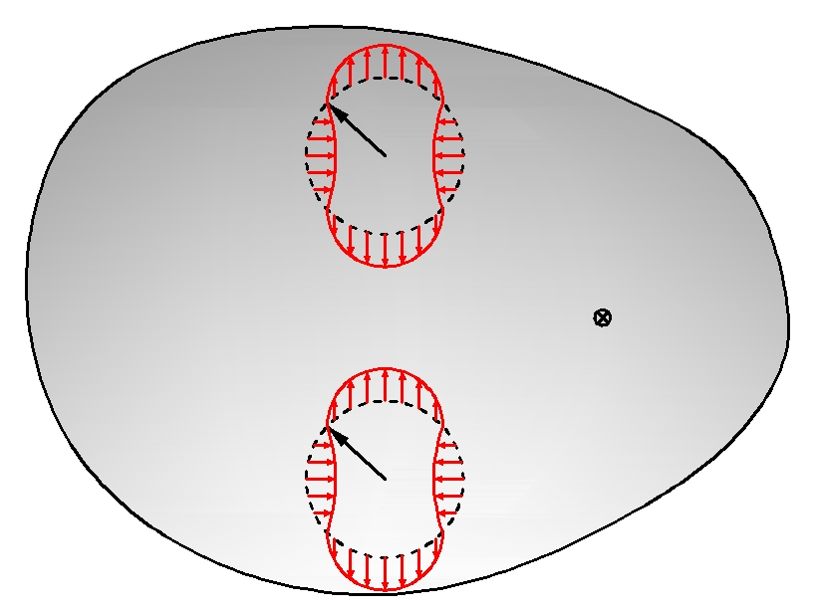
+
+
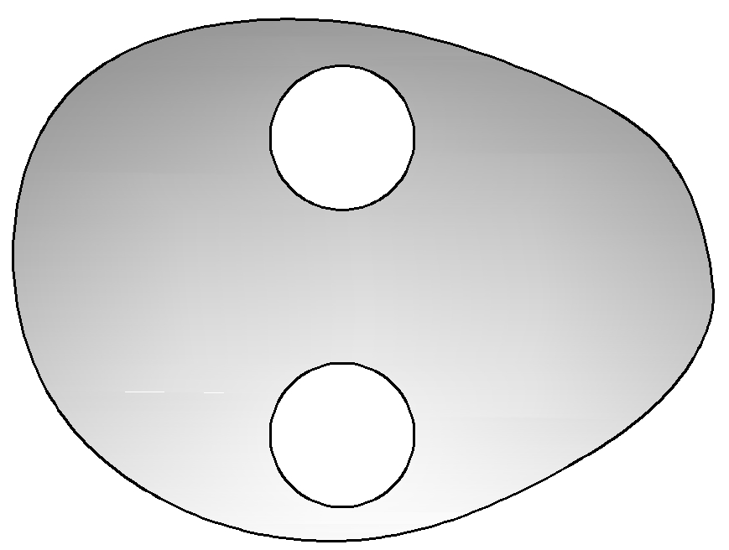

- method 1：BEM(陳義麟或陳桂鴻博士指導)
- method 2：null-field (using Green’s third identity)-查陳柏源學長論文
- method 3：addition theorem and superposition technique(周克勳學長碩士論文)

References:
R.V. Row, Theoretical and experimental study of electromagnetic scattering by two identical conducting cylinders. Journal of Applied physics 26 (1955) 666-675. C:pp.129, 177, 206 4.5.3(P.131)

