In the course, we separated the closed-form fundamental solution into separable form for the fundamental solution of Laplace problem as shown below:

Closed-form:
Degenerate form (separable form):
where $x=(ρ,φ)$ and $s=(R,θ)$.
Based on the degenerate kernel, please plot the boundary densities of and along the circular boundary.
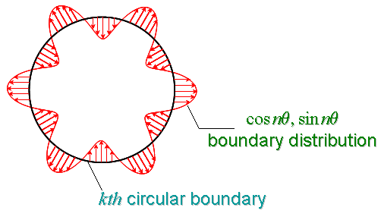

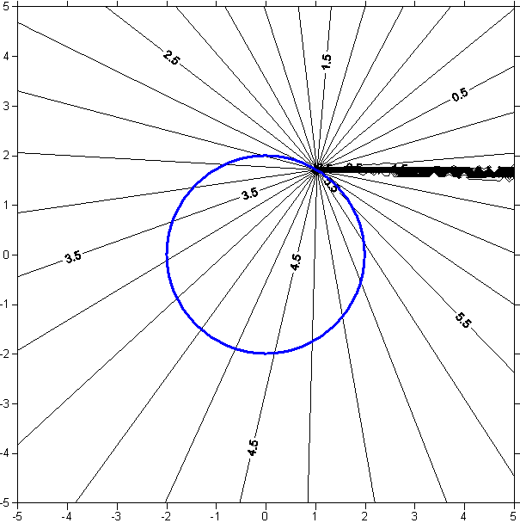

大學部
- Using the degenerate kernel of to plot the boundary densities and along the circular boundary .
將觀察點座標架在，如圖
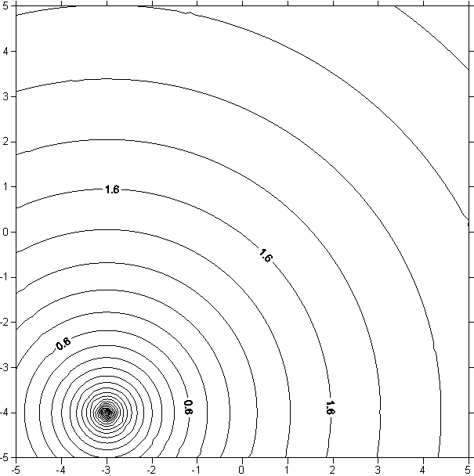 INTEGER M,I
s
x
PARAMETER (M=100)
REAL*8 R,RHO,SUM,PI,PHI,THETA
101 FORMAT (100F16.8)
OPEN(15,FILE='OUT.TXT')
OPEN(16,FILE='IN.TXT')
OPEN(17,FILE='ALL.TXT')
PI=Atan(1.0)*4.0
R=5.
THETA=Atan(-4.0/-3.0)+PI
DO PHI=0.,2*PI,0.01
DO RHO=0.1,10,0.1
IF (R.LT.RHO) THEN
SUM=LOG(RHO)
DO I=1,M
SUM=SUM-1./I*((R/RHO)**I)*COS(I*(THETA-PHI))
ENDDO
WRITE(15,101) RHO*COS(PHI),RHO*SIN(PHI),SUM
ELSE
SUM=LOG(R)
DO I=1,M
SUM=SUM-1./I*((RHO/R)**I)*COS(I*(THETA-PHI))
ENDDO
WRITE(16,101) RHO*COS(PHI),RHO*SIN(PHI),SUM
ENDIF
WRITE(17,101) RHO*COS(PHI),RHO*SIN(PHI),SUM
ENDDO
ENDDO
STOP
END
IMPLICIT NONE
INTEGER M,I
PARAMETER (M=1)
REAL*8 R,RHO,SUM,PI,PHI,THETA,U,Q,V
101 FORMAT (100F16.8)
OPEN(11,FILE='U_RHO_PHI_1.TXT')
OPEN(12,FILE='U_X_Y_1.TXT')
OPEN(13,FILE='BEFORE.TXT')
OPEN(14,FILE='T_RHO_PHI_1.TXT')
OPEN(15,FILE='T_X_Y_1.TXT')
OPEN(16,FILE='U_R_RHO_PHI.TXT')
OPEN(17,FILE='U_R_X_Y.TXT')
OPEN(18,FILE='T_R_RHO_PHI.TXT')
OPEN(19,FILE='T_R_X_Y.TXT')
PI=Atan(1.0)*4.0
R=5.
RHO=1.
THETA=Atan(-4.0/-3.0)+PI
DO PHI=0.,2*PI,0.01
Q=LOG(R)
DO I=1,M
Q=Q-1./I*((RHO/R)**I)*COS(I*(THETA-PHI))
ENDDO
WRITE(11,101) PHI,Q
WRITE(12,101) (RHO+Q)*COS(PHI),(RHO+Q)*SIN(PHI)
WRITE(13,101) COS(PHI),SIN(PHI)
SUM=0.
DO I=1,M
SUM=SUM-1./(R**I)*COS(I*(THETA-PHI))
ENDDO
WRITE(14,101) PHI,SUM
WRITE(15,101) (RHO+SUM)*COS(PHI),(RHO+SUM)*SIN(PHI)
U=1/2.*LOG(RHO**2+R**2-2*RHO*R*COS(THETA-PHI))
WRITE(16,101) PHI,U
WRITE(17,101) (RHO+U)*COS(PHI),(RHO+U)*SIN(PHI)
V=1/2.*(2*RHO-2*R*COS(THETA-PHI))/(RHO**2+R**2-
& 2*RHO*R*COS(THETA-PHI))
WRITE(18,101) PHI,V
WRITE(19,101) (RHO+V)*COS(PHI),(RHO+V)*SIN(PHI)
ENDDO
STOP
END

