日期：2008年11月18日 姓名： 學號：
第九次作業

1.
(a) Please plot the curve in (u,v) plane for, when x=1
(b) Please plot the curve in (u,v) plane for, when y=1
(c) Please plot the curve in (x,y) plane for, when u=1
(d) Please plot the curve in (x,y) plane for, when v=1
y
v

mapping
u
x
2. An eccentric circle in the x-y coordinate is mapped to an annulus in
(u,v) plane for the mapping
y
v

u
1
2.5
1/4
1/2
mapping
(1,0)
x

3. Please use “Mathenatica” to plot the bipolar coordinate (choose a c
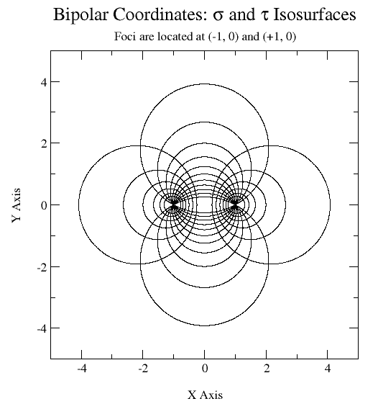
value) .
- Please plot the curve in (x,y) plane for=const
- Please plot the curve in (x,y) plane for=const

