- Linkage between bipolar coordinate and conformal mapping.

- Derivation of degenerate kernel ($r^{2}\text{ln}r$) by using the method of complex variable. In the polar coordinate, we choose $z=(s_{1},s_{2})={\text{Re}}^{iθ}$ and$\overset{}{z}=(x_{1},x_{2})={ρe}^{iφ}$.
$\left.\begin{matrix}\text{ln}r\vec{\text{complex}}\text{degenerate kernal} \\ r^{2}\vec{\text{complex}}\text{cosine theorem}\end{matrix}\right\}→r^{2}\text{ln}r$ (ok)
$r^{2}\text{ln}r\vec{\text{complex}}?$ (try)
- Derivate the degenerate kernel for elliptical coordinate by using the method of conformal mapping.
Mapping

$$z=x+\text{yi}$$
$$z=u+\text{vi}$$

- Degenerate kernel
4.1談直接法與間接法之等效性
4.2談内域與外域問題

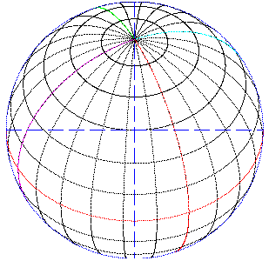
- Torsion problem (A. K. Naghdi)

- Two spheres radiator and scatter.

- Dynamic stress concentration.

- SH Wave → SV and P Waves.

- Torsion rigidity (Lin) 沈文成.

- Two scatters (BEM) 陳佳聰.

- Analytical solution 蕭嘉俊.

- BEM for multiple radiators (Dr. I. L. Chen easy manual).

【file:Integral_hw.doc by Henry 2005/06/20 】

