班級：_____________學號：______________姓名：______________
國立台灣海洋大學河海工程研究所科技論文寫作HW1 (2011) NTOU-MSV

In the future, you may have a paper to publish. The publisher may need your information. Please provide one for yourself. See the example.

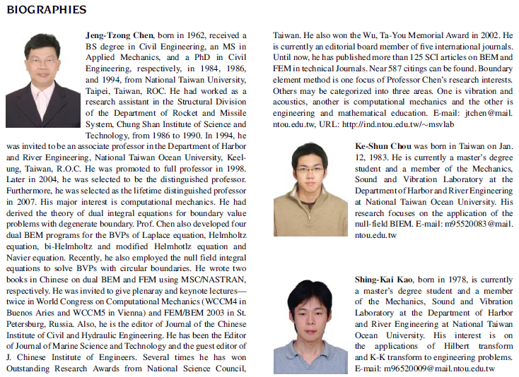

Ref:
J. T. Chen, K. S. Chou and S. K. Kao, 2009, One-dimensional wave animation using Mathematica, Computer Applications in Engineering Education, Vol.17, No.3, pp.323-339.

Writing 2011-1.doc (逸維製表)

