班級：_____________學號：______________姓名：______________
國立台灣海洋大學河海工程研究所科技論文寫作HW5 (2011) NTOU-MSV

Please choose one scholar as an example, download his information by using WOS.

EX: Chen J T
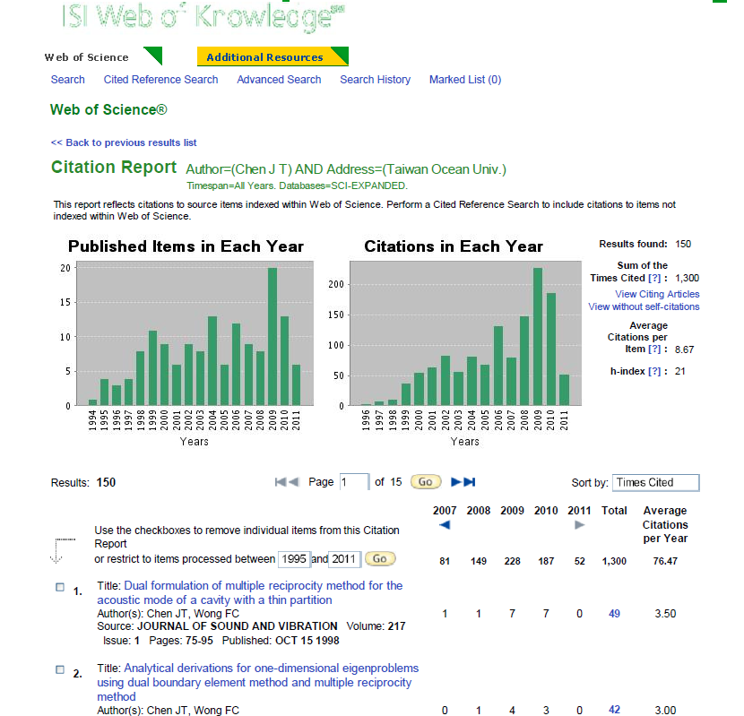

Writing 2011-5.doc (范羽製表)

