個人資料
中文姓名：陳柏源 | 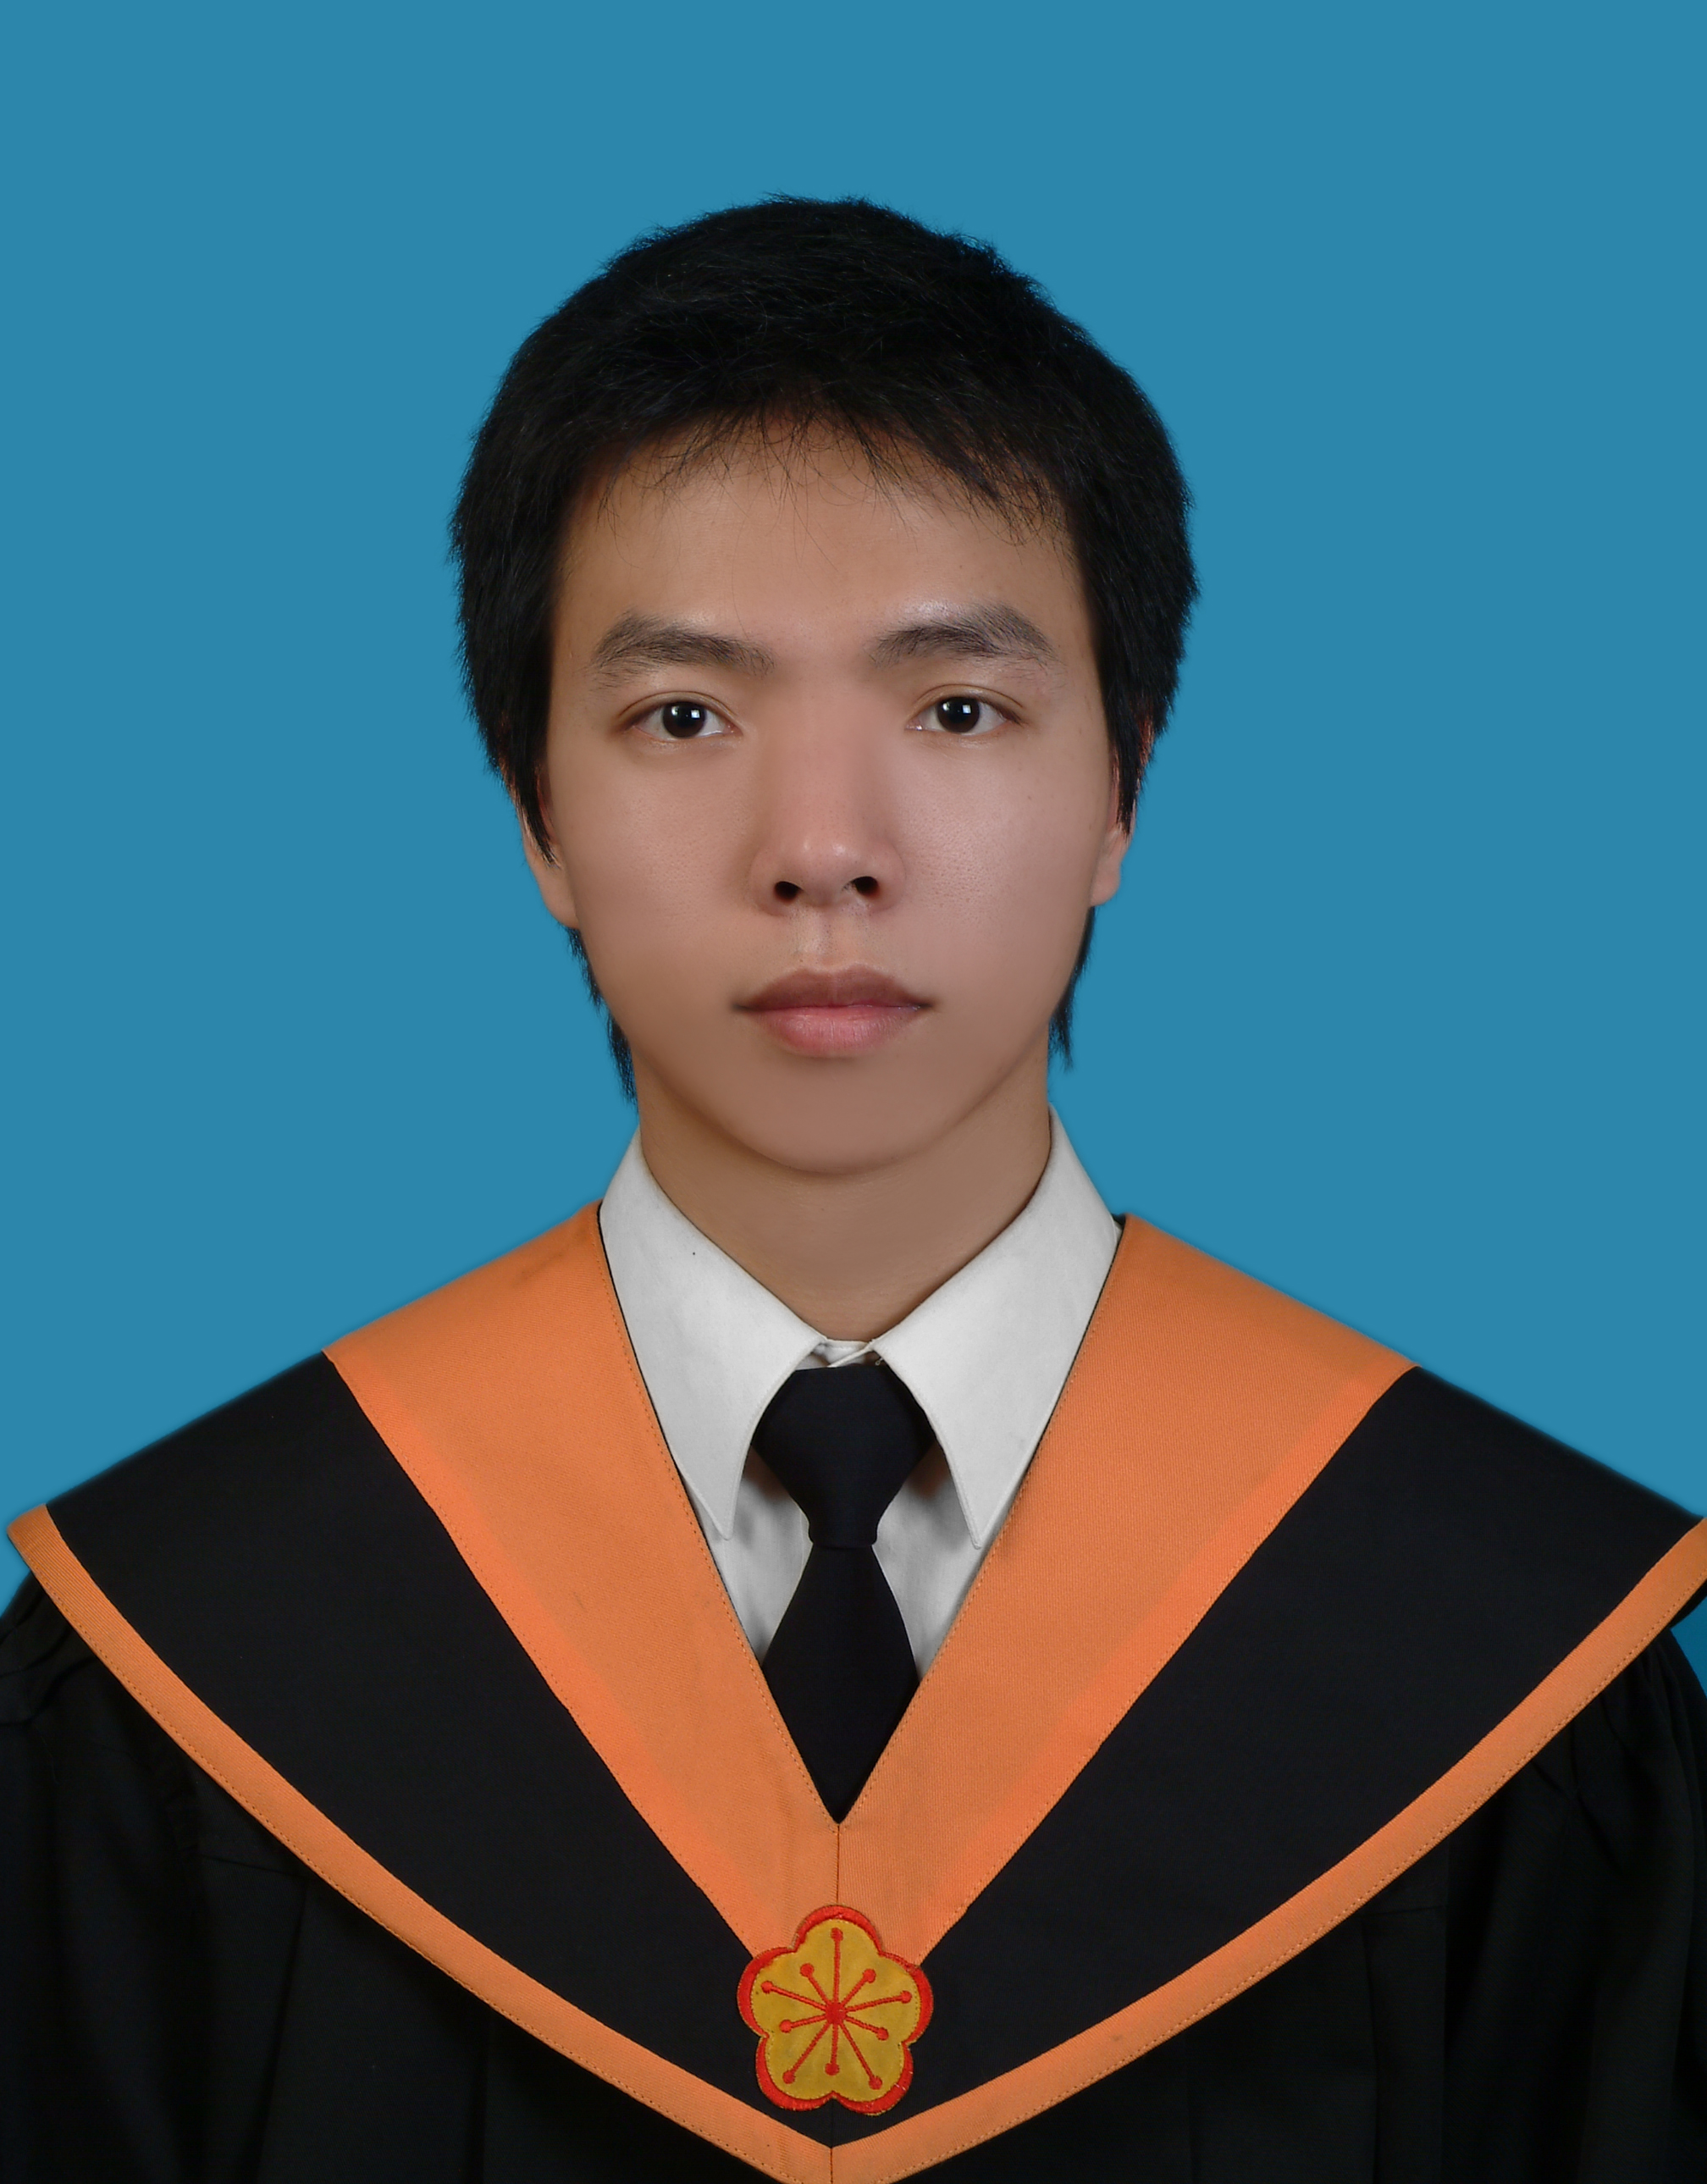
出生日期：中華民國71年06月17日
籍貫：台灣省新竹縣
聯絡地址：303新竹縣湖口鄉愛勢村民族街181號
聯絡電話：(03)5993-308
行動電話：0919-391493
E-mail address: M93520010@mail.ntou.edu.tw
學歷：
國立台灣海洋大學河海工程研究所碩士 (2004.8 ~ 2006.7)
論文指導教授：陳正宗終身特聘教授
論文題目：零場積分方程求解含圓形邊界之應力集中問題
國立台灣海洋大學河海工程系學士 (2000.8 ~ 2004.7)
國立新竹高級中學 (1997.8 ~ 2000.7)
校內經歷:
海洋大學河海工程學系93級碩士班班代
九十四學年度積極性補強教學課輔助教
校內獲獎:
大學部及碩士班在校生論文發表於SCI,SSCI,或TSSCI期刊獎勵
PERSONAL DATA
Po-Yuan Chen Nationality : R.O.C. (Taiwan)
Date of Birth : Jun. 17, 1982. Sex : Male
Permanent address: No. 181, Min-Zu street, Hu-Kou, HsinChu, Taiwan, ROC
TEL:886-3-5993308
Cell phone:0919-391493
E-mail address: M93520010@mail.ntou.edu.tw

EDUCATION
2006 M.S., Department of Harbor and River Engineering, National Taiwan Ocean University
Adviser: Jeng-Tzong Chen, Life-time Distinguished Professor
Thesis topic: Null-field integral equation approach for solving stress concentration problems with circular boundaries
2004 B.S., Department of Harbor and River Engineering, National Taiwan Ocean University
2000 National HsinChu Senior high school

EXPERIENCES (in school)
2005, class representative of the graduate school
2006, teaching assistant of active education

PUBLICATIONS
- Refereed Papers
- Chen, J.T., Chen, P.Y. and Chen, C.T., 2007, Surface motion of multiple alluvial valleys for incident plane SH-waves by using a semi-analytical approach, Soil Dynamics and Earthquake Engineering, Accept. (SCI)
- Chen, J.T. and Chen, P.Y., 2007, A semi-analytical approach for stress concentration of cantilever beams with circular holes under bending, Journal of Mechanics, Vol.23 (3), pp.211-221. (SCI)
- Chen, J.T., Chen C.T., Chen, P.Y. and Chen, I.L., 2007, A semi-analytical approach for radiation and scattering problems with circular boundaries, Computer Methods in Applied Mechanics and Engineering, Vol.196, pp.2751-2764. (SCI)
- Chen, J.T., Shen, W.C. and Chen, P.Y., 2006, Analysis of circular torsion bar with circular holes using null-field approach, Computer Modeling in Engineering Science, Vol.12 (2), pp.109-119. (SCI)
- Conference Papers
- Chen, J.T. and Chen, P.Y., 2007, Null-field integral equations and their applications, BEM/MRM 29, The New Forest, UK.
- Chen, P.Y. and Chen, J.T., 2006, A semi-analytical approach for solving surface motion of multiple alluvial valleys for incident plane SH-waves, The 30th National Conference on Theoretical and Applied Mechanics, DYU, Changhwa.
- Chen, P.Y. and Chen, J.T., 2006, A semi-analytical approach for stress concentration of cantilever beams with circular holes under bending, The 8th National Conference on Structure Engineering, Sun Moon Lake, Taiwan.
- Chen, P.Y., Chen, C.T. and Chen, J.T., 2005, A semi-analytical approach for dynamic stress concentration factor of Helmholtz problems with circular holes, The 29th National Conference on Theoretical and Applied Mechanics, NTHU, Hsinchu.
- Shen, W.C., Chen, P.Y. and Chen, J.T., 2005, Analysis of circular torsion bar with circular holes using null-field approach, 九十四年電子計算機於土木水利工程應用研討會, 台南成大.
自傳
我，陳柏源，來自純樸客家小鎮。家中五名成員，父親從事教職工作，由於從前務農的背景-認為沒吃過苦的小孩，是不知道惜福、無法茁壯的，所以，從小教育我要怎麼收穫先怎麼栽的道理，現在回想起來，也就是因為父母的苦心，才讓我有凡事能獨當一面的能力。

小時在聯考填鴨式教育制度下，一路順利進入竹中、海大就讀，但對於各方面的學習，仍保持一份好奇、向上的心態，特別對於音樂及美術有著濃厚的興趣。學生時期，曾多次參加美展書法比賽獲得佳績；在音樂方面，高中時一頭埋入古典樂的世界，參加校內管樂隊認識和弦的奧秘和社團生活，曾在全國音樂比賽中獲得特優佳績，大學時期並擔任清大管樂營隊輔工作。年紀的增長，並沒有降低體內好動因子不安分的情緒，縱使並未在運動方面嶄露頭角，但各項運動對我卻有種莫名的吸引力，大學畢業時，利用腳踏車踏遍這寶島，也算是個瘋狂的ending。

態度，決定高度。研究所時期，有幸在陳正宗教授的門下學習，除了學術的表現外，老師認真的態度，做事嚴謹，深深影響著我。除了自許學業方面比同學要加倍努力外，也積極參予各項活動，碩士期間擔任碩士班班代表，舉辦許多班級性的活動，並且以及擔任工數積極性補強教學助教，在課餘時間輔導學弟妹課業，藉此經驗學習領導與組織的能力和面對人群的勇氣。

碩士期間的研究方向，以研究數值方法為主，論文以〝零場積分方程求解含圓形邊界之應力集中問題〞為主題，研究地震波射入圓形孔洞以及含有夾雜物的位移及應力分析，在呂學育老師的協助下，並搭配套裝軟體(ABAQUS)相互比較。在陳正宗老師嚴謹的訓練下，從撰寫程式的能力培養、數值研究分析的能力，甚至堅持以英文撰寫碩士論文並發表於國際期刊，我對於計畫管理及執行，已具有相當的經驗。

回顧學習歷程，兩年來學習到做事執著的態度，以及面對難題時該怎麼解決是我最大的收穫。也許我的能力需要更深更廣的培養，我願努力充實所學，隨時補強不足之處，更積極吸收新知，望能進入貴單位，藉由如此良好的環境與專業的團隊，讓我學習到許多新知。

AUTOBIOGRAPHY

I, Po-Yuan Chen, was born and raised in little country, Hsin Chu. I earned a BS and MS degree in Harbor and River Engineering, respectively, in 2004 and 2006, from National Taiwan Ocean University, Keelung, Taiwan, R.O.C. Henry is nickname for PY, and it is more closed.
Man and boy, the life of student of him is smooth going without any big balks under the spoon-feed education system. Therefore, I still keep an upward heart in studying to different fields. Especially have thick interests to music and arts. In school-days, I have participated in the calligraphy match of art exhibit and obtained the good result many times. In music, I also take part in wind band in senior high school to learn the chord and team spirit. By the growth of the age, I still interested in outdoor activities. Even if I have not shown up prominently in this field but just for fun. It is a crazy ending that I had traveled around Taiwan by bicycle when graduated from university.
The attitude determines the height. Teacher's serious attitude is influencing me deeply. Except myself to make redouble efforts in the study than classmates, I also attend the school activity actively too. During the graduate school, I occupied representative of master class and the teaching assistant of advanced engineering mathematics. Because of these experiences I have learned something like the abilities of organize, leadership, and bravery.
The research direction during the master is about surface motion of multiple alluvial valleys for incident plane SH-waves. I have to write the FORTRAN program language by myself and thanks for teacher S-Y Lu’s assists to compare with suit software’s results (ABAQUS). Because of teacher JT Chen's rigorous training, it is so lucky that I have the chance to write the thesis in English and publish in SCI journal. Not only I got the knowledge and tools, but also learned active attitude and how to find the answers when I was at a loss.
Review the course of studying, the inflexible attitude and the way to answer lots kinds of difficulties no meter in study or life was the most acquisitions. Hope to be a member of atomic energy council. By the good environment and specialized group, let me keep learning.

