

Elastic and water waves by NTOU/MSV

Elastic wave
- J. T. Chen, P. Y. Chen and C. T. Chen, 2008, Surface motion of multiple alluvial valleys for incident plane SH-waves by using a semi-analytical approach, Soil Dynamics and Earthquake Engineering,, Vol.28, pp.58-72.
- J. T. Chen, J. W. Lee, C. F. Wu and I. L. Chen, 2011, SH-wave diffraction by a semi-circular hill revisited: a null-field boundary integral equation method using degenerate kernels, Soil Dynamics and Earthquake Engineering, Vol.31, pp.729-736.
- J. T. Chen, J. W. Lee and W. S. Shyu, 2012, SH wave scattering by a semi-elliptical hill using null-field integral equation method and a hybrid method, Geophysical Journal International, Vol.188, pp.177-194.

Water wave
- J. T. Chen, Y. T. Lee and Y. J. Lin, 2009, Interaction of water waves with arbitrary vertical cylinders using null-field integral equations, Applied Ocean Research, Vol.31, pp.101-110.
- J. T. Chen, C. F. Wu, J. W. Lee and Y. C. Hsiao, 2011, Analysis of water wave problems containing single and multiple cylinders by using the degenerate kernel method, ISOPE Journal, Vol.21, No.1, pp.13-21.
- J. T. Chen, Y. J. Lin, Y. T. Lee and C. F. Wu, 2011, Water wave interaction with surface-piercing porous cylinders using null-field integral equations, Ocean Engineering, Vol.38, pp.409-418.
- J. T. Chen and J. W. Lee, 2012, Water wave problems using null-field boundary integral equations: Ill-posedness and remedies, Applicable Analysis, Vol.91, No.4, pp.675-702.
- J. T. Chen, C. F. Wu, I. L. Chen and J. W. Lee, 2012, On the near-trapped modes and fictitious frequencies for water wave problems containing an array of circular cylinders using a null-field integral equations, European Journal of Mechanics-B/Fluids, Vol.32, pp.32-34.
- J T Chen, J W Lee, C F Wu and Y T Lee, 2013, Study of harbor resonance and focusing by using the null-field BIEM, Engineering Analysis with Boundary Elements, Vol.37, pp.1107-1116.
- J. T. Chen and J. W. Lee, 2013, A near-trapped mode and fictitious frequencies of multiple scattering by an array of elliptical cylinders in water waves, Physics of Fluids, Vol.25, No.9, 079103.
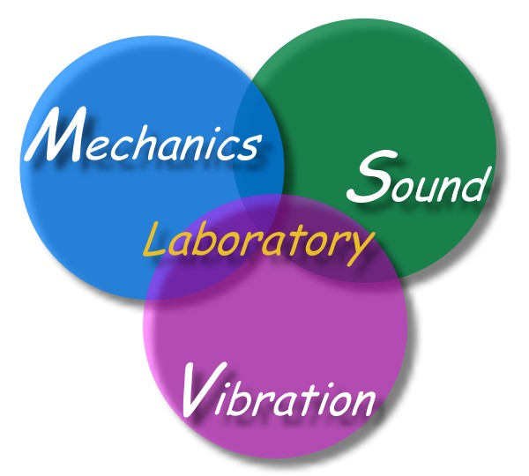

edited by J T Chen, Feb.16, 2014 (Helmholtz problem by NTOU/MSV.doc)

