


Image Method by NTOU/MSV

1. J. T. Chen, H. C. Shieh, Y. T. Lee and J. W. Lee, 2011, Bipolar coordinates, image method and the method of fundamental solutions for Green’s functions of Laplace problems with circular boundaries, Engineering Analysis with Boundary Elements, Vol.35, pp.236-143.
2. J. T. Chen, H. G. Shieh, J. J. Tsai and J. W. Lee, 2010, A study on the method of fundamental solutions using the image concept, Appl. Math. Model., Vol.34, pp.4253-4266.
3. J. T. Chen, H. C. Hsieh, Y. T. Lee and J. W. Lee, 2010, Image solutions for boundary value problems without sources, Applied Mathematics and Computation, Vol.216, pp.1453-1468, 2010.
4. J. T. Chen, Y. T. Lee, K. H. Chou and J. W. Lee, 2010, Image location for screw dislocation, Boundary Value Problems, Vol.2010, Article ID 731741, 13 pages, 2010.
5. J. T. Chen, Y. T. Lee, S. R. Yu and S. C. Shieh, 2009, Equivalence between Trefftz method and method of fundamental solution for the annular Green’s function using the addition theorem and image concept, Engineering Analysis with Boundary Elements, Vol.33, pp.678-688.
6. J. T. Chen and C. S. Wu, 2006, Alternative derivations for the Poisson integral formula, Int. J. Math. Edu. Sci. Tech, Vol.37, No.2, pp.165-185.

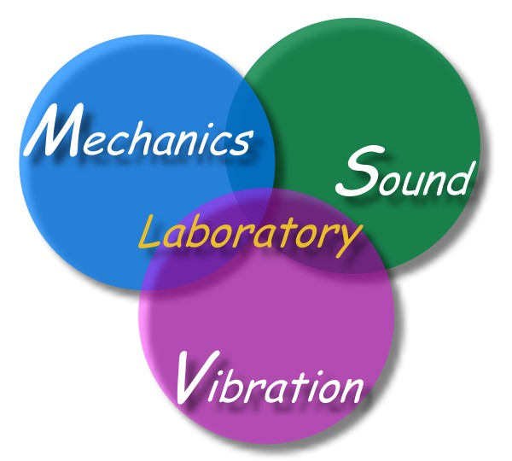

Edited by Chen J T, Jan.27, 2011

