Null-field integral equation approach for structure problems with circular boundaries
Jeng-Tzong Chen¹ Ying-Te Lee² Wei-Ming Lee³ I-Lin Chen⁴
¹Life-time Distinguished Professor, Department of Harbor and River Engineering
²Ph.D. Candidate, Department of Harbor and River Engineering
National Taiwan Ocean University, Keelung
³Associate Professor, Department of Mechanical Engineering
China Institute of Technology, Taipei
⁴Associate Professor, Department of Naval Architecture
National Kaohsiung Marine University, Kaohsiung
Abstract
In this paper, null-field equation approach is developed to deal with the structural problems including multiple circular boundaries, e.g. holes or inclusions. The boundary integral approach is utilized in conjunction with degenerate kernel and Fourier series. To fully utilize the circular geometry, the fundamental solutions and the boundary densities are expanded by using degenerate kernels and Fourier series, respectively. Both direct and indirect formulations are proposed. This approach is a semi-analytical approach, since the error stems from the truncation of Fourier series in the implementation. The unknown Fourier coefficients are easily determined by solving a linear algebraic system after using the collocation method and matching the boundary conditions. Five goals: (1) free of calculating principal value, (2) exponential convergence, (3) well-posed algebraic system, (4) elimination of boundary-layer effect and (5) meshless model, of the formulation are achieved. Finally, the general-purpose program in a unified manner is developed for structure problems with circular boundaries including the torsion bar, plate vibration and elasticity problems.
Keywords: null-field integral equation approach, degenerate kernel, Fourier series, torsion, plate vibration, elasticity
摘要
本文使用零場積分方程配合退化核與傅立業級數來處理含多圓洞與夾雜結構問題。為了充分利用圓形的幾何特性，我們將基本解與邊界密度函數分別以退化核與傅立業級數展開。除了直接法外，我們也會使用間接法來求解。由於誤差來自於傅立業級數的項數擷取多寡，故此套方法可被視為是一套半解析法。我們藉由佈點法可建構出一線性代數系統並進而求得未知的傅立業係數。本法將達成五個預期目標: (1) 毋須計算主值問題，(2)指數收歛特性，(3)良態代數系統的建構，(4)邊界層效應的消除與(5)無網格模式。最後，我們將發展一套廣用程式來處理含圓型邊界的扭轉、薄板振動與彈力問題。
關鍵字: 零場積分方程法，退化核函數，傅立業級數，扭轉問題，薄板振動，彈性力學

Introduction
Unlike the conventional BEM and BIEM, Waterman [1] introduced first the so-called T-matrix method for electromagnetic scattering problems. Various names, null-field approach or extended boundary condition method (EBCM), have been coined. The null-field approach or T-matrix method was used widely for obtaining numerical solutions of acoustics [2], elastodynamics [3] and hydrodynamics [4]. Boström [5] introduced a new method of treating the scattering of transient fields by a bounded obstacle in the three-dimensional space. He defined new sets of time-dependent basis functions, and use of these to expand the free space Green’s function and the incoming and scattered fields. The method is a generalization to the time domain of the null-field approach first given by Waterman [1]. A crucial advantage of the null-field approach or T-matrix method consists in the fact that the influence matrix can be computed easily. Although many works for acoustic, elastodynamic and hydrodynamic problems have been done, only a few articles on elastostatics can be found [6]. The idea of changing the singularity distribution from real boundary to fictitious boundary (fictitious BEM) or putting the observation point outside the domain (null-field approach) can remove the singular and hypersingular integrals. However, they may result in an ill-posed matrix.
In the Fredholm integral equations, the degenerate kernel (or so-called separate kernel) plays an important role. However, its applications in practical problems seem to have taken a back seat to other methods. This degenerate kernel can be seen as one kind of approximation for fundamental solution, i.e., the kernel function is expressed as finite sums of products by two linearly independent functions. The concept of generating “optimal” degenerate kernels has been proposed by Sloan et al. [7]. They also proved it to be equivalent to the iterated Petrov-Galerkin approximation. Later, Kress [8] proved that the integral equations of the second kind in conjunction with degenerate kernels have the convergence rate of exponential order instead of the linear algebraic order of conventional BEM.
Recently, meshless methods [9] become very popular, since it is free of mesh generation and only nodes are needed. The present formulation can be seen as one kind of meshless methods, since it belongs to the boundary collocation method. Mogilevskaya and Crouch [10] have solved the problem of an infinite plane containing arbitrary number of circular inclusions based on the complex singular integral equation. Later, they [11] utilized Somigliana's formula and Fourier series for elasticity problems with circular boundaries. In their analysis procedure, the unknown tractions are approximated by using the complex Fourier series. However, for calculating an integral over a circular boundary, they didn’t expand the fundamental solution to degenerate kernel using the polar coordinate of local system. By moving the null-field point exactly on the real boundary, the boundary integral can be easily determined using series sums in our formulation due to the introduction of degenerate kernels. Mogilevskaya and Crouch [10] have used the Galerkin method instead of collocation approach. Free of worrying how to choose the collocation points, uniform collocation along the circular boundary yields a well-conditioned matrix [11]. On the other hand, Bird and Steele [12] have also used separated solution procedure for bending of circular plates with circular holes in a similar way of the Trefftz method by using the addition theorem. Recently, Chen and his coworkers [13] have utilized the null-field integral equations in conjunction with the degenerate kernel and Fourier series to solve the torsion problem of a circular bar including multiple circular holes. Following the success of [13], we extend to solve the stress of torsion problems, plate vibration and elasticity with multiple circular holes.
In this paper, the null-field integral equation is utilized to solve the structure problems of a circular bar with circular boundaries. The mathematical tools, the degenerate kernel for the fundamental solution and Fourier series for the boundary density, are utilized in the null-field integral formulation. By collocating the null-field point exactly on the real boundary and matching the boundary condition, the linear algebraic system is obtained and the unknown Fourier coefficients can be easily determined. Finally, three numerical examples for torsion, plate vibration and elasticity problems are given to show the validity and efficiency of our formulation.
Method of solution
Problem statements
Suppose there are H randomly distributed circular cavities and/or inclusions bounded in the domain and enclosed with the boundary, $B_{k}$ ($k=0, 1, 2, ⋯, H$),
$$B=\underset{k=0}{\overset{H}{}}B_{k}$$ | (1)
as shown in Figure 1. The medium and inclusions are considered as an isotropic, elastic and homogenous body. The governing equation is
$u(x)=0, x∈Ω$, | (2)
where $u(x)$ is the potential function, $Ω$ is the domain of interest and $$ denotes the operator and the corresponding problems are shown below
$$u(x)=\left\{\begin{matrix}∇^{2}u(x) : \text{Laplace} \text{problem,} \\ (∇^{4}−ζ^{4})u(x) : \text{BiHelmholtz} \text{problem,} \\ (λ+G)∇(∇⋅\underset{\text{\sim }}{u}(x))+G∇^{2}\underset{\text{\sim }}{u}(x) : \text{Elasticity} \text{problem,} \end{matrix}\right.$$ | (3)
where $∇^{2}$ is Laplacian operator, $∇^{4}$ is biharmonic operator, $ζ$ is the frequency parameter, $ζ^{4}=\frac{ω^{2}ρ_{0}h}{D}$, $ω$ is the circular frequency, $ρ_{0}$ is the surface density, D is the flexural rigidity expressed as $D=\frac{{\text{Eh}}^{3}}{\text{12}(1−ν)}$ in terms of Young’s modulus E, the Poisson ration $ν$, and the plate thickness h, and $λ$ and G are the Lamé constants.
Dual integral equations - conventional version
Based on the dual boundary integral formulation for the domain point can be derived form the third Green’s identity, we have
$2πu(x)=\int{T(s,x)u(s) }\text{dB}(s)−\int{U(s,x)t(s)} \text{dB}(s), x∈Ω$, | (4)
$2π\frac{∂u(x)}{∂n_{x}}=\int{T(s,x)u(s) }\text{dB}(s)−\int{U(s,x)t(s)} \text{dB}(s), x∈Ω$, | (5)
where s and x are the source and field points, respectively, B is the boundary, n_{x} denotes the outward normal vector at field point x, and the kernel function U(s,x) is the fundamental solution which satisfies
$$\left\{U(x,s)\right\}=δ(x−s),$$ | (6)
in which $δ(x−s)$ denotes the Dirac-delta function. The other kernel functions,
$T(s,x)≡\frac{∂U(s,x)}{∂n_{s}}$, $L(s,x)≡\frac{∂U(s,x)}{∂n_{x}}$, $M(s,x)≡\frac{∂^{2}U(s,x)}{∂n_{s}∂n_{x}}$ | (7)
where n_{s} denotes the outward normal vector at the field point s. By moving the field point x to the boundary, the dual boundary integral equations for the boundary point can be obtained as follows:
$πu(x)=C\text{.}P\text{.}V\text{.}\int{T(s,x)u(s)}\text{dB}(s)−R\text{.}P\text{.}V\text{.}\int{U(s,x)t(s)}\text{dB}(s), x∈B$, | (8)
$π\frac{∂u(x)}{∂n_{x}}=H\text{.}P\text{.}V\text{.}\int{M(s,x)u(s)}\text{dB}(s)−C\text{.}P\text{.}V\text{.}\int{L(s,x)t(s)}\text{dB}(s), x∈B$, | (9)
where the R.P.V. is the Riemann principal value, C.P.V. is the Cauchy principal value and H.P.V. is the Hadamard (or called Mangler) principal value. The dual null-field integral equations are
$0=\int{T(s,x)u(s)}\text{dB}(s)−\int{U(s,x)t(s)}\text{dB}(s), x∈Ω^{c}$, | (10)
$0=\int{M(s,x)u(s)}\text{dB}(s)−\int{L(s,x)t(s)}\text{dB}(s), x∈Ω^{c}$, | (11)
when the field point x is moved to the complementary domain, and the superscript “c” denotes the complementary domain.
Dual integral equations - present version
By introducing the degenerate kernels, the collocation point can be located on the real boundary and it is without singularity. Therefore, the integral equations for the domain point and null-field integral equations are shown below:
$2πu(x)=\int{T(s,x)u(s) }\text{dB}(s)−\int{U(s,x)t(s)} \text{dB}(s), x∈Ω∪B$, | (12)
$2π\frac{∂u(x)}{∂n_{x}}=\int{M(s,x)u(s) }\text{dB}(s)−\int{L(s,x)t(s)} \text{dB}(s), x∈Ω∪B$, | (13)
and
$0=\int{T(s,x)u(s)}\text{dB}(s)−\int{U(s,x)t(s)}\text{dB}(s), x∈Ω^{c}∪B$, | (14)
$0=\int{M(s,x)u(s)}\text{dB}(s)−\int{L(s,x)t(s)}\text{dB}(s), x∈Ω^{c}∪B$. | (15)
Expansions of the fundamental solution and boundary density
The fundamental solutions above mentioned are
$$U(s,x)=\left\{\begin{matrix}\frac{1}{2π}\text{ln}r \text{for} \text{the} \text{Laplace} \text{problem} \\ \frac{i}{8λ^{2}}\left[Y_{0}(λr)+{\text{iJ}}_{0}(λr)+\frac{2}{π}(K_{0}(λr)+{\text{iI}}_{0}(λr))\right] \text{for} \text{the} \text{BiHelmholtz} \text{problem} \\ \frac{−1}{8πG(1−ν)}\left((3−4ν)δ_{ki}\text{ln}(r)−\frac{y_{i}y_{k}}{r^{2}}\right) \text{for} \text{the} \text{elasticity} \text{problem}\end{matrix}\right.$$ | (16)
where $r≡\left|s−x\right|$ is the distance between the source point and field point, $i^{2}=−1$ is the imaginary number, G is the shear modulus, $ν$ is the Poisson ratio, $y_{i}=s_{i}−x_{i}$ and for plane elasticity $i=1,2$ and $k=1,2$, J₀(kr) and Y₀(kr) are the zeroth-order of first kind and second Bessel functions, and I₀(kr) and K₀(kr) are the zeroth-order of first kind and second modified Bessel functions. To fully utilize the property of circular geometry, the mathematical tools, separate kernel (or called degenerate kernel) and Fourier series, are utilized to analytically study. By employing the separation technique for the source point and field point, the kernel function U(s, x) can be expanded in terms of degenerate (separable or of finite rank) kernel in a series form as shown below:
$U(s,x)=\left\{\begin{matrix}U^{I}(s,x)=\sum_{j=0}^{∞}{A_{j}(s)B_{j}(x),} \left|x\right|≤\left|s\right|, \\ U^{E}(s,x)=\sum_{j=0}^{∞}{A_{j}(x)B_{j}(s),} \left|x\right|>\left|s\right|,\end{matrix}\right.$. | (17)
where the superscripts “I” and “E” denote the interior and exterior cases, respectively. The other kernels in the boundary integral equation can be obtained by utilizing the operators of Eqs.(7)-(9) with respect to the kernel U(s, x). When the degenerate kernel was used, we shall assume that each of the sets {A_{j}}, {B_{j}} is linear linearly independent. In the computation, the degenerate kernel can be expressed as finite sums of products of functions of s alone by functions of x alone. The detail of degenerate kernels for Laplace, Helmholtz and elasticity problem can be found in [13-15].
We apply the Fourier series expansion to approximate the boundary potential (u(s)) and its normal derivative (t(s)) as shown in
$$u(s)=a_{0}+\sum_{n=1}^{∞}{a_{n}\text{cos}nθ+b_{n}\text{sin}nθ}, s∈B,$$ | (18)
$$t(s)=p_{0}+\sum_{n=1}^{∞}{p_{n}\text{cos}nθ+q_{n}\text{cos}nθ}, s∈B,$$ | (19)
where $a_{n}$, $b_{n}$, $p_{n}$ and $q_{n}$ (n=0,1,2,…) are the Fourier coefficients and $θ$ is the polar angle. In the real computation, the integrations can be easily calculated by employing the orthogonal property of Fourier series and only the finite M number of terms is used in the summation. The present method can be treated as one kind of semi-analytical method since error only attributes to the truncation of Fourier series. The flowchart of the present approach is shown in Figure 2.
Illustrative examples
Example 1: The stress of a circular bar with one circular hole
The stress analysis has been done by Ling [16]. The corresponding parameters are shown in Figure 3. The stresses along the inner and outer boundaries for $λ=0\text{.}3$ and $p=0\text{.}4$ are shown in Table 1. It is found that the errors are less than two percents. The stresses on the x axis in the domain are shown in Table 2. The results are very close to the Ling’s analytical results obtained by using the bipolar coordinate system.
Example 2: A circular plate with two holes
In order to demonstrate the generality of the present method, a circular plate with two holes is considered as shown in Figure 4. The radii of holes are 0.25m and 0.15m and the coordinates of the center are (0.5,0) and (-0.4,-0.3), respectively, in the coordinate system with origin at the center of outer circle. The former five natural frequency parameters using different numbers of terms of Fourier series (M) is shown in Figure 5. Owning to the complex configuration, the fewer terms of Fourier series (M=1 or 2) can not approach the second and higher natural frequencies of parameters well. Figure 6 shows the minimum singular value of the influence matrix versus the frequency parameter where the number of Fourier series terms M is taken as 7. Figure 7 shows the former five natural frequency parameters and modes of FEM using ABAQUS and the present method. Good agreement between the results of the present method and those of ABAQUS is obtained.
Example 3: An infinite plate with a circular hole subject to remote tension
In this example, the classical problem, stress concentration factor problem, in the Timoshenko and Goodier’s book [17] is revisited. An infinite plate with a circular hole subject to remote tension is shown in Figure 8. The medium is considered as an isotropic, elastic and homogeneous body. The radius of the hole is . The problem can be decomposed into two parts by using the superposition technique as shown in Figures 9(a) and 9(b). One is an infinite plate subject to a uniform tension and another is an infinite plate with a hole. On the boundary of the hole, it needs to satisfy the boundary conditions of free traction, and , for the superposing total solution. By using the present approach, the deformations of an infinite plate with a hole are
$u_{1}^{h}(x)=\frac{(1−ν)S}{G}\frac{a^{2}}{ρ}\text{cos}φ+\frac{S}{4G}\frac{a^{2}}{ρ}\left(1−\frac{a^{2}}{ρ^{2}}\right)\text{cos}3φ,$ $u_{2}^{h}(x)=−\frac{(1−2ν)S}{2G}\frac{a^{2}}{ρ}\text{sin}φ+\frac{S}{4G}\frac{a^{2}}{ρ}\left(1−\frac{a^{2}}{ρ^{2}}\right)\text{sin}3φ$ | (20)
and the representations of deformation of free field are
$u_{1}^{∞}(x)=\frac{(1−ν)Sρ}{2G}\text{cos}φ+b_{1,1}^{∞}\frac{ρ}{b}\text{sin}φ,$ $u_{2}^{∞}(x)=−\frac{νSρ}{2G}\text{sin}φ−b_{1,1}^{∞}\frac{ρ}{b}\text{cos}φ$ | (21)
Although there is a free coefficient (), it can be neglected for the near field since the outer radius b is infinity. Based on the displacement fields, the stresses are easily obtained as
, | (22)
When , Eq. (22) is reduced to
, | (23)
The hoop stress distribution in Eq.(45) is the same as that of Timoshenko and Goodier’s book [17]. When or , the hoop stress () reaches the maximum of .
Conclusions
The structure problems with circular boundaries have been successfully solved by using the present formulation. Our solutions match well with the exact solution and other solutions by using the integral formulation. Five gains of our approach, (1) free of calculating principal value, (2) exponential convergence, (3) free of boundary-layer effect, (4) meshless method and (5) well-posed model, were obtained. Besides, the BIEs for the domain point or the null-field equation in our formulation can both be employed by exactly collocating the point on the real boundary thanks to the introduction of the degenerate kernels.
References
- Waterman, P.C., “Matrix formulation of electromagnetic scattering,” Proceedings of the IEEE, Vol. 53, pp. 805-812 (1965).
- Bates, R.H.T., “Modal expansions for electromagnetic scattering from perfectly conducting cylinders of arbitrary cross-section,” Proceedings of the Institution of Electrical Engineers, Vol. 115, pp. 1443-1445 (1968).
- Waterman, P.C., “Matrix theory of elastic wave scattering,” The Journal of the Acoustical Society of America, Vol. 60, pp. 567-580 (1976).
- Martin, P.A., “On the null-field equations for water-wave radiation problems,” Journal of Fluid Mechanics, Vol. 113, pp. 315-332 (1981).
- Boström, A., “Time-dependent scattering by a bounded obstacle in three dimensions,” Journal of Mathematical Physics, Vol. 23, pp. 1444-1450 (1982).
- Olsson, P., “Elastostatics as a limit of elastodynamics – a matrix formulation,” Applied Scientific Research, Vol. 41, pp. 125-151 (1984).
- Kisu, H., and Kawahara, T., “Boundary element analysis system based on a formulation with relative quantity,” Boundary Elements X (Eds. Brebbia, C.A.), Springer-Verlag, pp. 111-121 (1988).
- Chen, J.T., and Hong, H.-K., “Dual boundary integral equations at a corner using contour approach around singularity,” Advances in Engineering Software, Vol. 21, pp. 169-178 (1994).
- Sladek, V., Sladek, J., and Tanaka, M., “Local integral equations and two meshless polynomial interpolations with application to potential problems in non-homogeneous media,” Computer Modeling in Engineering and Sciences, Vol. 7, pp. 69-84 (2005).
- Mogilevskaya, S.G., and Crouch, S.L., “A Galerkin boundary integral method for multiple circular elastic inclusions,” International Journal for Numerical Methods in Engineering, Vol. 52, pp. 1069-1106 (2001).
- Crouch, S.L., and Mogilevskaya, S.G., “On the use of Somigliana's formula and Fourier series for elasticity problems with circular boundaries,” International Journal for Numerical Methods in Engineering, Vol. 58, pp. 537-578 (2003).
- Bird, M.D., and Steele, C.R., “Separated solution procedure for bending of circular plates with circular holes,” Journal of Applied Mechanics, ASME, Vol. 59, pp. 398-404 (1991).
- Chen, J.T., Shen, W.C., and Chen, P.Y., “Analysis of circular torsion bar with circular holes using null-field approach,” Computer Modeling in Engineering and Sciences, Vol. 12, pp. 109-119 (2006).
- Chen, J.T., Chen, C.T., Chen, P.Y., and Chen, I.L., “A semi-analytical approach for radiation and scattering problems with circular boundaries,” Computer Methods in Applied Mechanics and Engineering, Vol. 196, pp. 2751-2764 (2007).
- Lee, Y.T., Chen, J.T., and Chou K.S., “Revisit of two classical elasticity problems by using the null-field BIE,” APCOM’07 in conjunction with EPMESC XI, Kyoto, Japan, 2007.
- Ling, C.B., “Torsion of a circular tube with longitudinal circular holes,” Quarterly of Applied Mathematics, Vol. 5, pp. 168-181 (1947).
- Timoshenko, S.P., and Goodier, J.N., “Theory of elasticity,” McGraw-Hill, New York (1970).

Table 1 $ξ_{z}$ on the boundaries
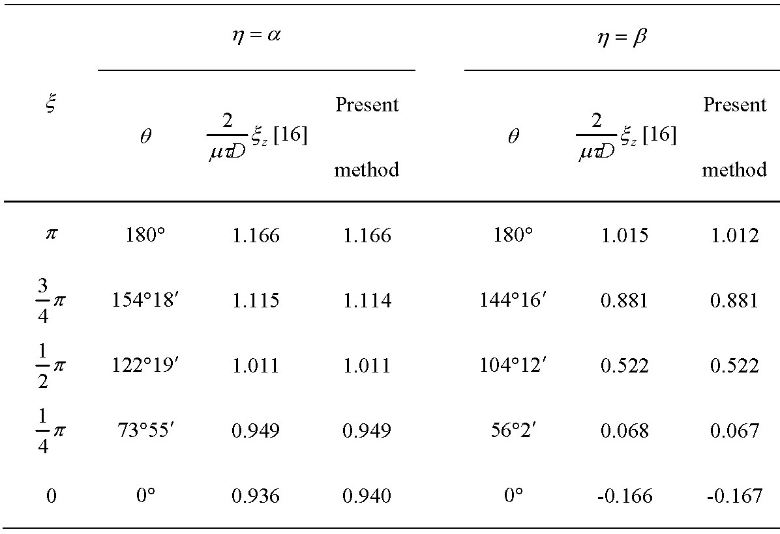
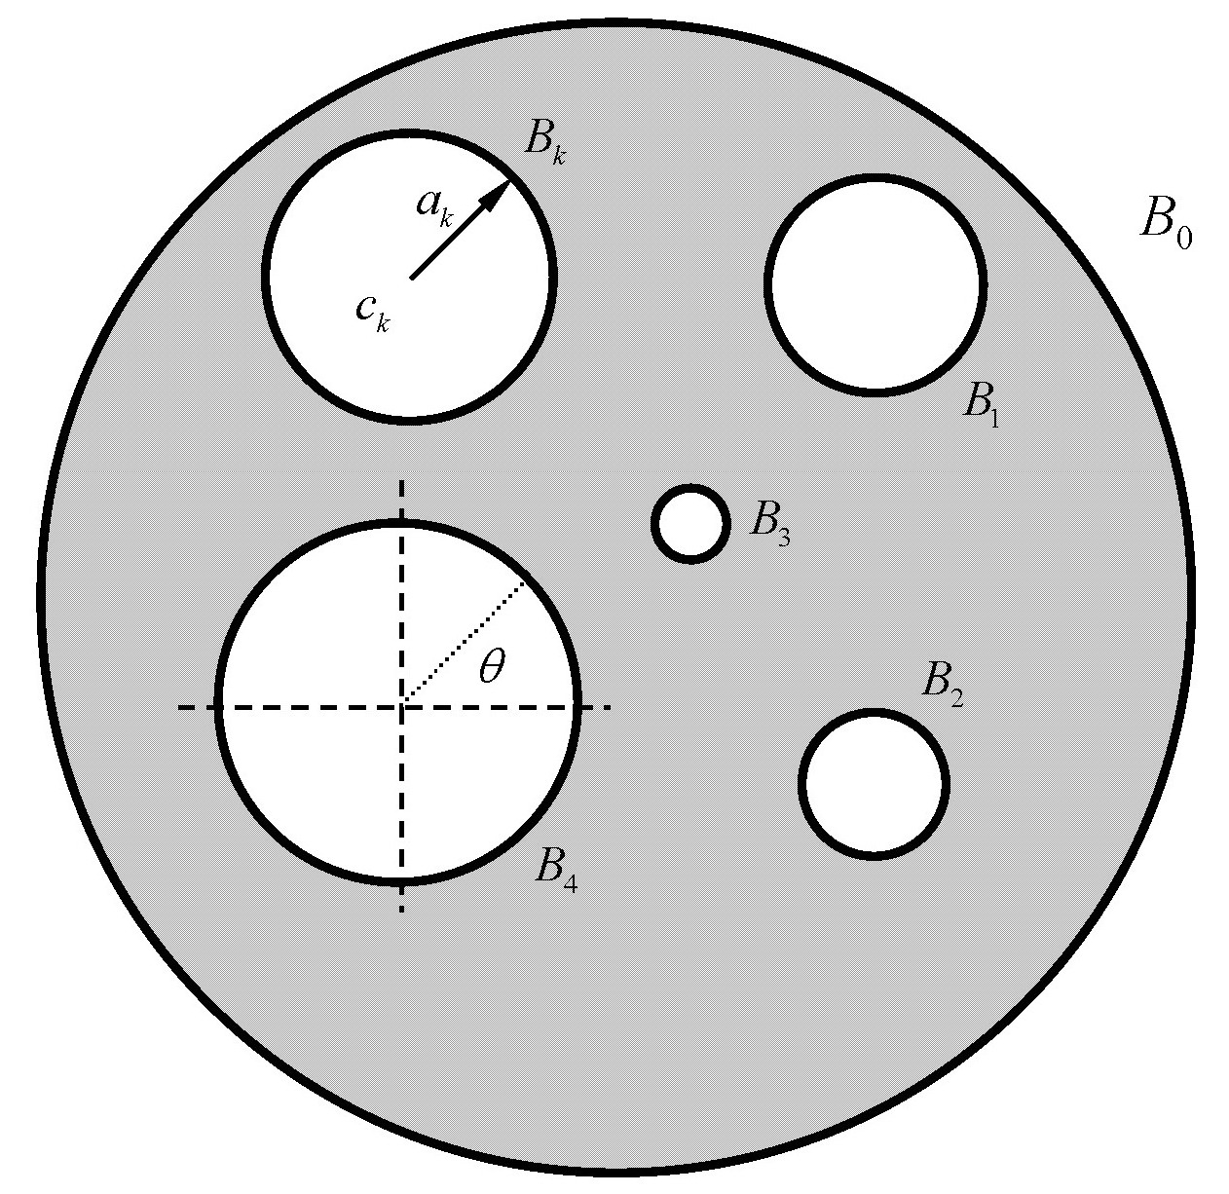
Figure 1 Problem statement
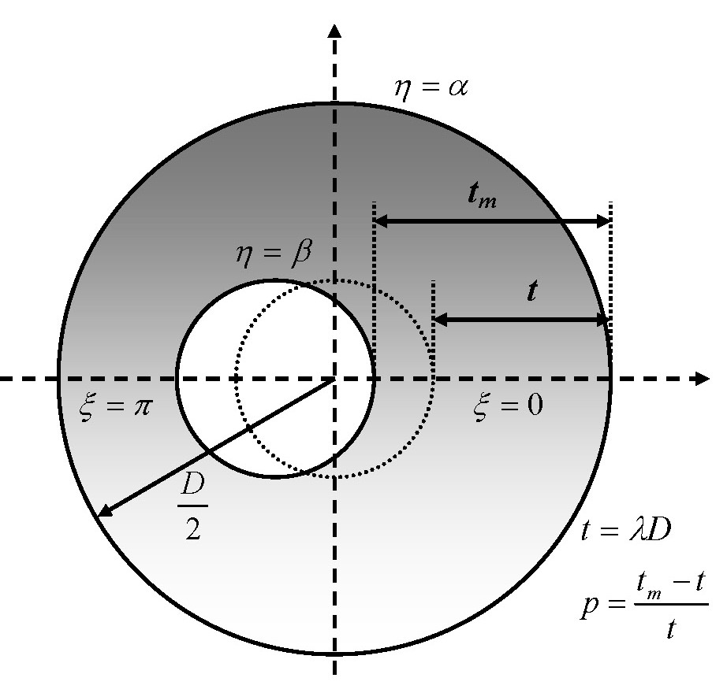
Figure 3 A circular bar with a hole
Table 2 $ξ_{z}$ along the line of $ξ=0$ and $π$
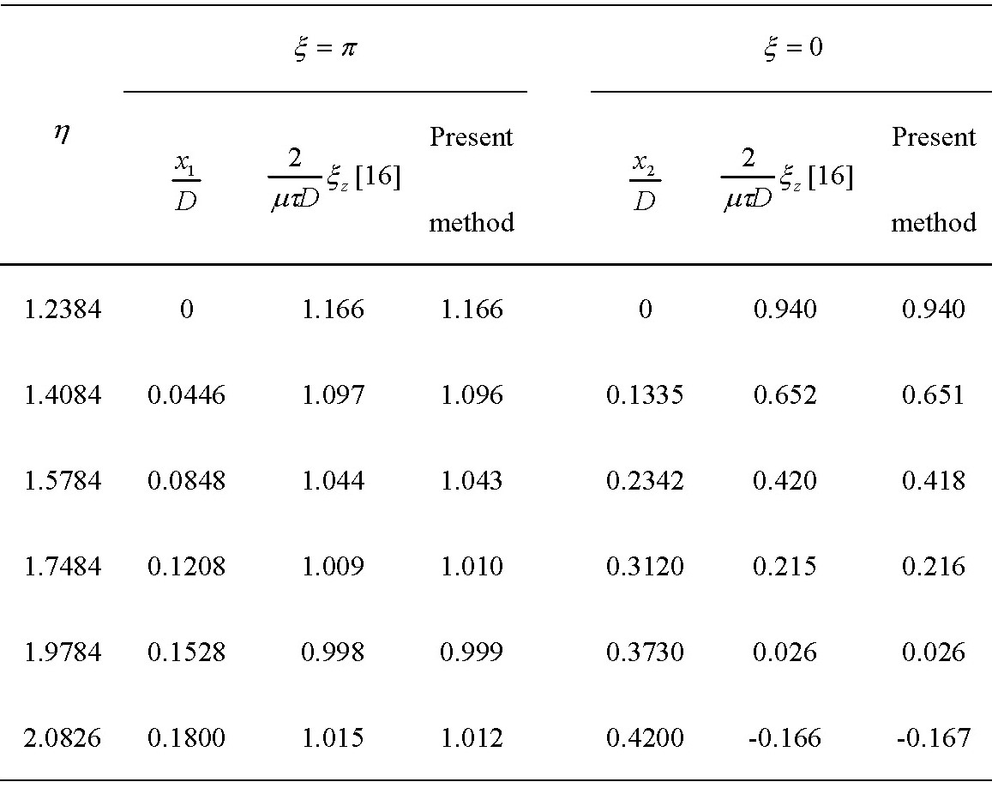

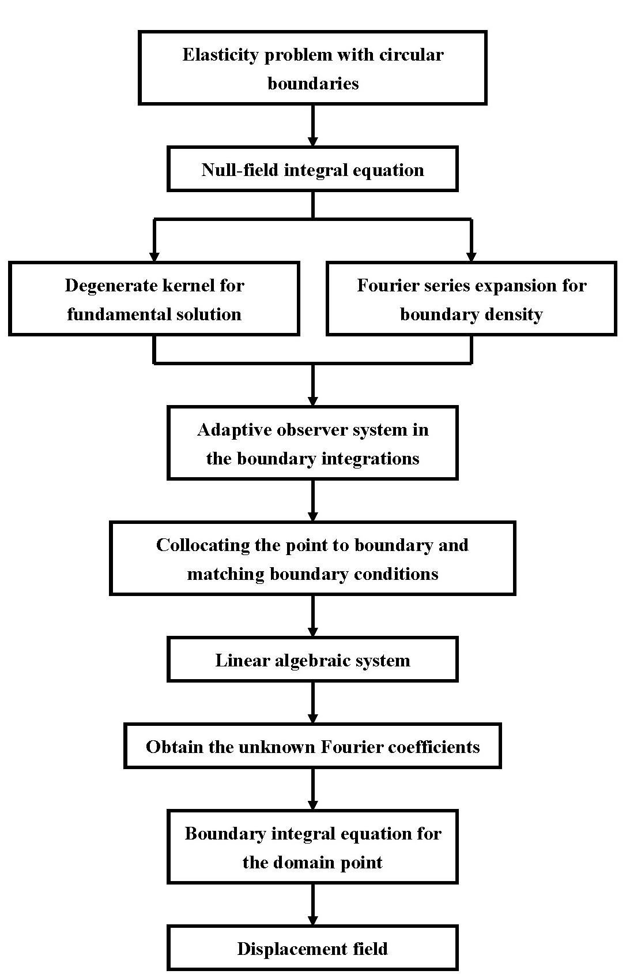
Figure 2 Flowchart of the present approach
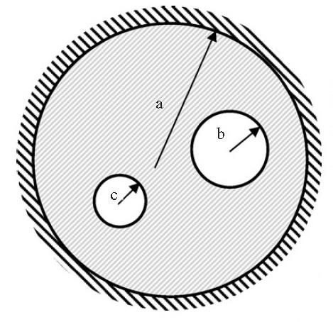
Figure 4 A circular plate with two circular holes in clamped-free boundary condition
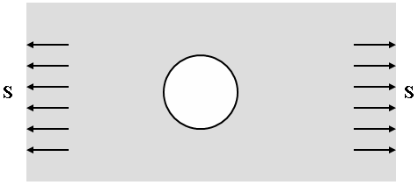
Figure 8 An infinite plate with a circular hole subject to remote tension
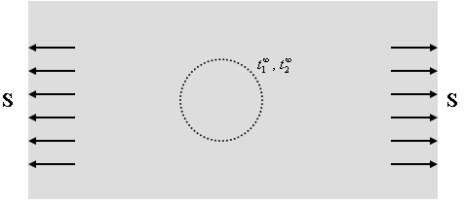
Figure 9(a) An infinite plate subject to a uniform tension
Figure 5 Natural frequency parameter versus terms of Fourier series
Figure 6 The minimum singular value versus the frequency parameter for a circular plate with two holes
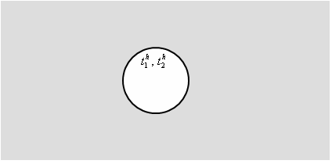
Figure 9(b) An infinite plate with a hole

Figure 7 The former five eigenvalues and eigenmodes of a circular plate with two holes

