

Degenerate Scale by NTOU/MSV
- J. T. Chen, J. H. Lin, S. R. Kuo and Y. P. Chiu, 2001, Analytical study and numerical experiments for degenerate scale problems in boundary element method using degenerate kernels and circulants, Engineering Analysis with Boundary Elements, Vol.25, No.9, pp.819-828. (SCI and EI) (NSC-89-2011-E-019-021)
- J. T. Chen, S. R. Kuo and J. H. Lin, 2002, Analytical study and numerical experiments for degenerate scale problems in the boundary element method for two-dimensional elasticity, Int. J. Numer. Meth. Engng., Vol.54, No.12, pp.1669-1681. (SCI and EI) (NSC-89-2011-E-019-021)
- J. T. Chen, C. F. Lee, I. L. Chen and J. H. Lin, 2002, An alternative method for degenerate scale problems in boundary element methods for the two-dimensional Laplace equation, Engineering Analysis with Boundary Elements, Vol.26, No.7, pp.559-569. (SCI and EI) (NSC-89-2011-E-019-021)
- J. T. Chen, W. C. Chen, S. R. Lin and I. L. Chen, 2003, Rigid body mode and spurious mode in the dual boundary element formulation for the Laplace equation, Computers and Structures, Vol.81, No.13, pp.1395-1404. (SCI and EI)
- J. T. Chen, S. R. Lin and K. H. Chen, 2005, Degenerate scale problem when solving Laplace equation by BEM and its treatment, Int. J. Numer. Meth. Engng., Vol.62, No.2, pp.233-261. (SCI and EI)
- J. T. Chen, C. S. Wu, K. H. Chen and Y. T. Lee, 2006, Degenerate scale for analysis of circular plate using the boundary integral equations and boundary element method, Computational Mechanics, Vol.38, pp.33-49 (SCI and EI)
- J. T. Chen and W. C. Shen, 2007, Degenerate scale for multiply connected Laplace problems, Mechanics Research Communications, Vol.34, pp.69-77. (SCI and EI)
- S. W. Chyuan, Y. S. Liao and J. T. Chen, 2008, Efficient Techniques for BEM Rank-deficiency Electrostatic Problems, Journal of Electrostatics, Vol.66, No.1-2, pp.8-15.
- J. T. Chen, Y. T. Lee, S. R. Kuo and Y. W. Chen, 2012, Analytical derivation and numerical experiments of degenerate scale for an ellipse in BEM, Engineering Analysis with Boundary Elements, Vol.36, pp.1397-1405.
- S. R. Kuo, J. T. Chen, J. W. Lee, and Y. W. Chen, 2013, Analytical derivation and numerical experiments of degenerate scale for regular N-gon domains in BEM, Applied Mathematics and Computation, Vol.219, pp.5668-5683.
- S. R. Kuo and J. T. Chen, 2013, Linkage between the unit logarithmic capacity in the theory of complex variables and the degenerate scale in the BEM/BIEMs, Applied Mathematics Letters, Vol.29, No.6, pp.929-938.
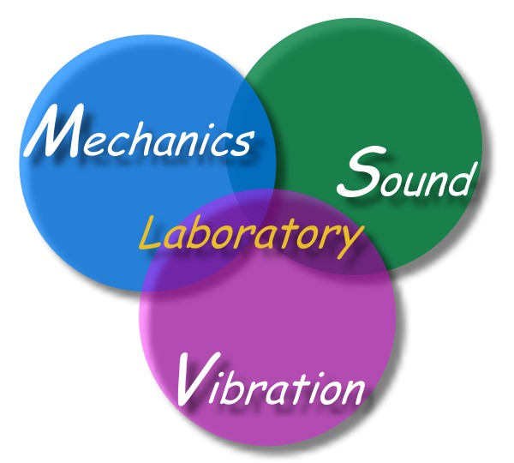
- J. T. Chen, H. D. Han, S. R. Kuo and S. K. Kao, 2013, Regularized methods for ill-conditioned system of the integral equations of the first kind, Inverse Problem in Science and Engineering, Accepted.

- I. L. Chen, S. R. Kuo, Y W Chen and J. T. Chen, 2013, Study of degenerate scale for a half-disc domain using the BEM and conformal mapping, Applied Mathematical Modelling, Revised.

