Autobiography of authors

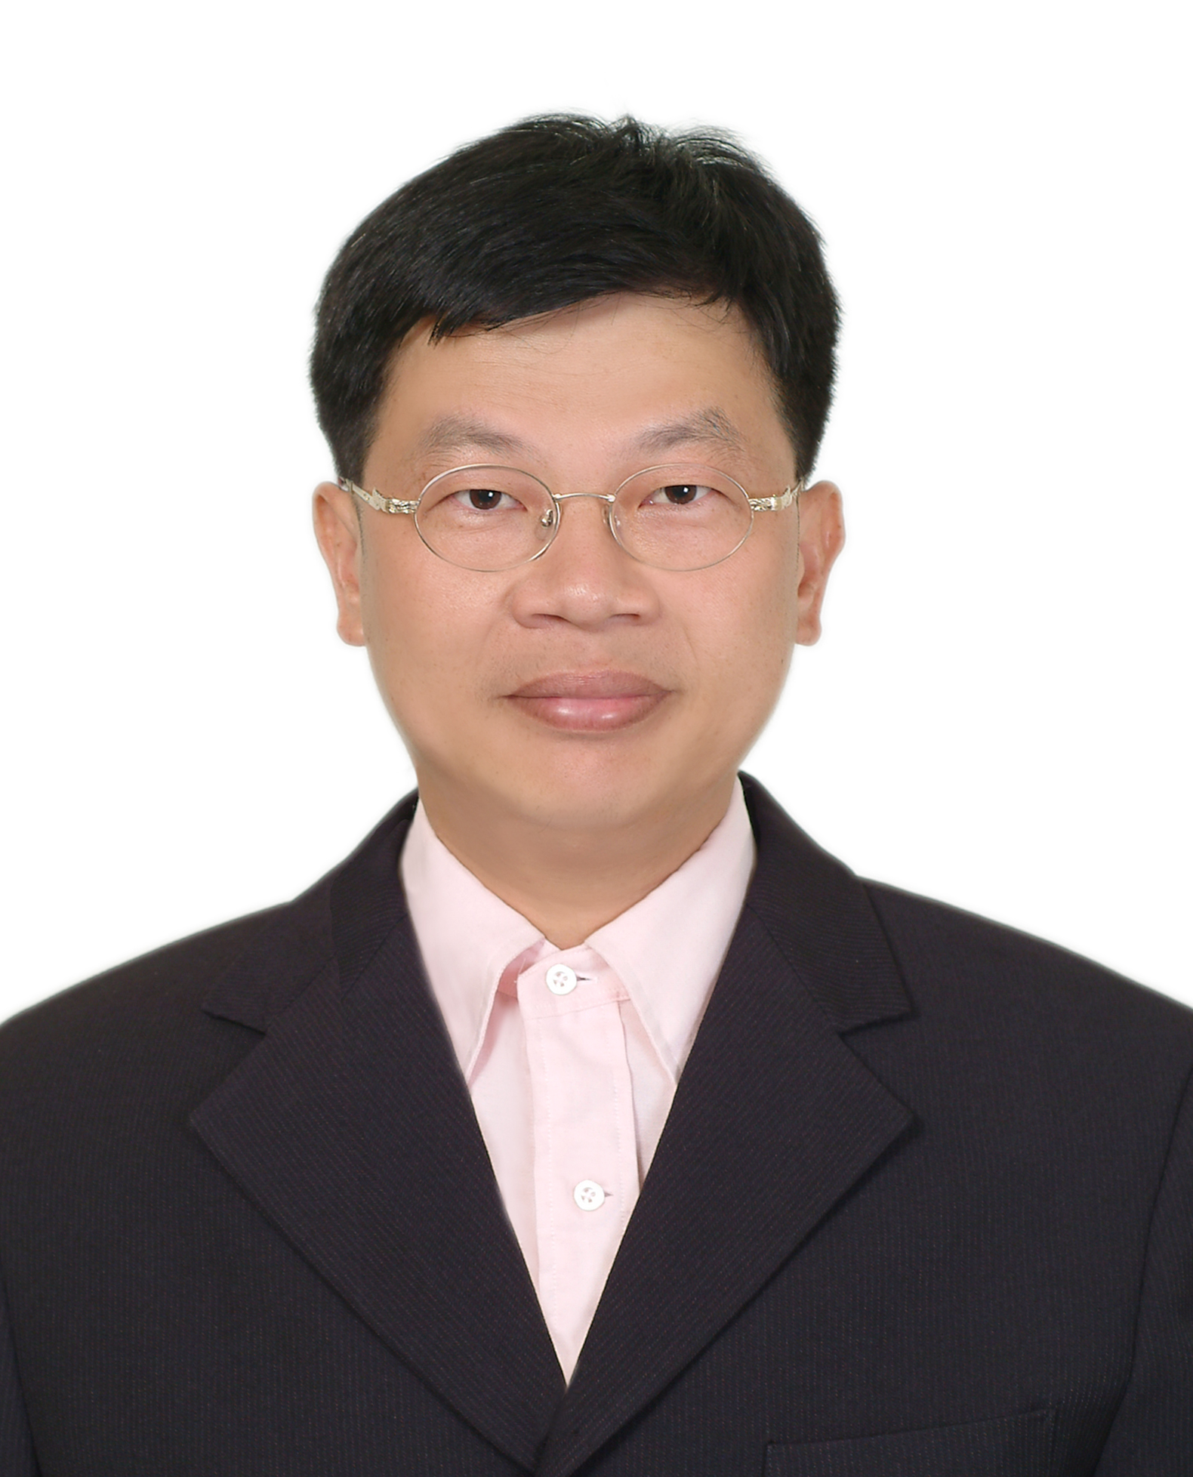
Jeng-Tzong Chen, born in 1962, received a BS degree in Civil Engineering, an M.S. in Applied Mechanics, and a Ph.D. in Civil Engineering, respectively, in 1984, 1986 and 1994, from National Taiwan University, Taipei, Taiwan, R.O.C. He had worked as a research assistant in the Structural Division of the Department of Rocket and Missile System, Chung Shan Institute of Science and Technology, from 1986 to 1990. In 1994, he was invited to be an Associate Professor in the Department of Harbor and River Engineering, National Taiwan Ocean University, Keelung, Taiwan, R.O.C. He was promoted to full professor in 1998. Later in 2004, he was selected to be the Distinguished Professor. In 2007, he was selected as the Life-time Distinguished Professor. His major interest is computational mechanics. He had derived the theory of dual integral equations for boundary value problems with degenerate boundary. Prof. Chen also developed four dual BEM programs for the BVPs of Laplace equation, Helmholtz equation, bi-Helmholtz and modified Helmhotlz equation and Navier equation. Recently, he also employed the null field integral equations to solve BVPs with circular boundaries. He wrote two books in Chinese on dual BEM and FEM using MSC/NASTRAN, respectively. He was ever invited to give plenaray and keynote lectures, e.g., twice in World Congress on Computational Mechanics (WCCM4 in Buenos Aries and WCCM5 in Vienna) and FEM/BEM 2003 in St. Petersburg, Russia. Also, he is the editor of Journal of the Chinese Institute of Civil and Hydraulic Engineering. He has been the Editor of Journal of Marine Science and Technology and the guest editor of J. Chinese Institute of Engineers. He won several times of Outstanding Research Awards from National Science Council, Taiwan. He also won the Wu, Ta-You Memorial Award in 2002. He is currently the member of editorial board of five international journals. Until now, he has published more than 120 SCI papers on BEM and FEM in technical Journals. Near 563 citings can be found. Boundary element method is one focus of Professor Chen's research interests. Others may be categorized into two areas. One is vibration and acoustics, and the other is computational mechanics.

E-mail: jtchen@mail.ntou.edu.tw
URL: http://ind.ntou.edu.tw/~msvlab
Autobiography2008-oct.doc

