Distinguished Chair Prof. J T Chen
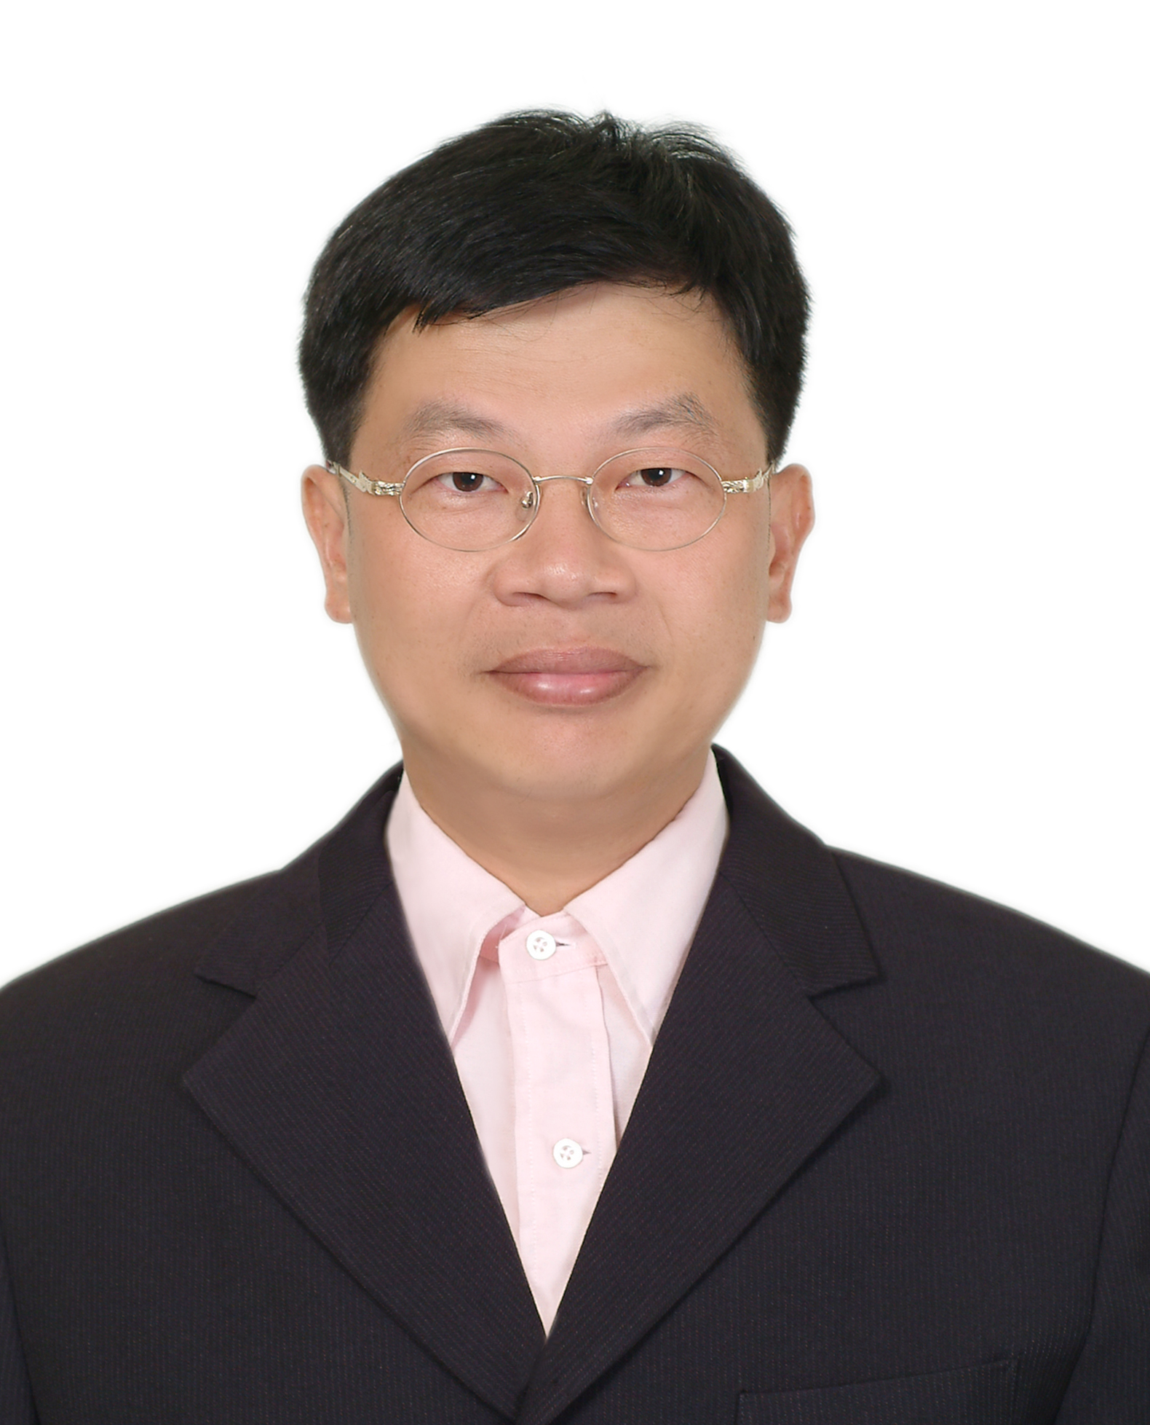
Jeng-Tzong Chen received a BS degree in Civil Engineering, an M.S. in Applied Mechanics, and a Ph.D. in Civil Engineering, respectively, in 1984, 1986 and 1994, from National Taiwan University, Taipei, Taiwan, R.O.C.

In 2023, he is
Distinguished Chair Professor Taiwan Ocean Univ.
Guset Prof. Taiwan Univ.
Jointly Appointed Prof. Cheng-Kung Univ.

Honor:
Du Q H Award (Mainland Chna)
Sun F D Award (Taiwan)
MOE Academic Award (Taiwan)
Outstanding Research Award (3 times, NSTC, Taiwan)
Fellow of IACAM, TwSIAM, STAM

He is now the associate editor of Journal of Mechanics (JOM), Journal of Chinese Institute of Engineers (JCIE), and Engineering Analysis with Boundary Elements (EABE). Besides, he has been the associate editor of the editor of Journal of Marine Science and Technology.

Until now, he has published more than 247 SCI journal papers on the BEM and the FEM in technical Journals. More than 5000 citings from 2500 papers are found to cite Chen’s work.
Two papers (ASME-AMR and ASCE-EMD) on the dual BEM were both cited 500 times.

E-mail:jtchen@mail.ntou.edu.tw
URL: http://ind.ntou.edu.tw/~msvlab Autobiography2023-18.doc

