Study on the rank deficiency in dual BEM using SVD
Jeng-Tzong CHEN*†, Ying-Te LEE#, Jia-Wei LEE#
*Dept. of Harbor and River Engineering & Dept. of Mechanical and Mechatronics Engineering, National Taiwan Ocean University, Keelung, Taiwan (jtchen@ntou.edu.tw)
#Dept. of Harbor and River Engineering, National Taiwan Ocean University, Keelung, Taiwan

It is well known that rank deficiency occurs in BEM for degenerate problems containing degenerate scale, degenerate boundary, spurious eigenvalue and fictitious frequency as shown in Figure 1. By employing the SVD technique with respect to the four influence matrices in the dual BEM, the degenerate mechanism can be studied in a unified manner. It is interesting to find that true information in physics due to rigid body mode and true eigensolution is found in the right unitary vector with respect to the corresponding zero singular value while the spurious information in mathematics due to degenerate boundary, degenerate scale, spurious mode and fictitious frequency is imbedded in the left unitary vector as shown in Figure 2. The SVD updating term is employed to extract the true information while SVD updating document is utilized to filter out the spurious information. Several examples including degenerate boundary, degenerate scale, spurious eigenvalue and fictitious frequency are demonstrated to see the unified formulation.
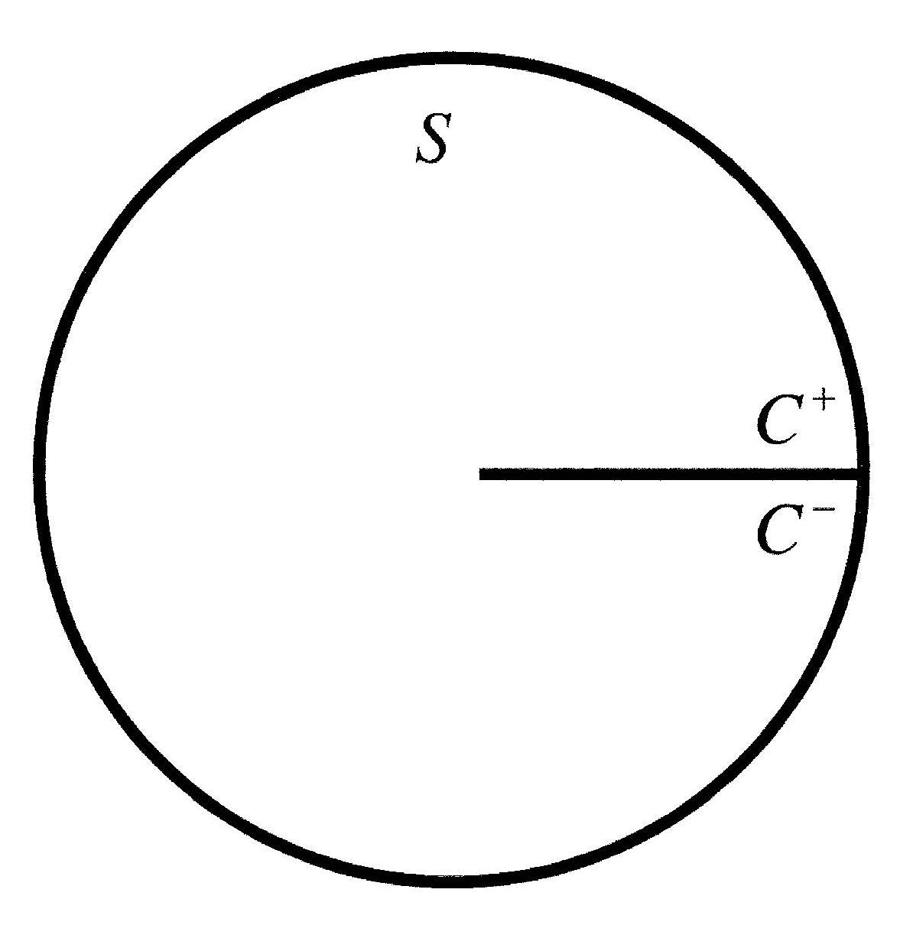 | 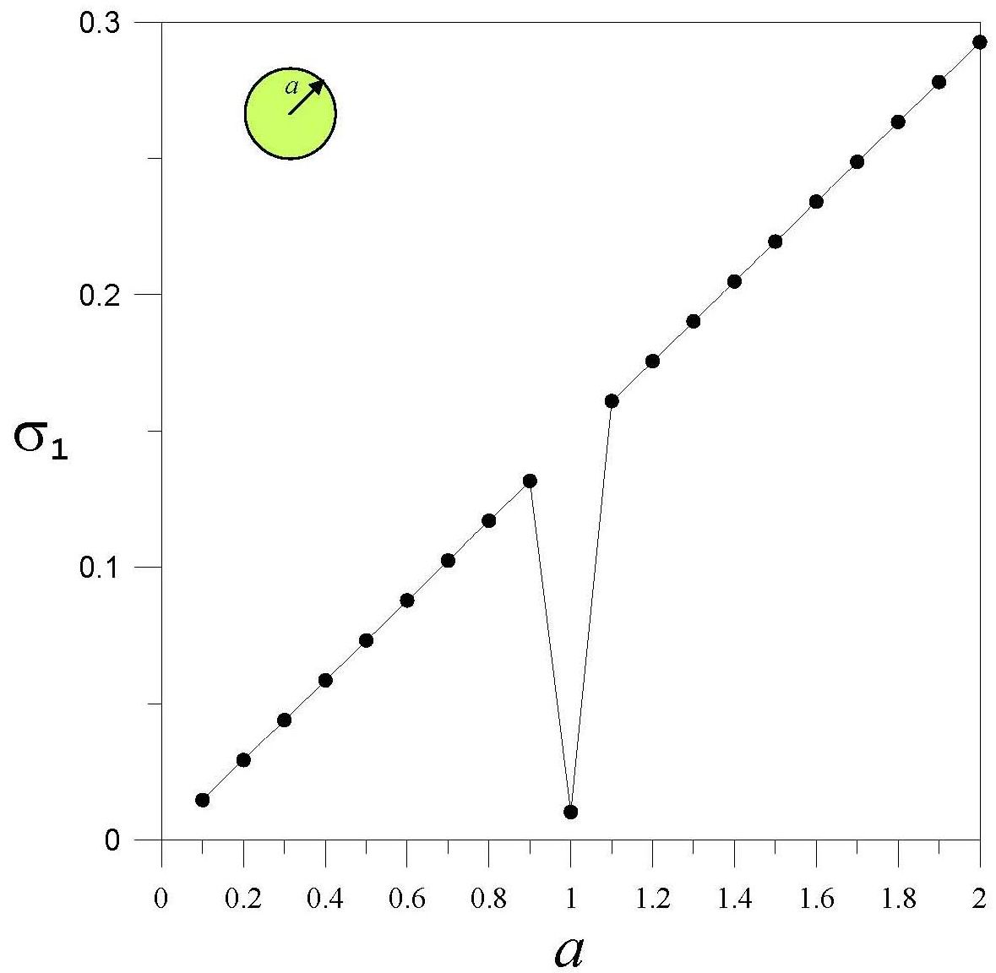
(a) Degenerate boundary | (b) Degenerate scale
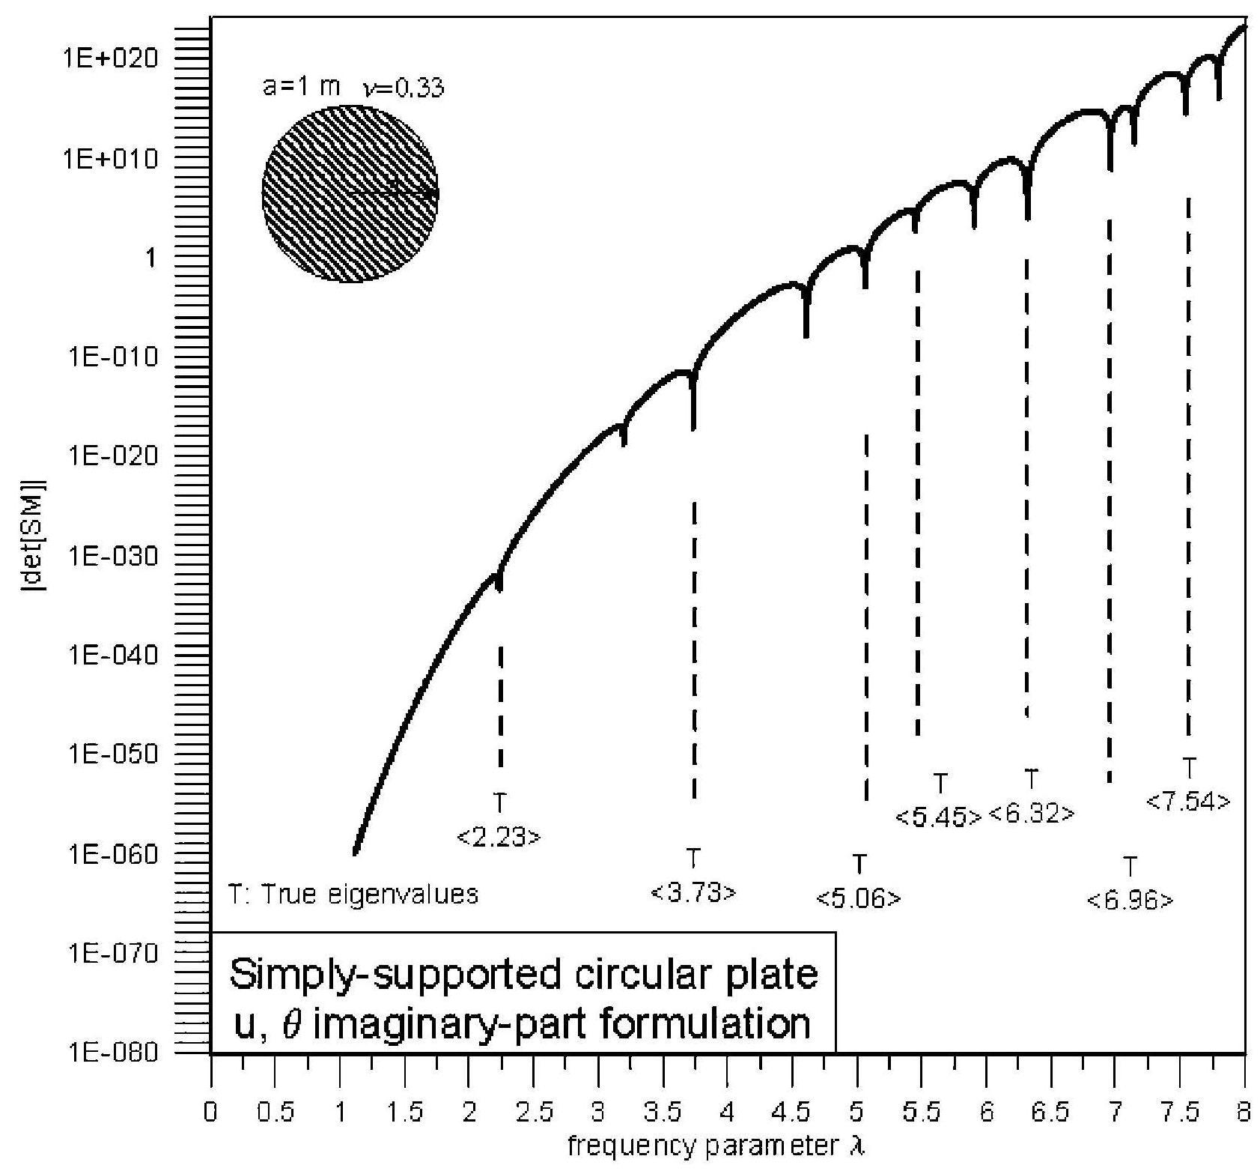 | 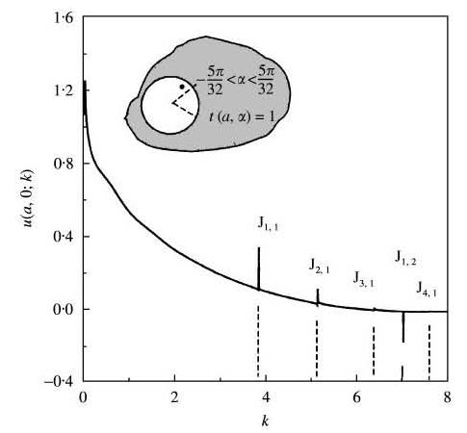
(c) Spurious mode | (d) Fictitious frequency
Figure 1: Degenerate mechanism in BEM

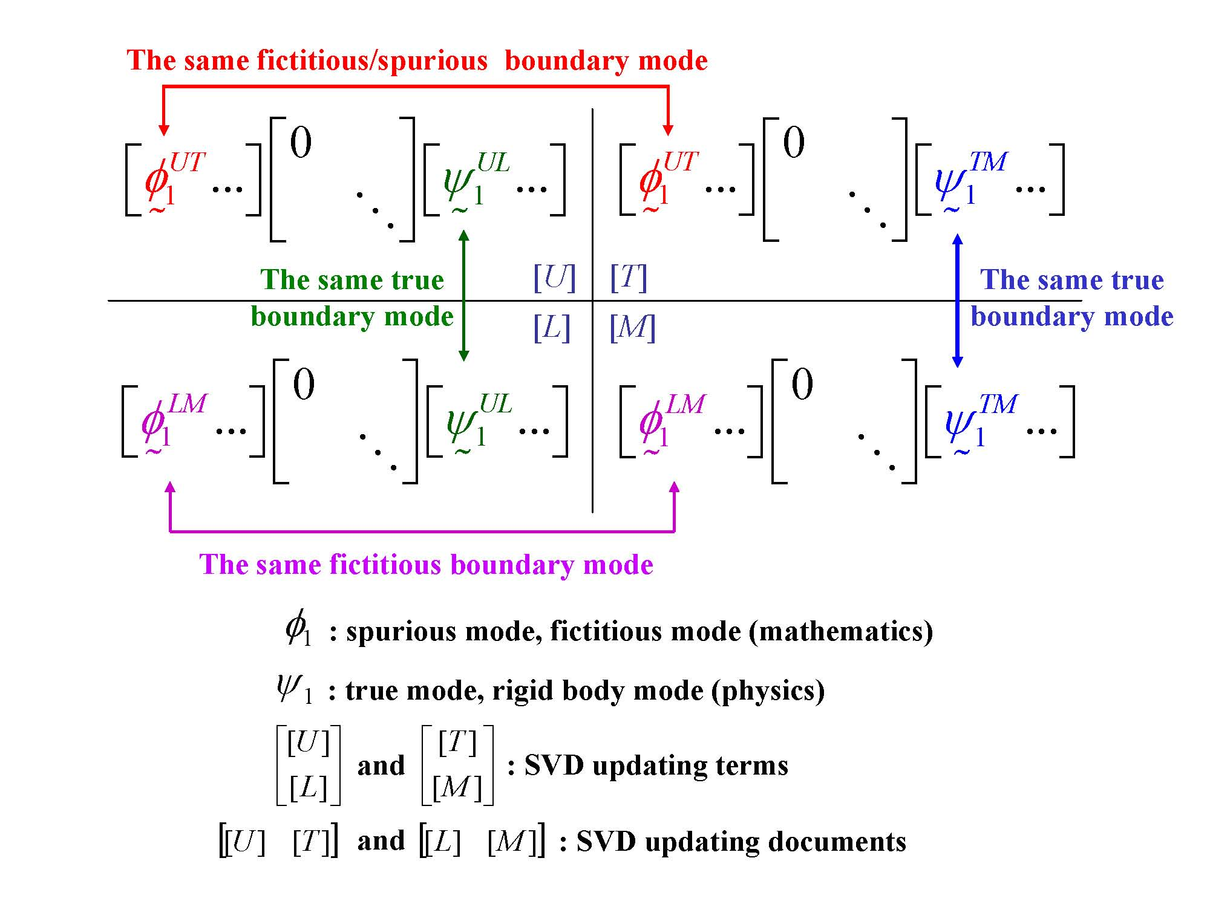
Figure 2: SVD structure for the four influence matrices in the dual BEM

References
- Hong H-K and Chen JT. Derivations of Integral Equations of Elasticity. ASCE, Journal of Engineering Mechanics 1988; 114 (6): 1028-1044.
- Chen JT and Hong H-K. Review of dual boundary element methods with emphasis on hypersingular integrals and divergent series. ASME, Applied Mechanics Reviews 1999; 52 (1): 17-33.
- Chen JT. On the rank-deficiency problems in boundary integral formulation using the Fredholm alternative theorem and singular value decomposition technique. In Fifth World Congress on Computational Mechanics. Keynote lecture, Vienna, Austria, July 07-12, 2002.
- Chen JT, Chen IL and Chen KH. Treatment of Rank-Deficiency in Acoustics Using SVD. Journal of Computational Acoustics 2006; 14 (2): 157-183.
- Chen JT, Lin SR and Chen KH. Degenerate scale problem when solving Laplace equation by BEM and its treatment. International Journal for Numerical Methods in Engineering 2005; 62 (2): 233-261.
- Chen IL, Chen JT and Liang MT. Analytical study and numerical experiments for radiation and scattering problems using the CHIEF method. Journal of Sound and Vibration 2001; 248 (5): 809-828.
- Chen IL, Chen JT, Kuo SR and Liang MT. A new method for true and spurious eigensolutions of arbitrary cavities using the CHEEF method. Journal of the Acoustical Society of America 2001; 109 (3): 982-999.

