行政院國家科學委員會補助國內專家學者出席國際學術會議報告
108年 10月 8日
附件三
報告人姓名 | 陳正宗 | 服務機關名稱（請註明系所）及職稱 | 國立臺灣海洋大學河海工程學系特聘講座教授
時間  會議地點 | 2019.09.27~2019.09.30  中國大連國際金融會議中心 | 本會核定  補助文號 | MOST  106-2221-E-019-009-MY3
會議  名稱 | (中文) 2019 第六屆亞太工程計算方法國際研討會  (英文) The 6th Asia-Pacific International Conference on Computational Methods in Engineering (ICOME2019)
發表論文  題目 | Paradox, paradise and parasite of the BEM/BIEM
- 參加會議經過
- 與會心得
- 與會相關照片
附錄一
附錄二
- 參加會議經過
本次會議為The 6th Asia-Pacific International Conference on Computational Methods in Engineering(ICOME 2019)，於中國大連國際金融會議中心舉行，由於此次會議與第12屆全國工程計算方法學術會議以及第2屆邊界元與降維方法學術會議一同舉辦，所以規模更勝以往。本研討會起源於1987年，由中日雙方聯合輪流舉辦的一個互訪會議；而到1993年開始改為泛太平洋計算工程會議，首次移師到韓國首爾舉行，並改成每兩年舉辦一次；直到2003年則改名為第一屆亞太工程計算方法國際研討會，由日本北海道大學的本間(Honma)教授主辦，爾後每三年舉辦一次迄今。分別在中國合肥(2006)，中國南京(2009)，而2012年，則移師到日本京都舉辦，由京都大學西村(Nishimura)教授負責承辦，並由本人、西村與姚振漢教授擔任大會共同主席。台灣組團參加，共有19人與會(科技部組團補助)，而大陸則是10名學者與會。上屆2015年則在中國杭州舉行，並與Trefftz/MFS 2015一同舉行，當時本人為共同主席，並與賽普勒斯(Cyprus)的Karageorghis教授、北京清華大學姚振漢教授、日本京都大學西村(Nishimura)教授、台灣大學劉進賢教授一同獲邀，進行大會演講。此研討會是以數值方法與工程應用為主，內容涵蓋範圍甚廣，也是近幾年來亞太地區邊界元素法的重大會議。今年本校組團出席此次研討會，一行7人分別為河工系郭世榮教授、范佳銘教授、李應德助理教授、3位研究生與本人，而台灣另有中華大學的李明恭教授，宜蘭大學土木系的吳清森助理教授與淡江大學李家瑋助理教授一同與會出席，期待於本次會議交流中能拓展國際學術交流之人脈與管道，本人於開幕時致詞，並於頒獎典禮時發表得獎感言(詳見附錄一、二)。
研討會首日(27日)，在簡單的開幕介紹後，隨後即進行大會演講。首先由大連理工大學的程耿東院士大會演講為此大會拉開序幕，接著由日本西村教授、本人、大陸姚振漢教授與美國程宏達教授接連演出。此次大會總共有20多場的大會演講。本人有幸獲邀進行大會演講，以「Paradox, paradise and parasite of the BEM/BIEM」為題進行交流。此研討會進行時，學者間高手過招，互有往來，交流熱烈，會後亦有學者持續進行討論，學術互動頻繁，好不熱鬧，隨著最後一位的大會演講結束，此次研討會也隨之落幕，期待2022年廈門的研討會再相會。在首日晚宴上頒發「杜慶華工程計算方法獎章(DU Qing-Hua Medal of Computational Method in Engineering 2019)」與「杜慶華工程計算方法優秀青年獎(DU Qing-Hua Young Researcher Award of Computational Method in Engineering 2019)」。杜慶華院士是1997年入選中國工程院院士，是中國應用力學的知名學者，對於力學的基礎教育上付出畢生心力，此獎項對於從事工程計算的研究學者而言，絕對是莫大的肯定。在杜慶華院士工程計算方法獎章的獎委員會票選之後，繼上屆2015年海大河工系范佳銘教授榮獲優秀青年獎，這次報告人有幸榮獲杜慶華工程計算方法獎章，與台灣團隊同喜的同時，亦希冀能夠學術傳承，代代皆有才人出，台灣計算力學在國際不會缺席。在研討會的最後一天(30日)，主辦單位安排與會學者導覽大連理工大學校史館與棒棰島，導覽的過程中，聆聽著解說人員細說有關大連理工的歷史典故。棒槌，是古代中國人洗衣服時用來打槌衣服的工具。50年代開始，眾多大陸領導人，包括周恩來、朱德、劉少奇、葉劍英、以至後來的華國鋒、胡耀邦、鄧小平和江澤民等，都先後來棒槌島住過，令棒槌島別墅區的名聲，一如山東青島的八大關，名人效應帶動地方景點。在棒棰島的漫步中不僅欣賞到了自然美景，也感受到了當時習金會的交流景象。
- 與會心得
此次會議是本人第5次出席ICOME系列研討會，今年會議在中國大連舉行，國立台灣海洋大學一行7人組團與會進行交流，希冀藉由此次機會為台灣學術界培育研究新進，並期待能藉此拓展國際人脈與學術交流管道。
此次研討會本人有幸獲邀，進行大會演講，本人以「Paradox, paradise and parasite of the BEM/BIEM」為題，將近年之學術發現和見解與國際學者分享。NTOU/MSV研究團隊成員，郭世榮教授、范佳銘教授與李應德教授，則分別以「Revisit of the degenerate scale for plate problems」、「Determining temperature distribution and heat source for materials with nonlinear heat conduction coefficients using Cauchy data」與「A nonsingular boundary collocation method for the inverse problems in elasticity」為題進行發表。所謂「上有天堂，下有蘇杭」，何其有幸，本人分別在2008年與2015年到蘇州(ICCES MM)與杭州(ICOME 2015)，人間天堂(paradise)，參加國際研討會。而今日雖在大連，所從事發表之研究─格林函數與基本解，其在邊界元素法固然是媒介帶來了許多好處，如是計算的天堂(paradise)，但也是核函數也是寄生蟲(parasite)。邊界元素法因他們而寄生了「退化尺度」的病態問題。「paradise」與「parasite」僅以兩字之差，卻有著截然不同的涵義，而此時此地，我都在研究領域碰上了。會中討論熱烈，諸多學者對於本團隊之研究相當重視並提出建議。浙江大學丁伯陽教授曾對我們的研究給予這樣的評價：『你們的研究與牛頓相反，牛頓是物理中找數學(自然的數學原理)，而你們團隊卻是數學中找物理(BEM中的退化尺度)』，利用分離核做為解析工具，探討現行邊界元素法的問題本質，並加以解決並作說明，是我們目前研究工作的最佳註解。
諸多良性交流與互動，及攜回的會議資料(大會論文與摘要與USB)，對本人日後研究方向與釐清問題本質等議題上皆會有所啟發，這也是吾輩參與國際研討會之初衷。最後感謝科技部經費補助與承辦單位─大連理工大學的熱情接待，讓本人能有此次豐富的學術交流之行。
- 與會相關照片
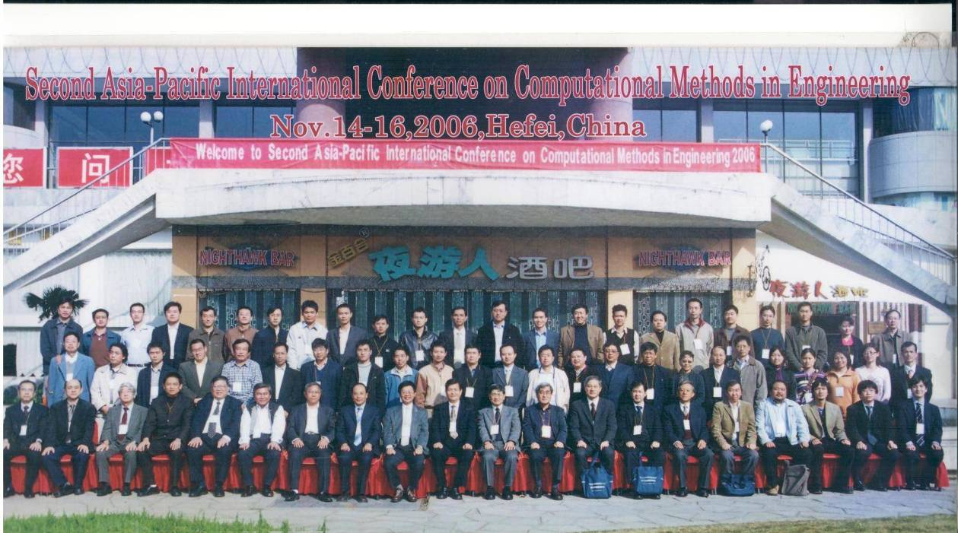
ICOME 2006 團體照(大陸合肥)

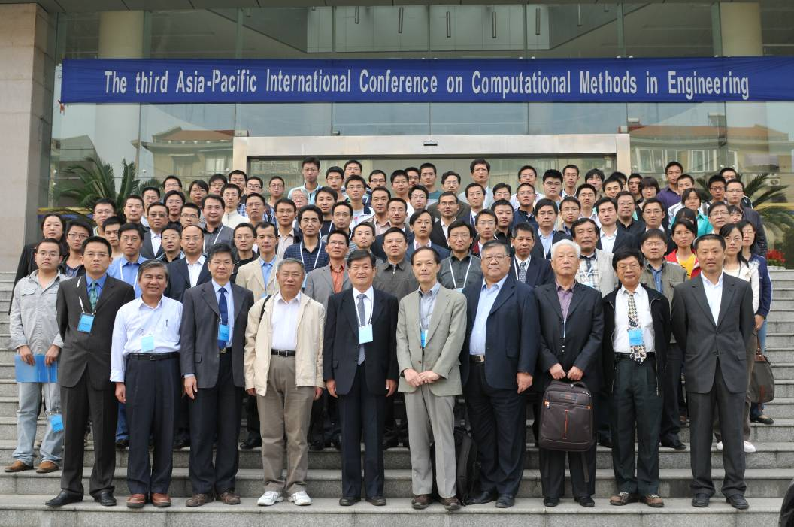
ICOME 2009 團體照(大陸南京)

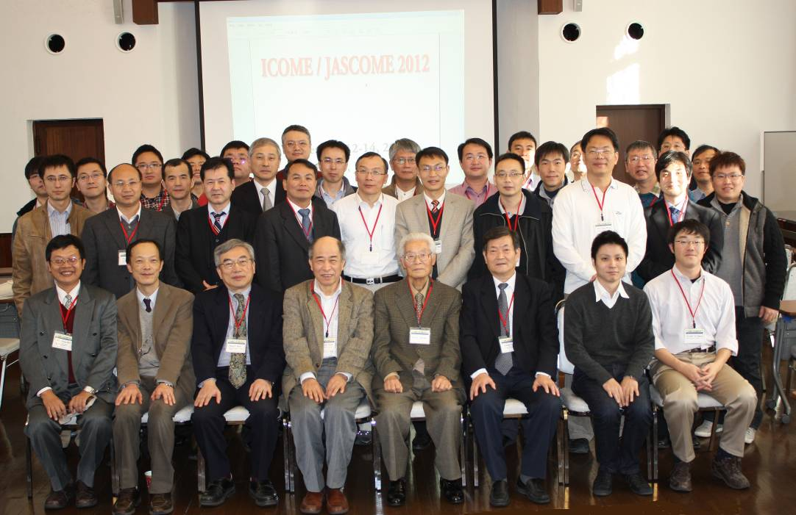
ICOME 2012 團體照(日本京都)
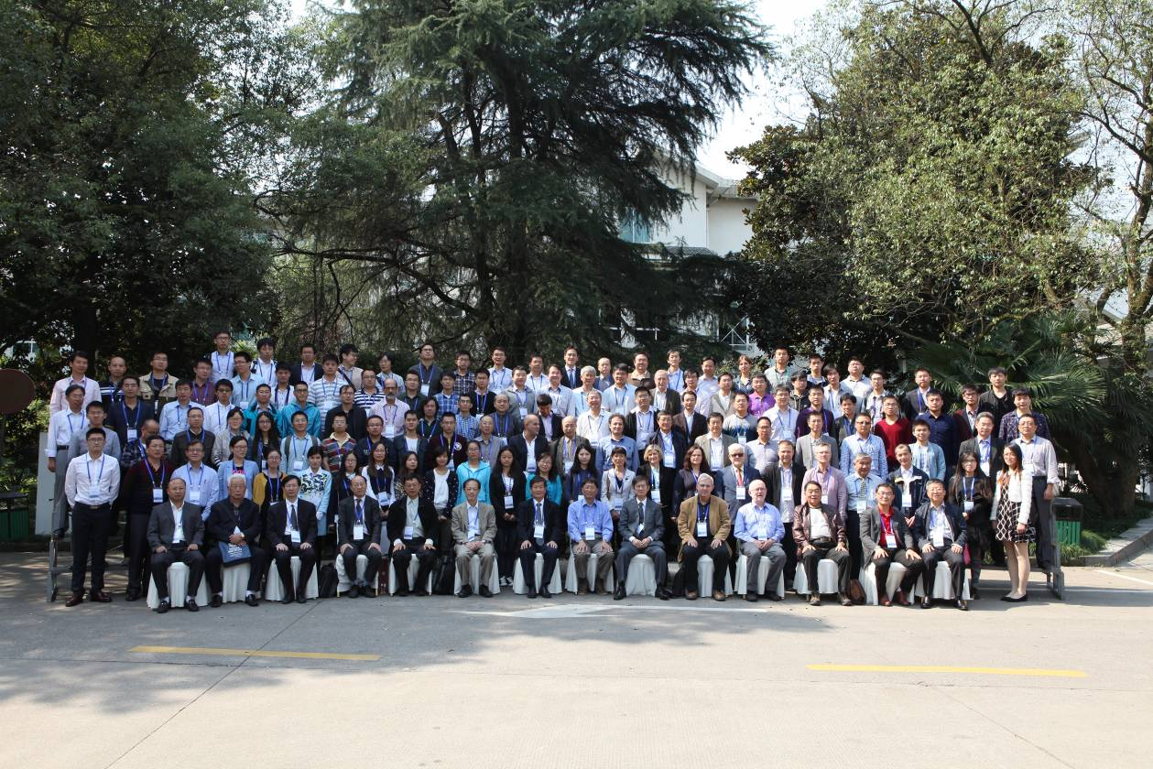
ICOME 2015 團體照(中國杭州)

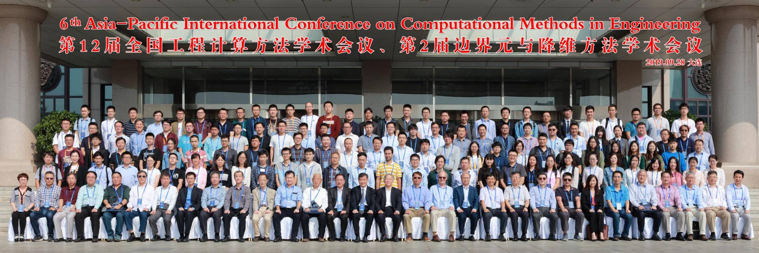
ICOME 2019 團體照(中國大連)

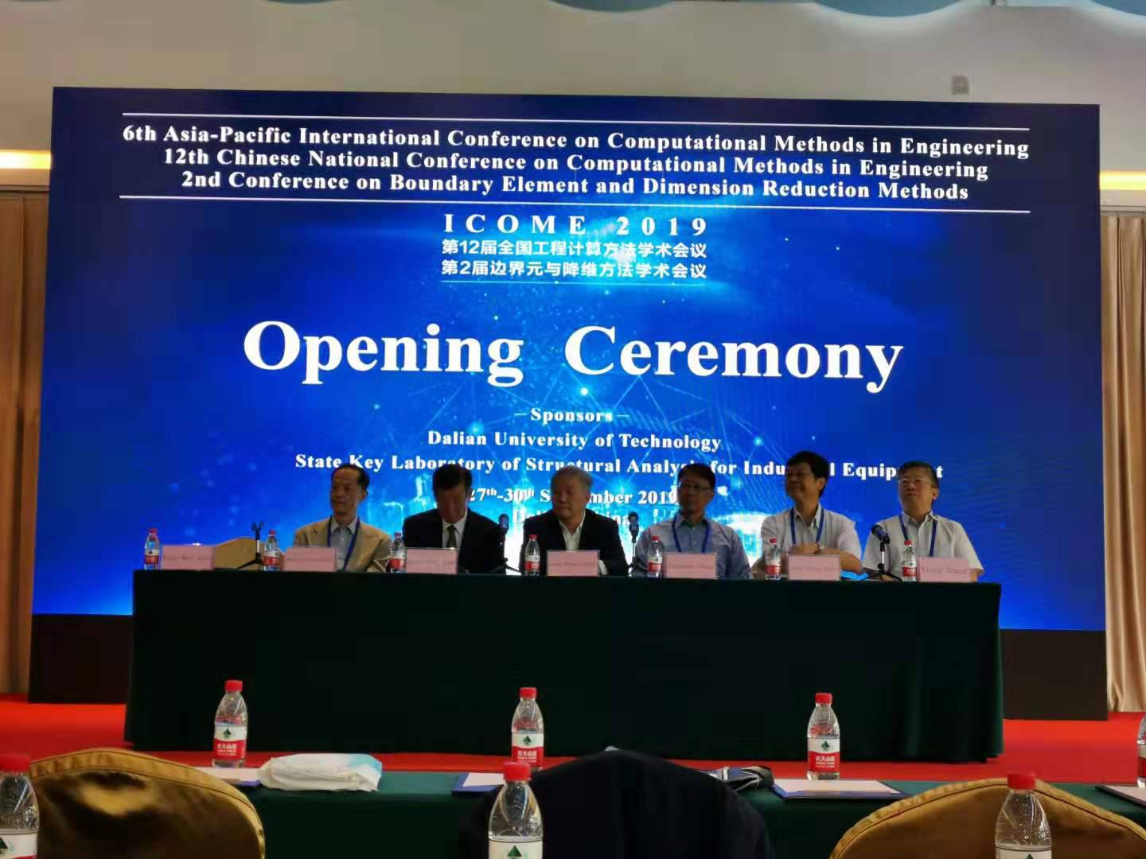 | 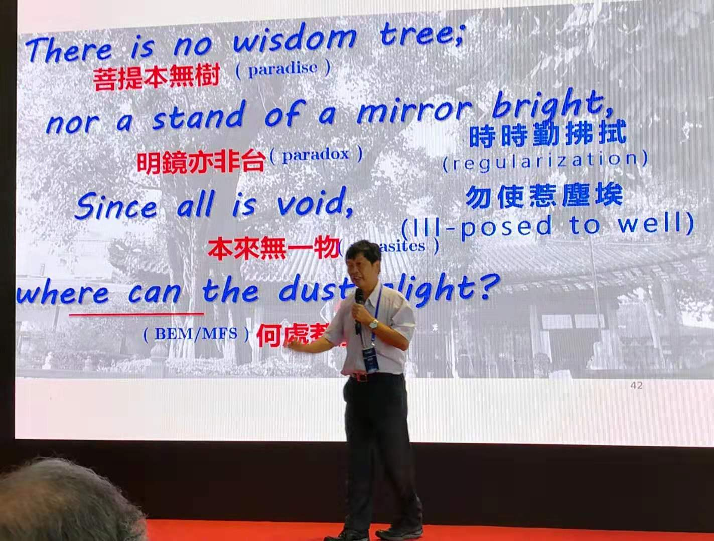
開幕儀式-大會共同主席 | 大會演講-海洋大學陳正宗特聘講座教授
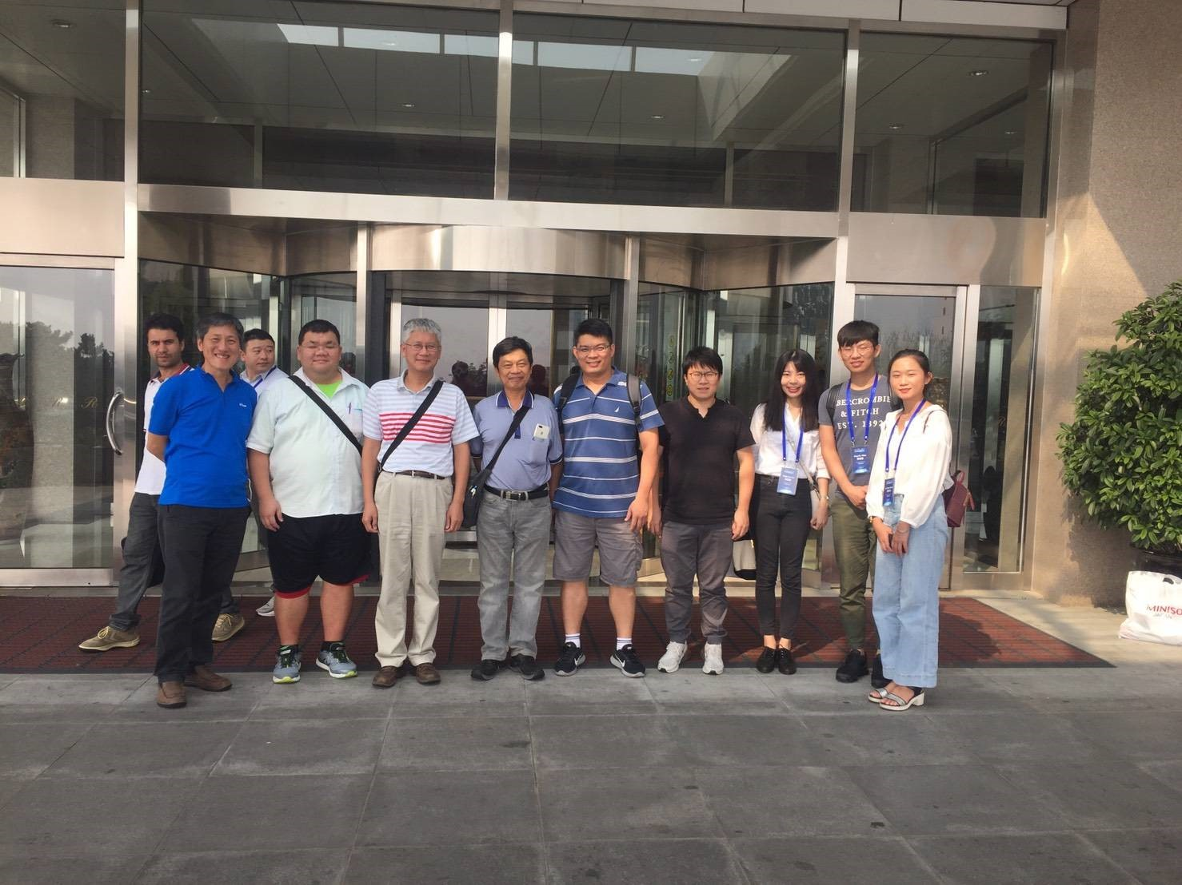 | 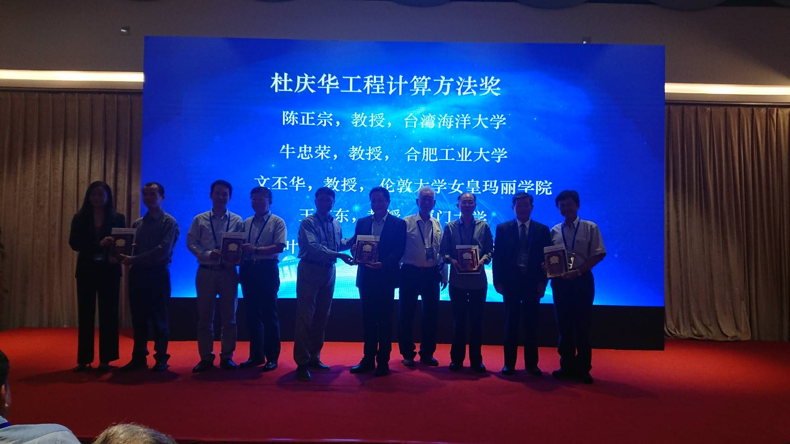
台灣團隊合影 | 海洋大學陳正宗特聘講座教授獲獎
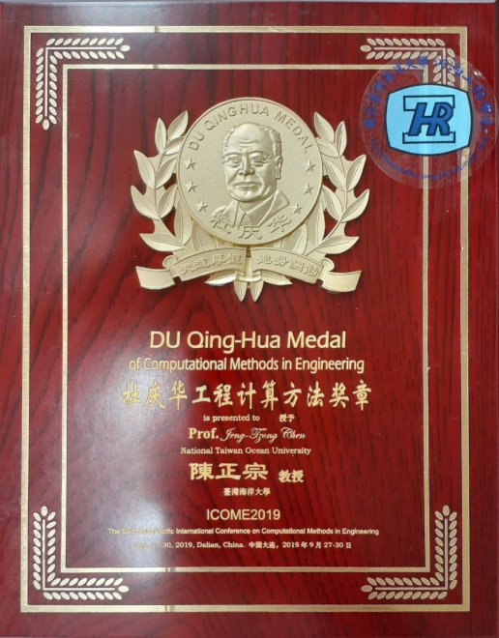 | 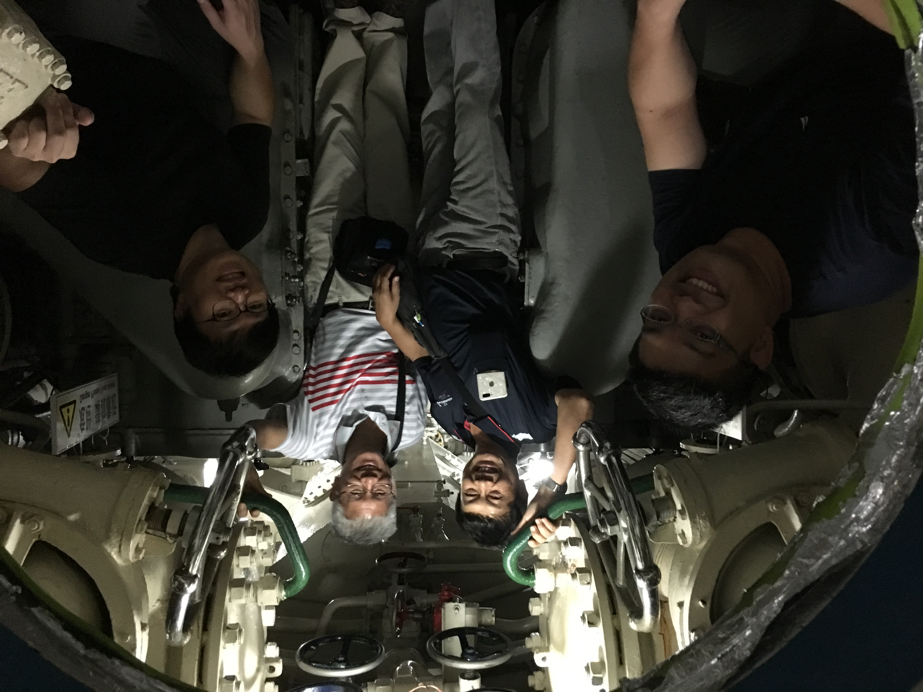
杜慶華計算力學獎章 | MSV 研究團隊於潛艇合影  (海大李應德助理教授、陳正宗特聘講座教授、郭世榮主任與宜大吳清森助理教授)

附錄一

Icome 2019 opening by Chen J T

This is my third visit of Dalian. Dalian is a beautiful city. On behalf of the Taiwan team organizer, we have ten participants from Taiwan, the same number of Japanese participants. We know that this icome series followed from the Japan-China joint meeting since 1980. Since 2002, I attended the Beteq organized by Yao in Beijing. Prof Yao always invited Taiwan scholars to join the meeting in Mainland China. I am glad to join the icome series since 2006. Prof. Yao and I were absent in the icome 2003 in Hoikaido.

Today is a teacher day in Taiwan since Confucius was born on September 28. However, today is not a teacher day in Mainland China. I do not know why they are so many difference cross the Taiwan strait. Anyway, we should remind our two teachers in BEM. One is Prof. Du in China and the other one is Prof. Kobayashi (小林昭一). Without their initiation of Japan-China BEM workshop, we cannot have the icome meeting today.

Prof. Du and Prof. Kobayashi are the two key persons to construct the platform of interaction. Prof. Yao, Prof. Nishimura and I all of us follow their step to initiate icome series. In 2019, it is a very special year of BEM. A memorial book for Prof. Du Q H 100 years old event is presented. I also contributed one paper. At the same year, Prof. Yao enjoyed his 80 birthday on April in Peiking meeting. We congratulate that Prof. Yao won the international Green medal on July. Last year, our Japanese old friend, the pioneer of BEM, Prof. Kobayshi passed away. We, bem researchers here, all still follow their steps of the two pioneers, Prof. Du in China and Prof. Kobayashi in Japan. The two big guys are our role model in our academic career. WE pay respect to them. Young generations in Mainland China, Japan and Taiwan should know the history of bem development in Asia as well as the world. To my personal feeling, we all belong to the BEM family. Today, I am glad to find that many young generations in Mainland China, Japan and Taiwan do a lot of nice work. We hope that not only generation transfer but also technology transfer is well done.

Finally, I will say that if there is without the effort of Prof. Gao’s organization, we cannot join together here. We thank Prof. Gao and Dalian university very much. Hope that all the participants can enjoy good days in this icome meeting since I come, you come and many old friends come.

附錄二
Good morning, Ladies and Gentlemen, dear friends,
It is my great honor to receive the Du award this year, which is not only a personal encouragement to me, but also an encouragement to all Taiwanese scholars engaged in the research of boundary element method and meshless methods.

At this moment, I would firstly remind my memories with Prof. Du during 1990. He processed my review article of dual BEM in Applied Mechanics Review. At that time, he was the associate editor of ASME, Applied Mechanics Review. He opened my view of Chinese scholars not only engineer professors in BEM but also mathematicians. For example, I make friendship with Prof. Yao Z H, Yu D H, Han H D, Zhu J L and Shi Z Z after his introduction. Prof. Du constructed the linking bridge of bem researchers across the Taiwan strait. Later, Prof. Yao and I continue to do.

Thanks Prof. Du in China and Prof. Kobayashi in Japan initiated the Chinese-Japan workshop and then the present icome series. Without both of them, we cannot have a meeting today in Dalian. This year is centenary of Prof. Du’s birth, and Chinese people have edited a collection of his photos and commemorative articles in memory of him. I also contribute one article to pay respect to him since I was the one to connect the cross strait interaction on BEM between Mainland China and Taiwan since 2000.

Here, I will say a few words since yesterday is a teacher day. Prof. Du said that to be a happy teacher, to be a nice teacher and to be a ladder of student. 樂為人師 善為人師 甘為人梯 We not only learn to do bem research but also learn how to be a qualified teacher from Prof. Du.

Although Prof. Du and Kobayashi both passed away, they have given us a perfect role modal to follow especially for young researchers.

Thank my teacher, Prof. H-K Hong for his leadership, let me started the research in the field of dual BEM thirty-five years ago, let me have the opportunity to play a larger role in Taiwan BEM community.

I would also like to thank my former graduate students worked with me in BEM and meshless methods during the past decades, it is their intelligence and innovative spirits inspired me to move forward on the road of academic research.

At the same time, I would also like to thank many colleagues in this field, we have been carrying out in-depth exchanges in decades. Of course, it also includes many international old friends, and we have had exchanges that benefited me a lot on many occasions.
Finally, I would like to wish our colleagues in this field to continue to move forward in the new situation, and to create a more brilliant future!

Thank you!
教育部第五十五屆工科 學術獎
科技部土木水利工程 學門召集人
台灣工業與應用數學會 副理事長
海大河海工程學系暨研究所 特聘講座教授
機械與機電工程學系暨研究所 合聘教授
成大土木工程學系暨研究所 合聘教授
陳 正 宗 博士

