Thermal Stress

(Rod and plane truss )

**Equivalence**

**Application**

Beam and space frame

MDOF Systems

Satellite structure

Direct problems

Inverse problems

**2025/08**

**2026/07**

Moore-Penrose inverse

Well-posed BIEM

See Table 1

Fichera’s method

SVD technique

**well-done researches**

Engineering problems

(PDE model)

BEM/BIEM

(Weak formulation)

Self-regularized approach

**Mathematical model**

**Physical behavior**

Ill-conditioned system

Bordered matrix

**Continuous system**

This proposal

(2024-2026)

**proposed researches**

See Fig. 2

**2015/08**

**2018/07**

**Discrete system**

**?**

無退化尺度之邊界積分方程推導及

邊界元素法之應用 (3年)  
(MOST 103-2221-E-019 -012 )

二維外域問題退化尺度之研究：雙極座標解析推導與邊界元素法數值實驗 (3年)

(MOST 106-2221-E-019-009)

無因次二維基本解之退化尺度研究

(MOST 107-2221-E-019 -003)

Truncated

SVD technique

Generalized inverse

Pseudo   
inverse

Least

squares method

Present

approach

Dummy link

Dummy degrees

Projection method

**2024/08**

**2025/07**

Degenerate scale (23 SCI papers, since 2001)

Fig. 1 Frame of the two-years proposal

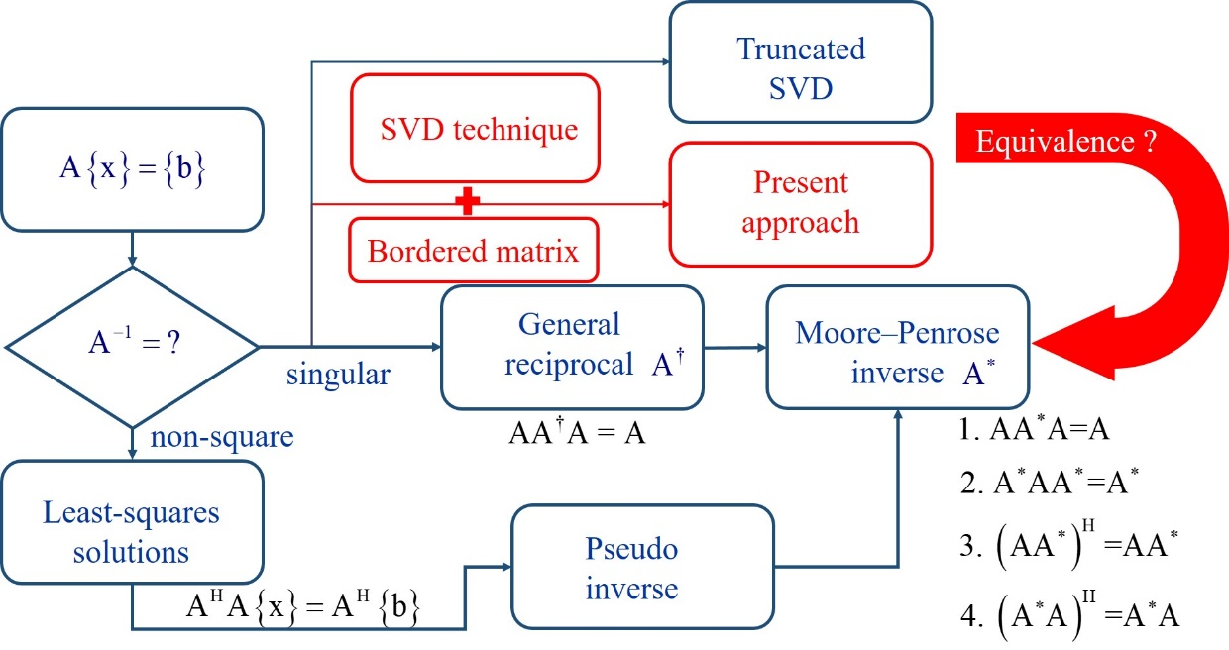

Fig. 2 Relationship among various techniques



Fig. 3 The action of a general matrix where the superscript “0” of  and  denotes the zero singular value [20].

|  |
| --- |
| **regularized** |
| Fig. 4 The self-regularized linear algebraic system from the continuous BIE system [28]. |

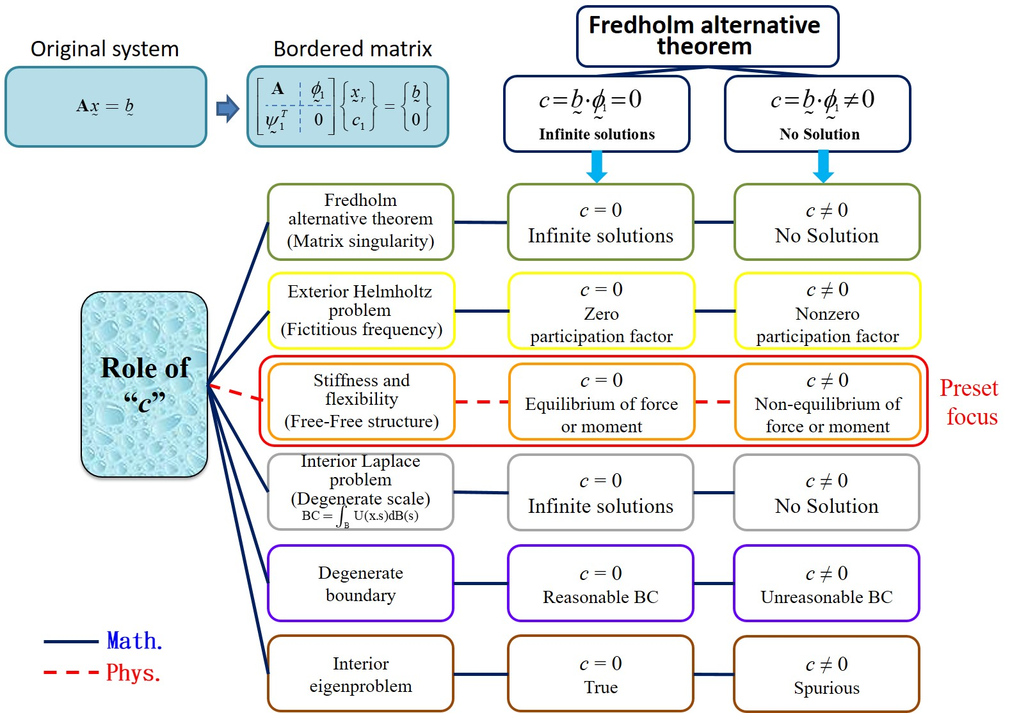

Fig. 5 The role of the slack variable “c” in the bordered matrix for rank-deficiency problems.

|  |  |
| --- | --- |
|  | |
| 1. A rod element | |
|  | |
| 1. A plane truss (second-order) | |
|  | |
| 1. A space truss (second-order) | |
|  | |
| 1. A Bernoulli-Euler beam element (fourth-order) | |
|  |  |
| 1. Space structure of a satellite [1] | 1. Satellite frame |
| Fig. 6 Illustrative examples of this proposal | |