Logarithmic capacity

BIEM

Rank deficiency

Well-posed BIEM

Fichera’s method

**well-done researches**

Engineering problems

(PDE model)

BEM/BIEM

(Weak formulation)

Ill-conditioned system

Statics

This proposal

(2025/08 - 2028/07)

**proposed researches**

**2013/08**

**2014/07**

邊界元素法中退化問題之統一推導 (3年)  
(NSC 91-2211-E-019-009)

邊界元素法求解板問題中退化尺度之研究  
(NSC 93-2211-E-019-010)

邊界元素法中的退化尺度與複變理論中單位對數容量關聯之研究  
(NSC 102-2221-E-019-034)

無退化尺度之邊界積分方程推導及

邊界元素法之應用 (3年)  
(MOST 103-2221-E-019 -012 )

二維外域問題退化尺度之研究：雙極座標解析推導與邊界元素法數值實驗 (3年)

(MOST 106-2221-E-019-009)

無因次二維基本解之退化尺度研究

(MOST 107-2221-E-019 -003)

邊界元素法/邊界積分方程法中雙退化問題之探討 (3年)

(MOST 109-2221-E-019 -001)

**2025/08**

**2026/07**

**2026/08**

**2027/07**

**Numerical implementation**

**Conjecture**

**Analytical derivation**

**Application**

**2027/08**

**2028/07**

**Application - CSF**

**Elasticity problems**

PDE model

(Strong form)

Special scale (2D)

(Degenerate scale)

(31 SCI papers, since 2001)

**Regular Star Polygons**

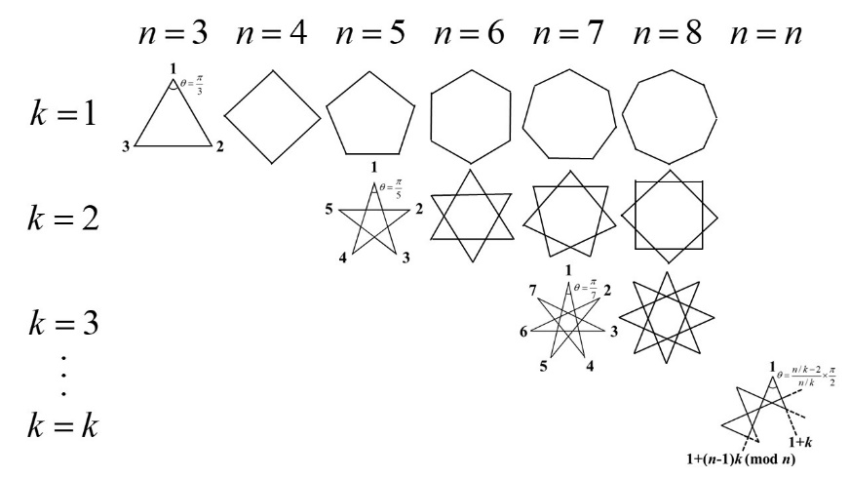



Heat exchangers

**Discriminant ?**



Gamma function

Self-regularization method

BEM

Singular matrix

Kolossoff-Muskhelishvili's

two stress function

Complex variables

Schwarz-Christoffel transformation





Conduction shape factor

Table A Frame of the three-years proposal